**Use case 01-Building a Sales and Geography Data Warehouse for Contoso in Microsoft Fabric**

**Introduction**

Contoso, a multinational retail company, is looking to modernize its data infrastructure to improve sales and geographical analysis. Currently, their sales and customer data is scattered across multiple systems, making it difficult for their business analysts and citizen developers to derive insights. The company plans to consolidate this data into a unified platform using Microsoft Fabric to enable cross-querying, sales analysis, and geographical reporting.

In this lab, you’ll assume the role of a data engineer at Contoso tasked with designing and implementing a data warehouse solution using Microsoft Fabric. You will start by setting up a Fabric workspace, creating a data warehouse, loading data from Azure Blob Storage, and performing analytical tasks to deliver insights to Contoso's decision-makers.

While many concepts in Microsoft Fabric may be familiar to data and analytics professionals, it can be challenging to apply those concepts in a new environment. This lab has been designed to walk step-by-step through an end-to-end scenario from data acquisition to data consumption to build a basic understanding of the Microsoft Fabric user experience, the various experiences and their integration points, and the Microsoft Fabric professional and citizen developer experiences.

**Objectives**

* Set up a Fabric workspace with trial enabled.
* Establish a new Warehouse named WideWorldImporters in Microsoft Fabric.
* Load data into the Warehouse_FabricXX workspace using a Data Factory pipeline.
* Generate dimension_city and fact_sale tables within the data warehouse.
* Populate dimension_city and fact_sale tables with data from Azure Blob Storage.
* Create clones of dimension_city and fact_sale tables in the Warehouse.
* Clone dimension_city and fact_sale tables into the dbo1 schema.
* Develop a stored procedure to transform data and create aggregate_sale_by_date_city table.
* Generate a query using the visual query builder to merge and aggregate data.
* Use a notebook to query and analyze data from the dimension_customer table.
* Include WideWorldImporters and ShortcutExercise warehouses for cross-querying.
* Execute a T-SQL query across WideWorldImporters and ShortcutExercise warehouses.
* Enable Azure Maps visual integration in the Admin portal.
* Generate column chart, map, and table visuals for Sales Analysis report.
* Create a report using data from the WideWorldImporters dataset in the OneLake data hub.
* Remove the workspace and its associated items.

# Exercise 1: **Create a Microsoft Fabric workspace**

## **Task 1: Sign in to Power BI account and sign up for free**[**Microsoft Fabric trial**](https://learn.microsoft.com/en-us/fabric/get-started/fabric-trial)

1. 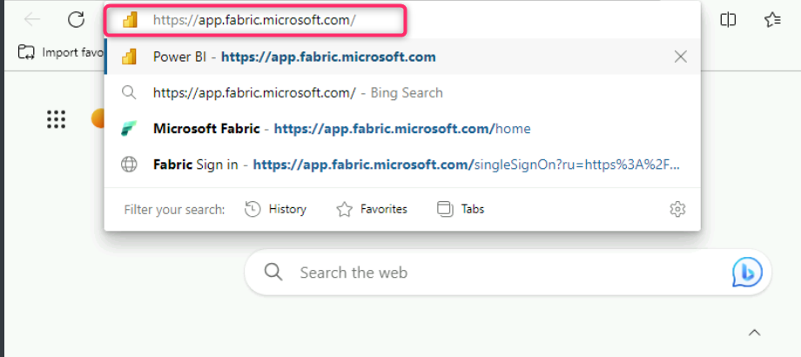Open your browser, navigate to the address bar, and type or paste the following URL: https://app.fabric.microsoft.com/ then press the **Enter** button.
2. In the **Microsoft Fabric** window, enter assigned credentials, and click on the **Submit** button.

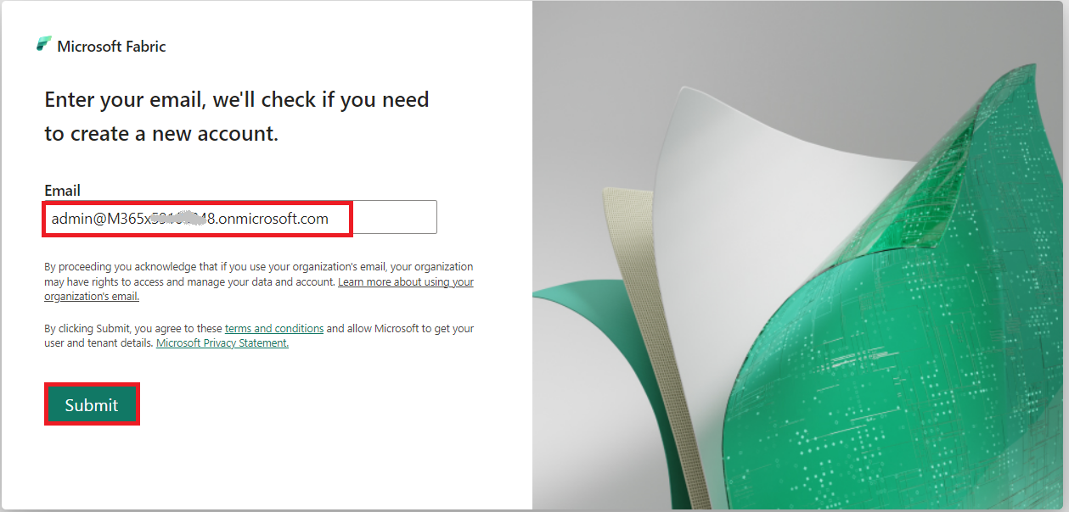

1. Then, In the **Microsoft** window enter the password and click on the **Sign in** button**.**

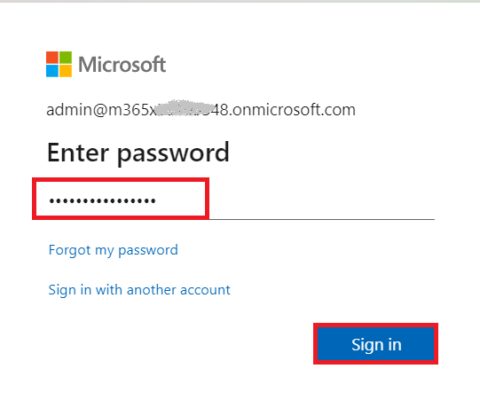

1. 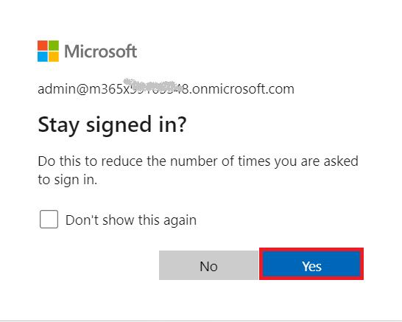In **Stay signed in?** window, click on the **Yes** button.
2. You’ll be directed to Power BI Home page.

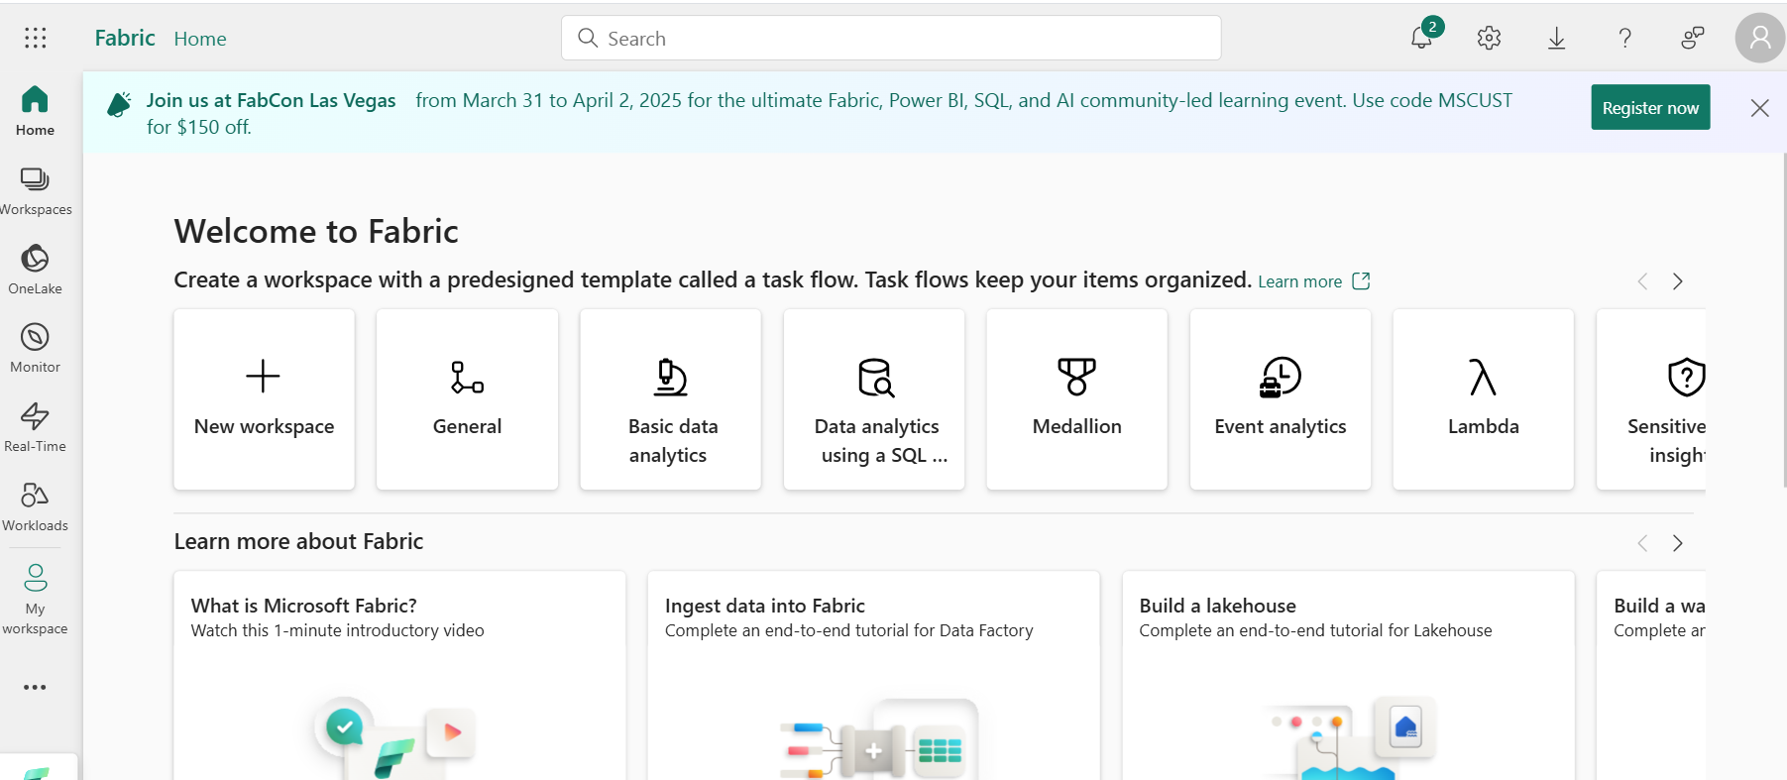

## **Task 2: Start the Microsoft Fabric (Preview) trial**

Follow these steps to start your Fabric trial.

1. On **Power BI Home** page, click on the **Account manager** on the right side. In the Account manager blade, navigate and select **Start trial as shown in the below image.**

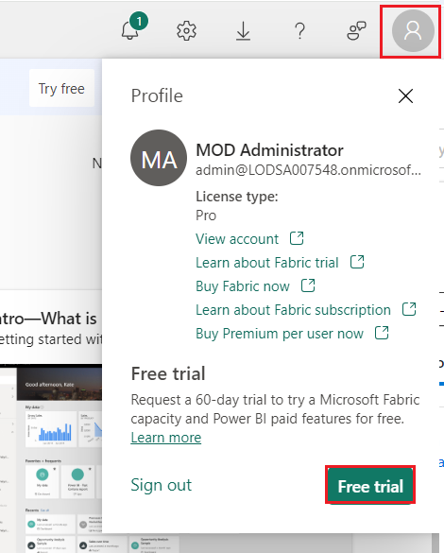

1. If prompted, agree to the terms and then select **Activate**.

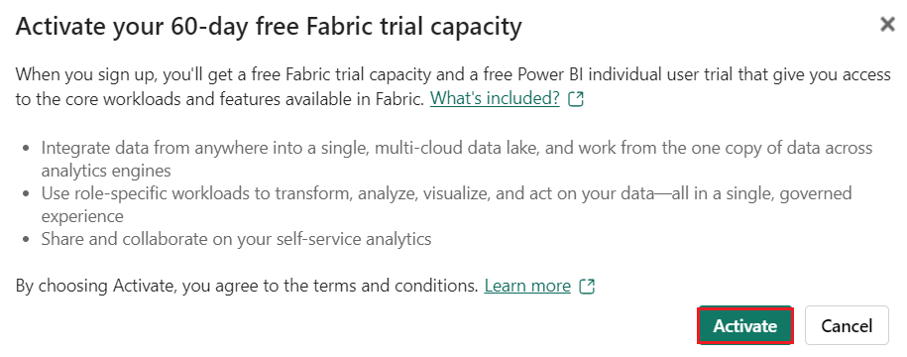

1. Once your trial capacity is ready, you receive a confirmation message. Select **Fabric Home Page** to begin working in Fabric.

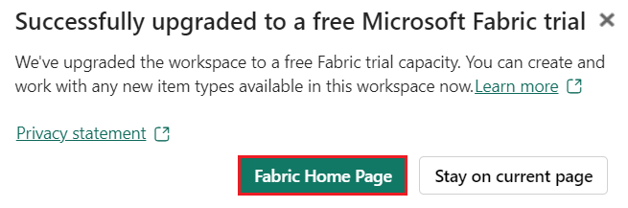

1. 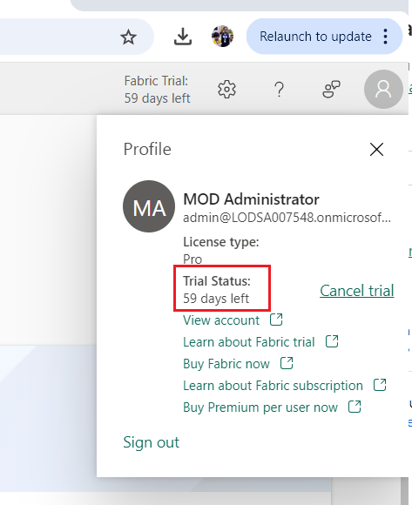Open your Account manager again. Notice that you now have a heading for **Trial status**. Your Account manager keeps track of the number of days remaining in your trial. You will also see the countdown in your Fabric menu bar when you work in a product experience.

## Task 3: Create a workspace

Before working with data in Fabric, create a workspace with the Fabric trial enabled.

1. In the Workspaces pane Select **+** **New workspace**.

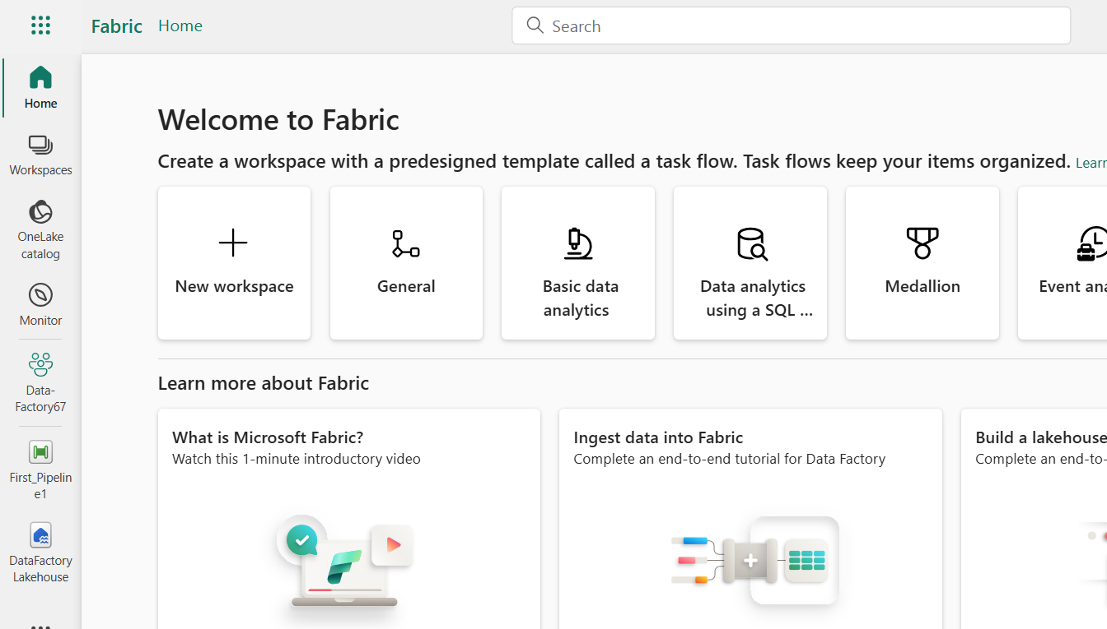

1. In the **Create a workspace tab, enter** the following details and click on the **Apply** button.

|  |  |
| --- | --- |
| **Name** | **Warehouse_FabricXX** (XX can be a unique number) (here, we entered **Warehouse_Fabric29)** |
| **Description** | This workspace contains all the artifacts for the data warehouse |
| **Advanced** | Under **License mode**, select **Trial** |
| **Default storage format** | **Small dataset storage format** |

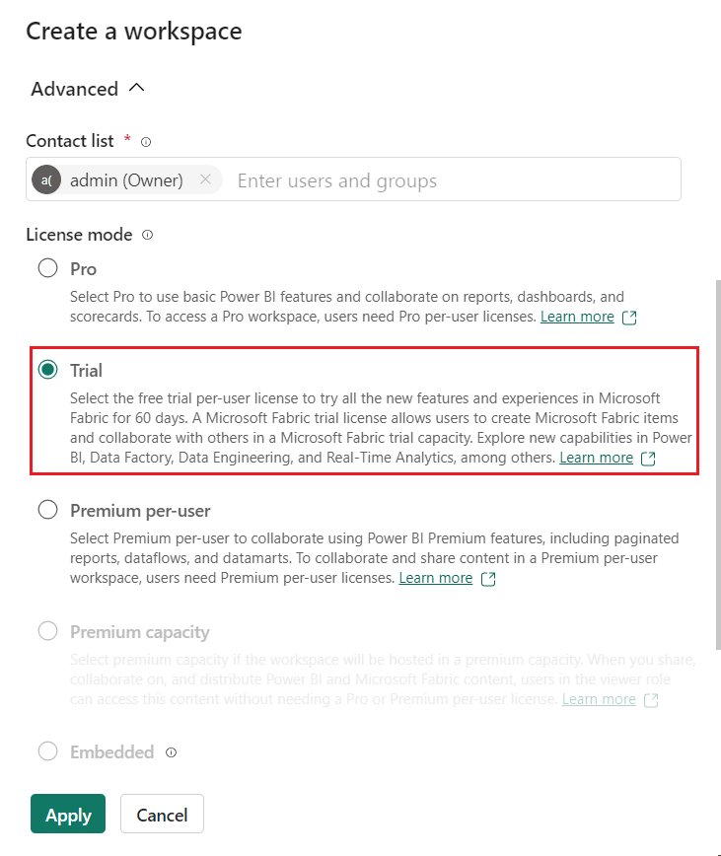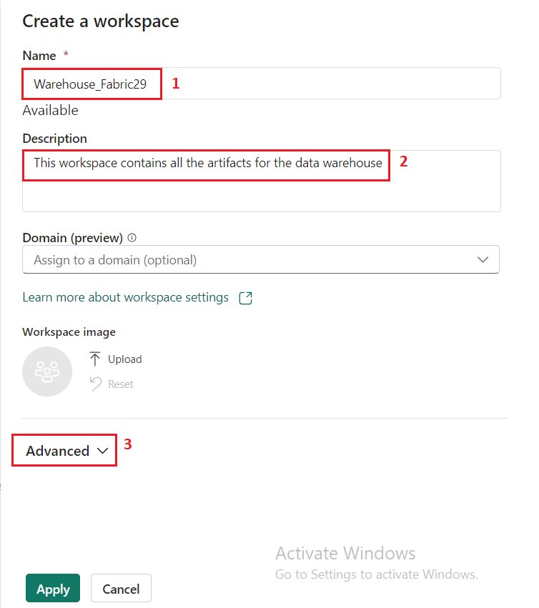

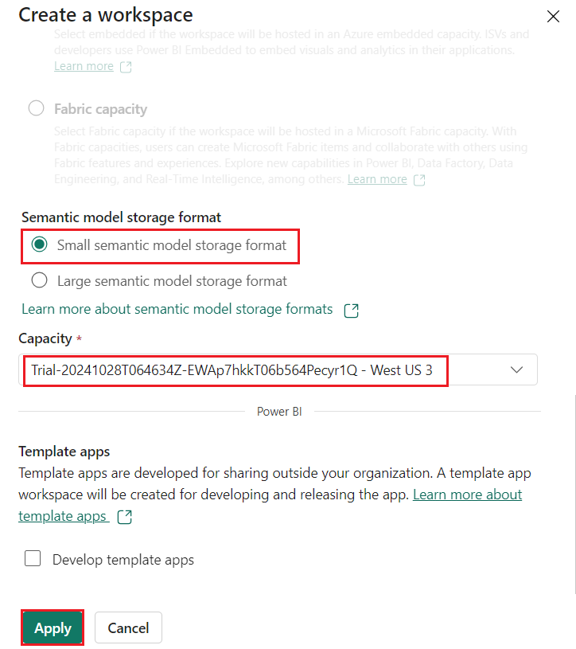

1. Wait for the deployment to complete. It takes 2-3 minutes to complete. When your new workspace opens, it should be empty.

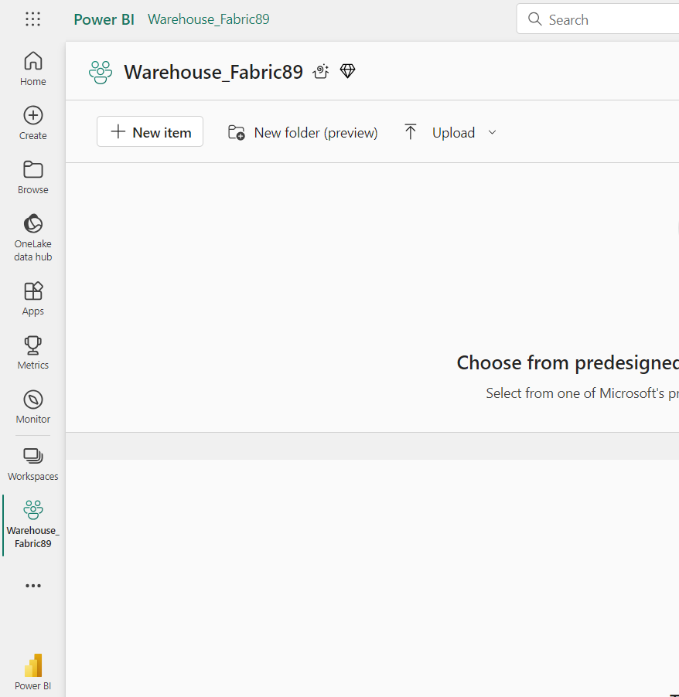

## Task 4: Create a Warehouse in Microsoft Fabric

1. In the **Synapse** **Data Warehouse** page, select **Warehouse** to create a lakehouse.

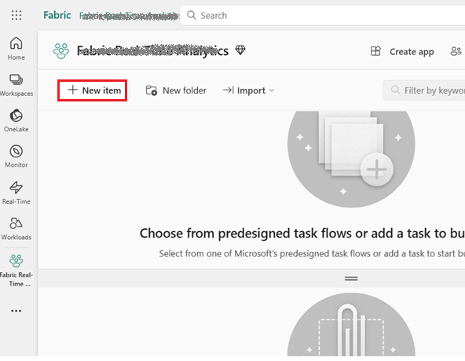

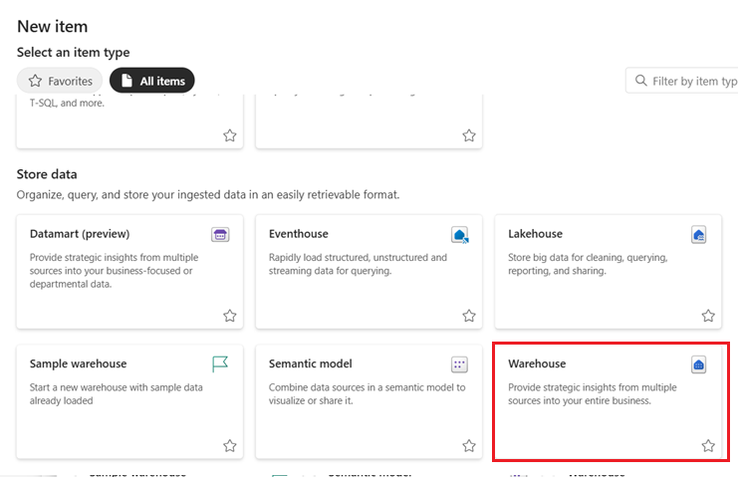

1. On the **New warehouse** dialog, enter +++**WideWorldImporters+++** and click on the **Create** button.

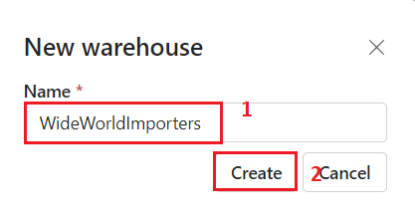

1. 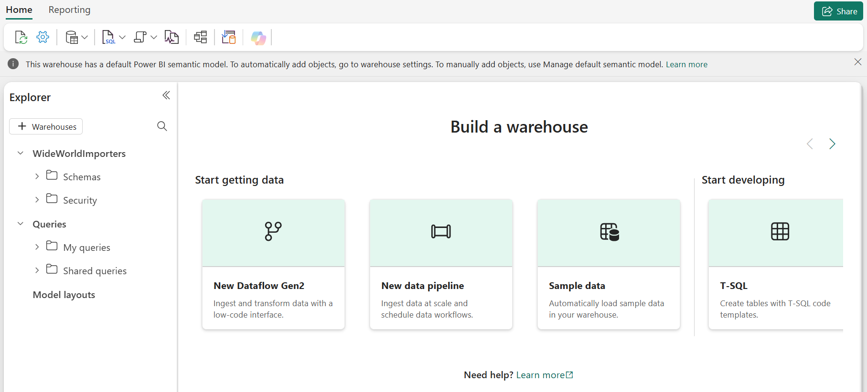When provisioning is complete, the **WideWorldImporters warehouse** landing page appears.

# **Exercise 2: Ingest data into a Warehouse in Microsoft Fabric**

## Task 1: Ingest data into a Warehouse

1. From the **WideWorldImporters warehouse** landing page, select **Warehouse_FabricXX** in the left-sided navigation menu to return to the workspace item list.

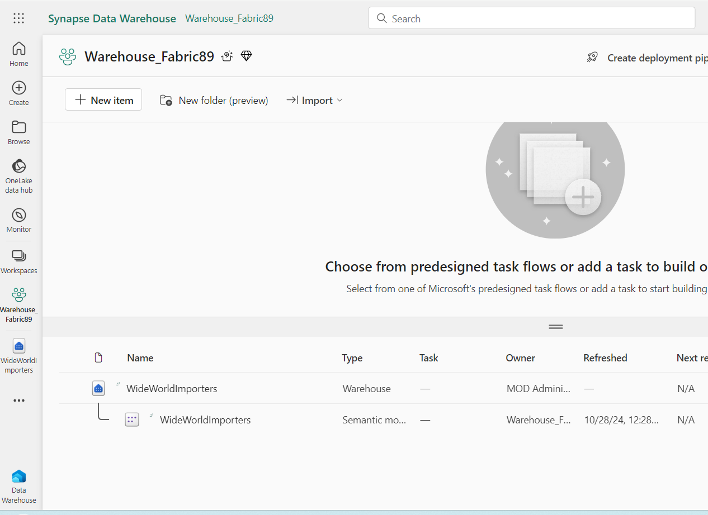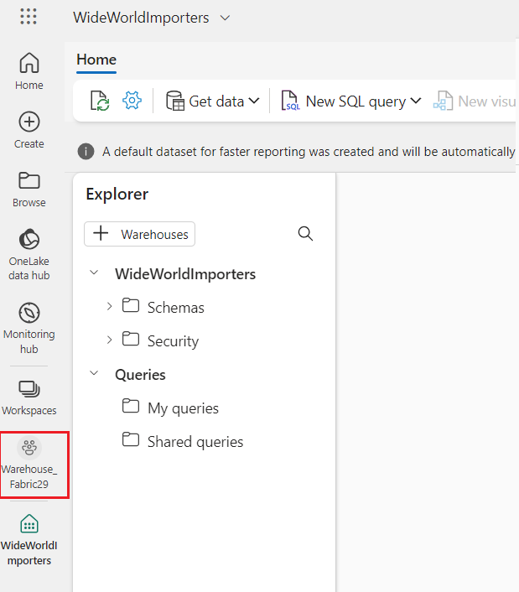

1. In the **Warehouse_FabricXX** page, select +**New item**. Then, click Data pipeline to view the full list of available items under Get data.

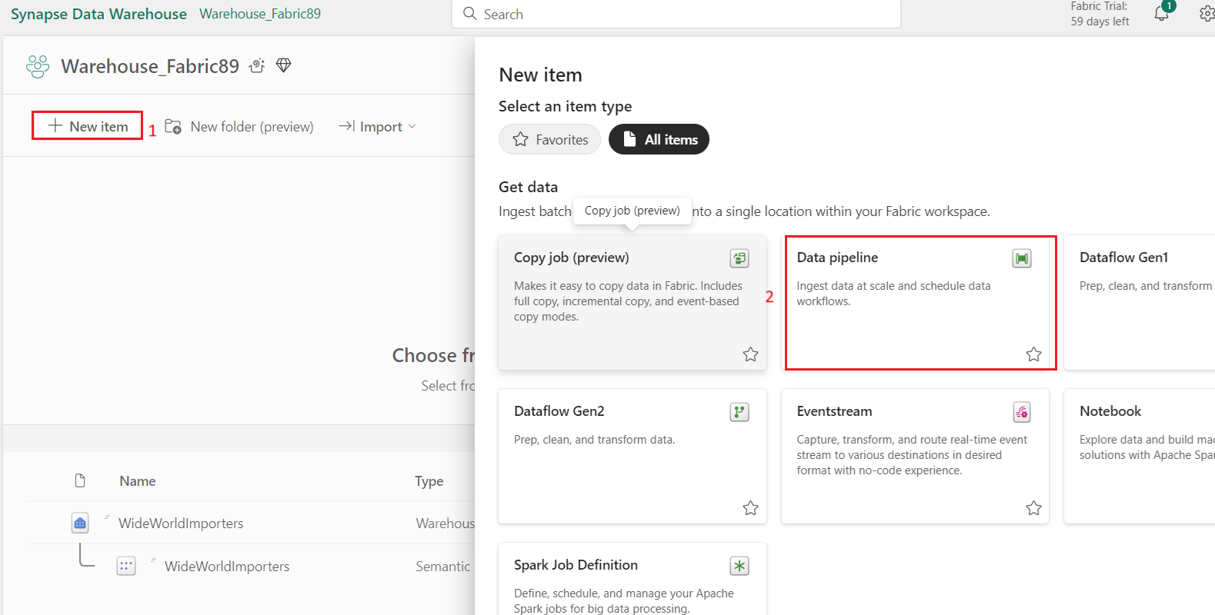

1. 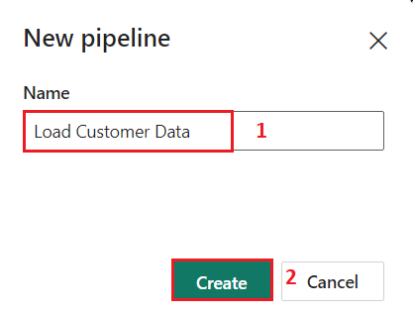On the **New** **pipeline** dialog box, in the **Name** field, enter +++**Load Customer Data+++** and click on the **Create** button.
2. In the **Load Customer Data** page, navigate to **Start building your data pipeline** section and click on **Pipeline activity**.

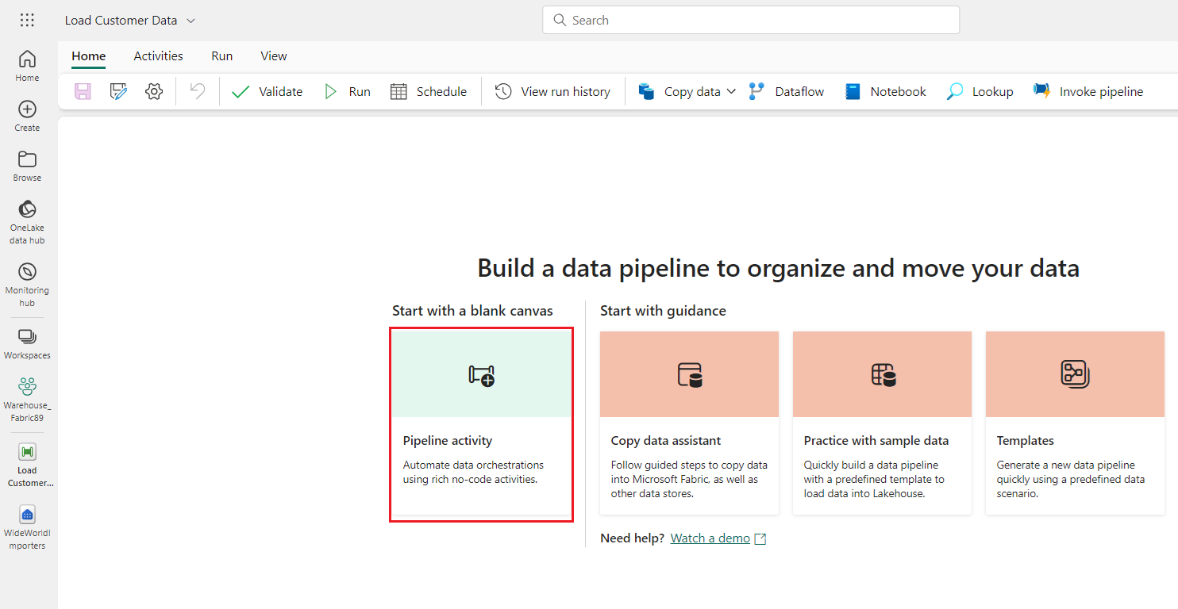

1. Navigate and select **Copy data** under **Move &** **transform** section.

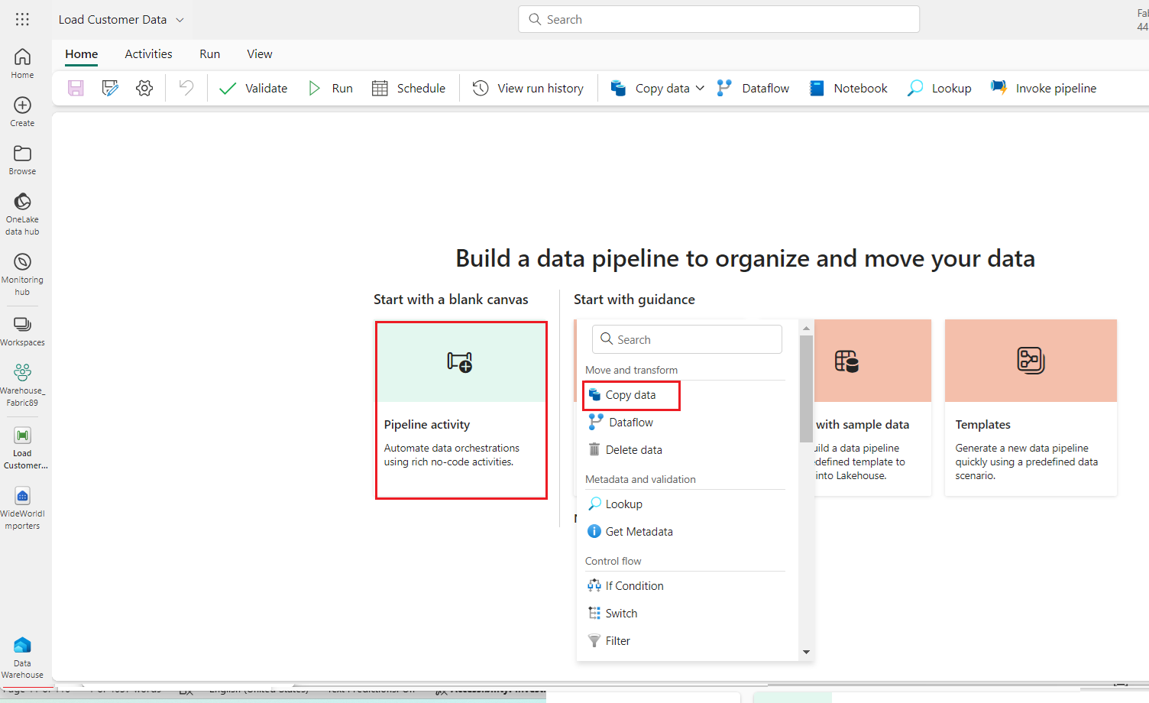

1. Select the newly created **Copy data** **1** activity from the design canvas to configure it.

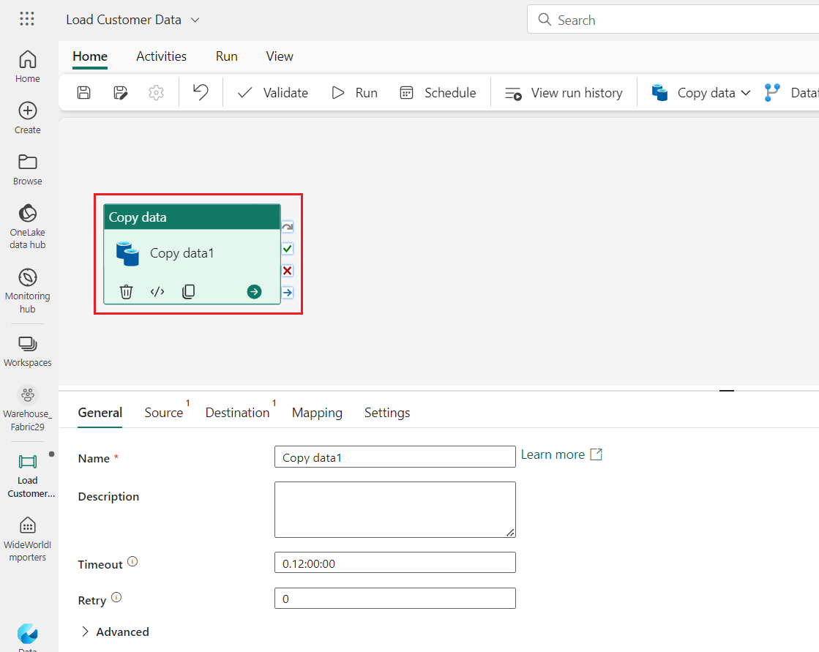**Note**: Drag the horizonal line in the design canvas to have a complete view of various features.

1. 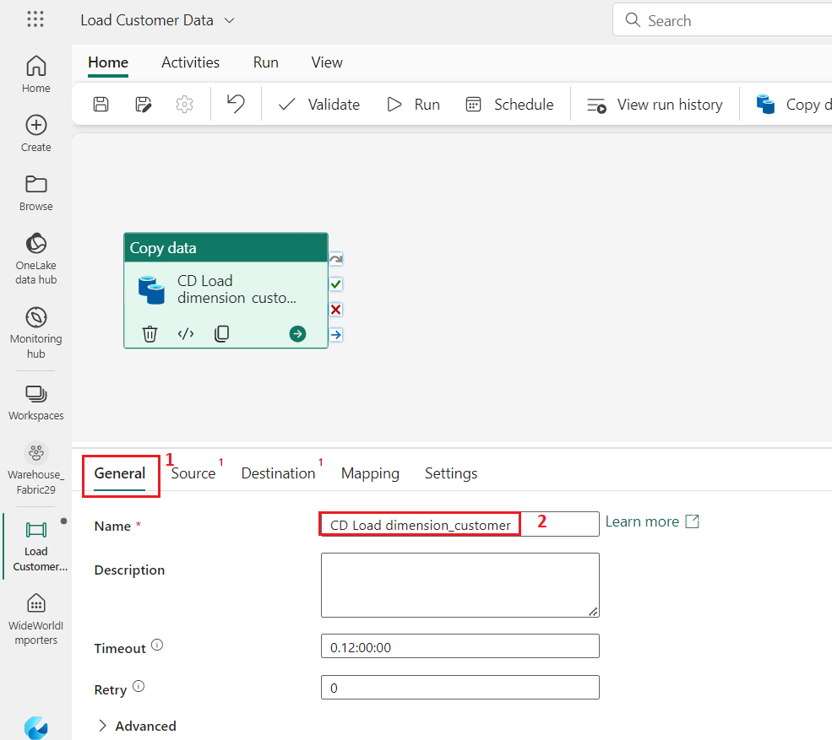On the **General** tab, in the **Name field,** enter +++**CD Load dimension_customer+++** .
2. On the **Source** page, select the **Connection** dropdown. Select **More** to see all of the data sources you can choose from, including data sources in your local OneLake data hub.

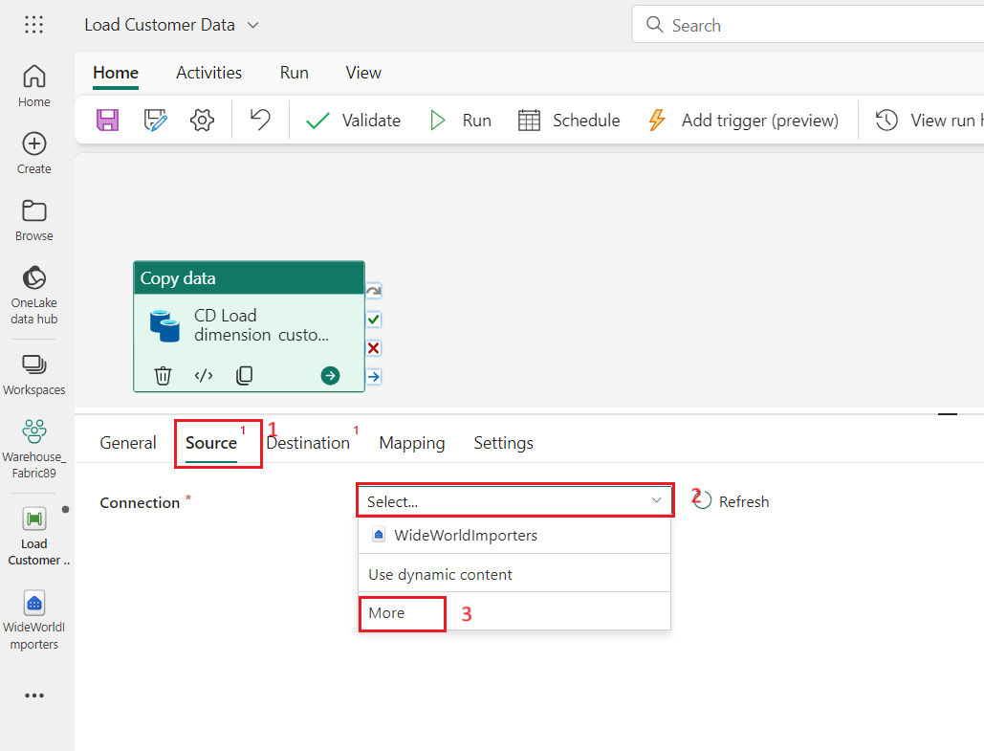

1. On the **Get data** window, search **Azure Blob Storage in**, then click on the **Azure Blob Storage** button.

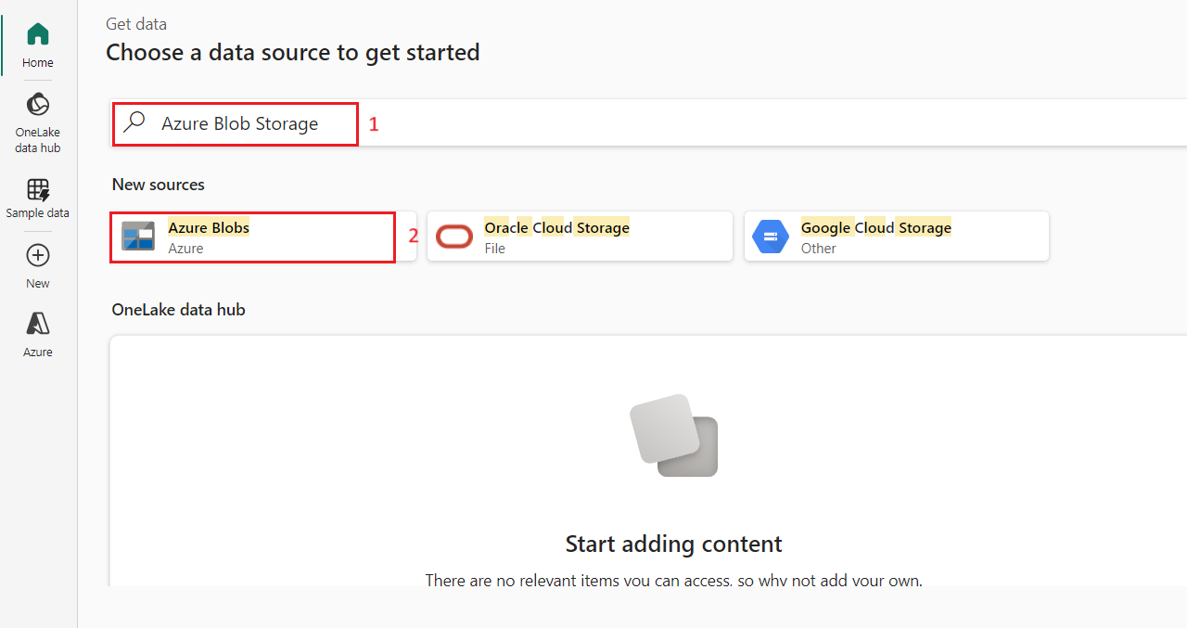

1. On the **Connection settings** pane that appears on the right side, configure the following settings and click on the **Connect** button.

* In the **Account name or URL**, enter +++**https://fabrictutorialdata.blob.core.windows.net/sampledata/+++**
* In the **Connection credentials** section, click on the dropdown under **Connection**, then select **Create new connection**.
* In **Connection name field,** enter +++**Wide World Importers Public Sample+++**.
* Set the **Authentication kind** to **Anonymous**.

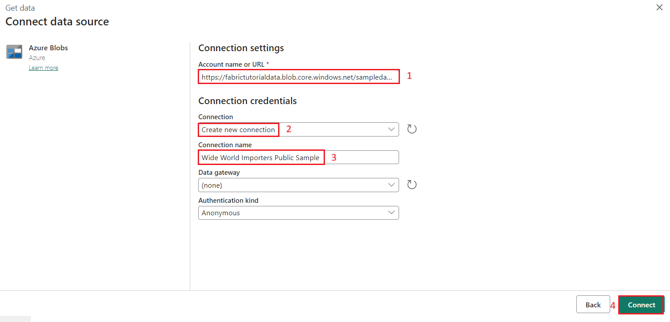

1. Change the remaining settings on the **Source** page of the copy activity as follows to reach the .parquet files in **https://fabrictutorialdata.blob.core.windows.net/sampledata/WideWorldImportersDW/parquet/full/dimension_customer/*.parquet**
2. In the **File path** text boxes, provide:

* **Container:** **sampledata**
* **File path - Directory:** **WideWorldImportersDW/tables**
* **File path - File name:** **dimension_customer.parquet**
  + In the **File format** drop down, choose **Parquet** (if you are unable to see **Parquet**, then type in the search box and then select it)

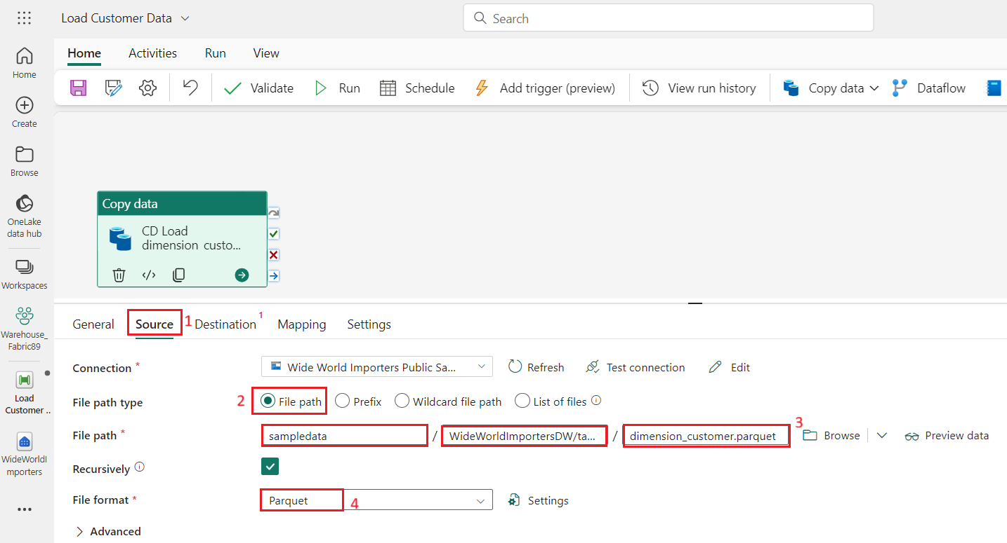

1. 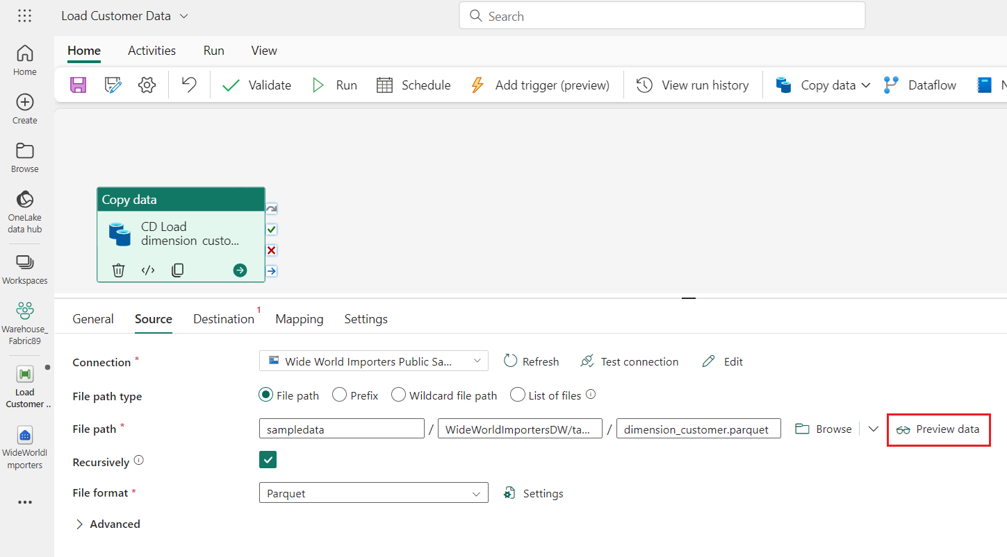Click on **Preview data** on the right side of **File path** setting to ensure that there are no errors and then click on **close.**

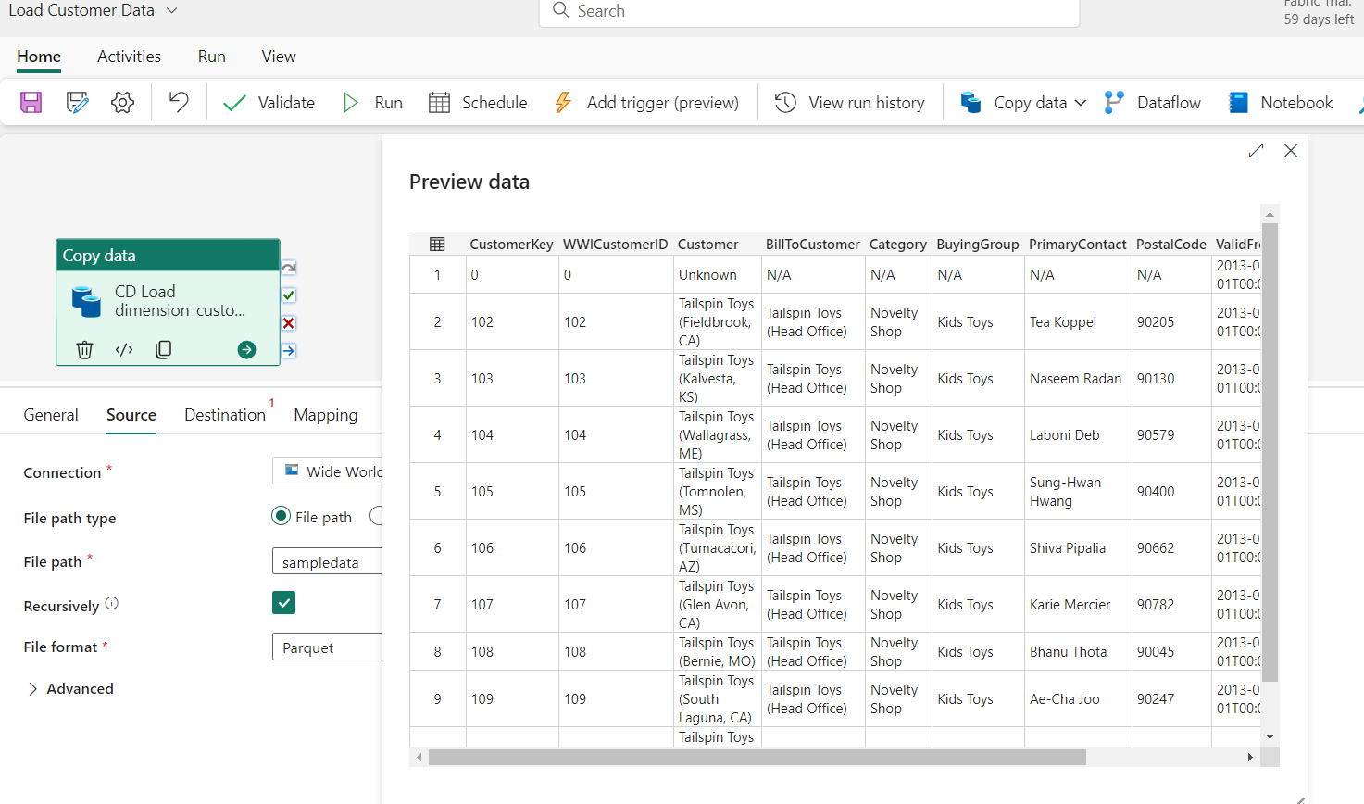

1. On the **Destination** tab, enter the following settings.

|  |  |
| --- | --- |
| **Connection** | **WideWorldImporters** |
| **Table option** | select the **Auto create table** radio button. |
| **Data Warehouse** | drop down, select **WideWorldImporters** from the list |
| **Table** | * **In the first box enter dbo** * **In the second box enter dimension_customer** |

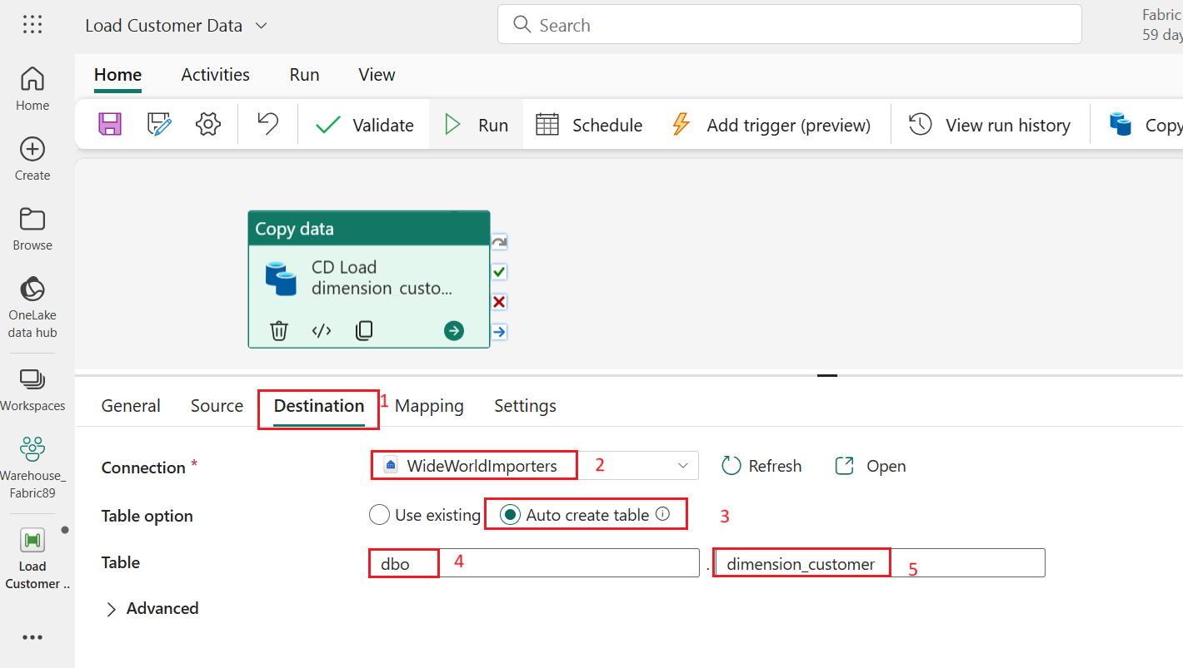

1. From the ribbon, select **Run**.

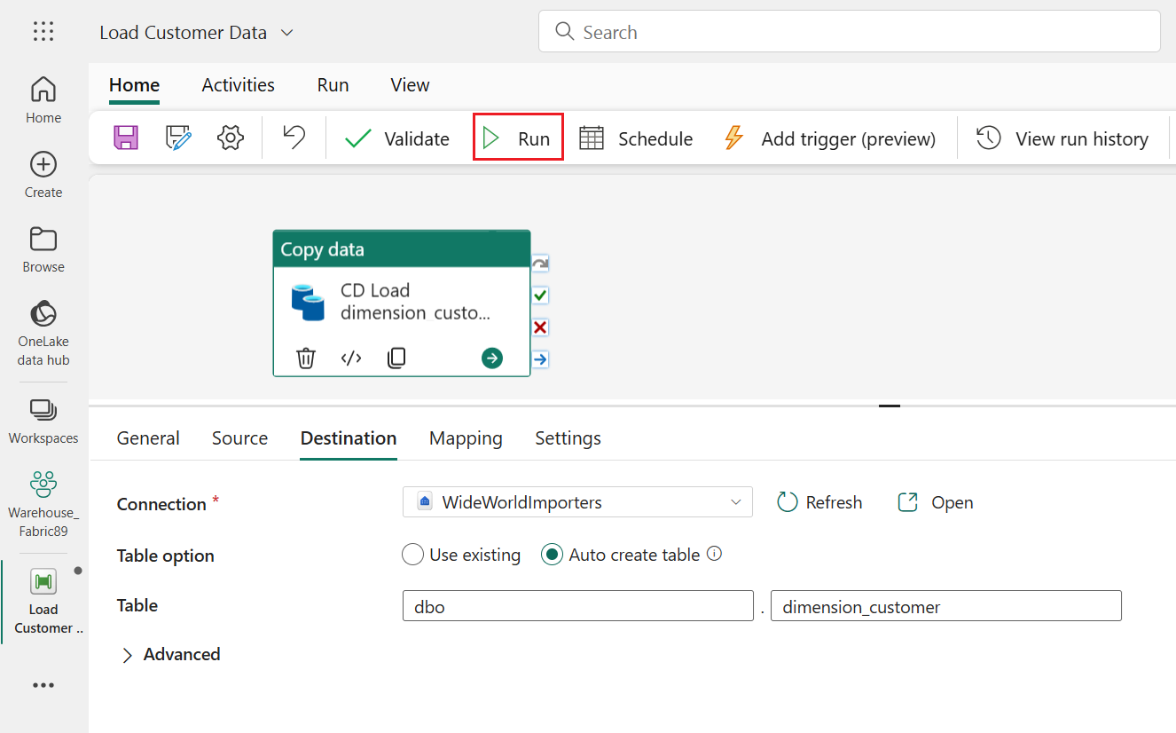

1. In the **Save and run?** dialog box, click on **Save and run** button.

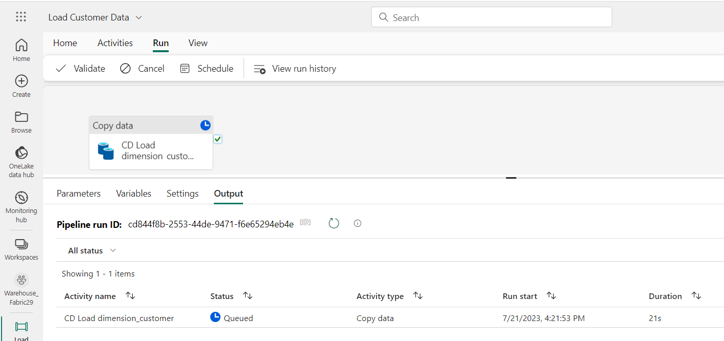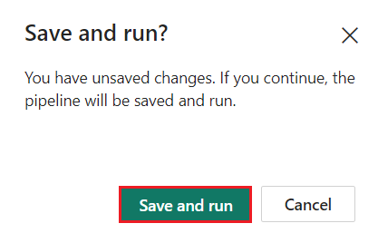

1. Monitor the copy activity's progress on the **Output** page and wait for it to complete.

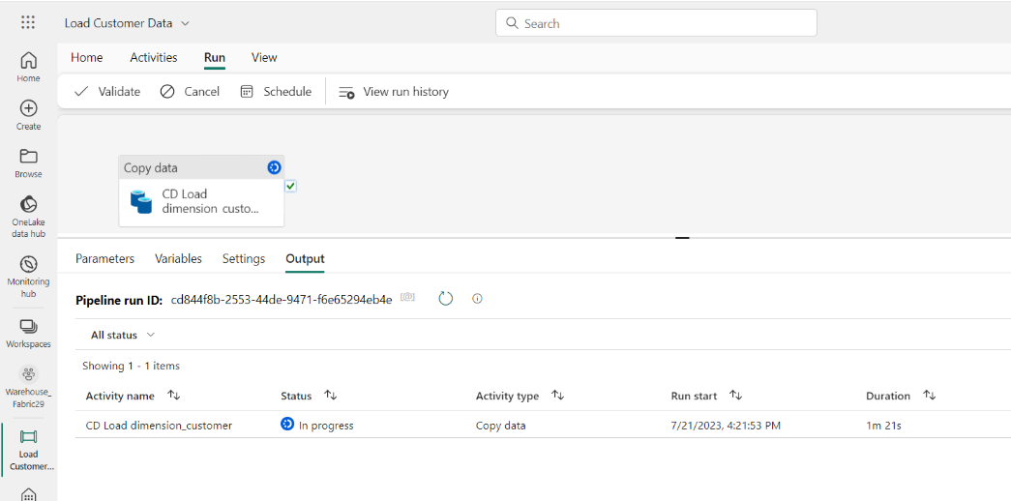

1. 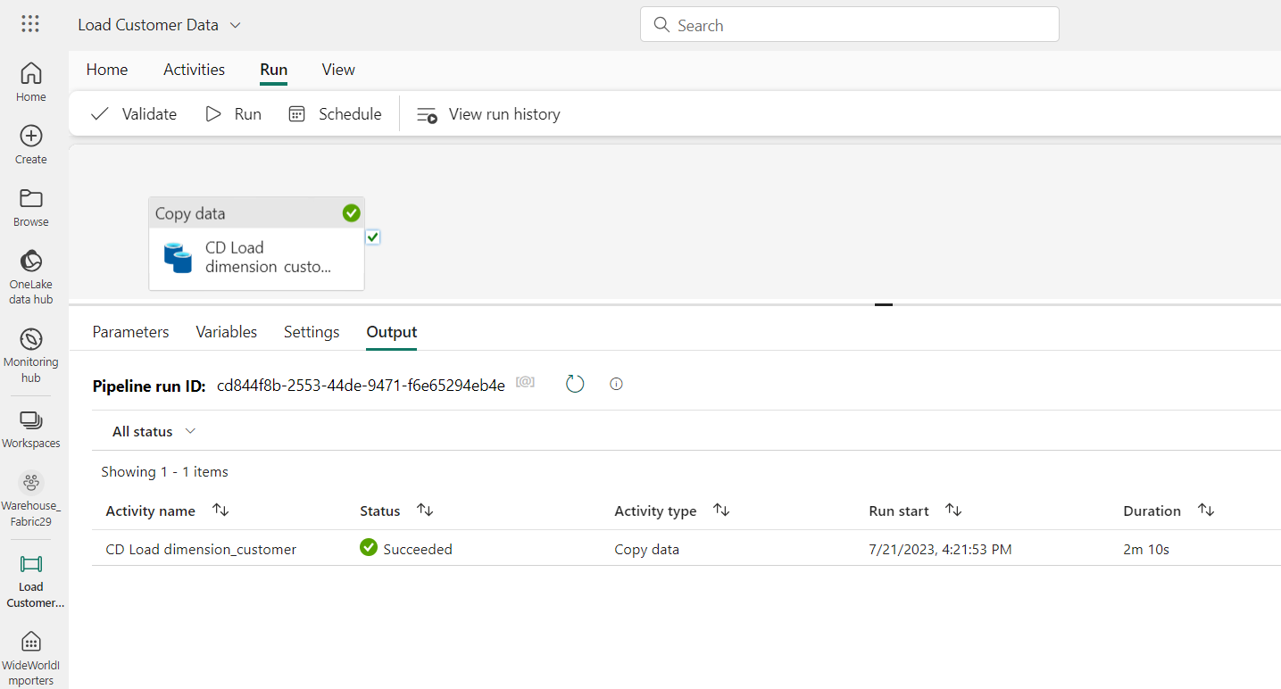To monitor the progress of the copy activity, review the pipeline run activities in the **Output** page (wait for it to complete with a **Succeeded** status).

# **Exercise 3: Create tables in a Data Warehouse**

## Task 1: Create table in a Data Warehouse

1. 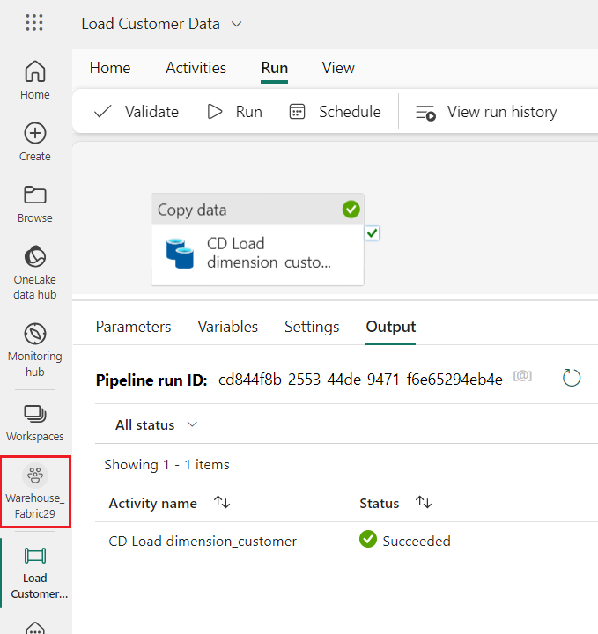On **Load Customer Data** page, click on **Warehouse_FabricXX** **workspace** in the left-sided navigation bar.
2. In the **Synapse Data Engineering** **Warehouse_FabricXX** page, carefully navigate and click on **WideWorldImporters** having **Warehouse** type as shown in the below image.

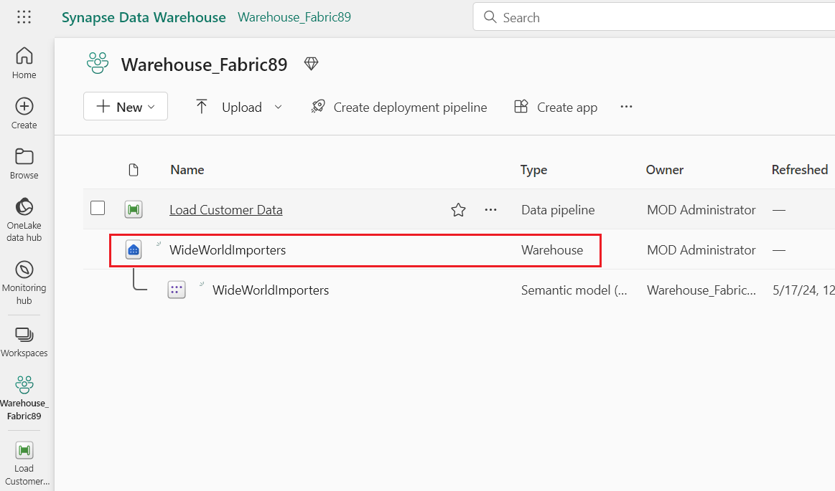

1. 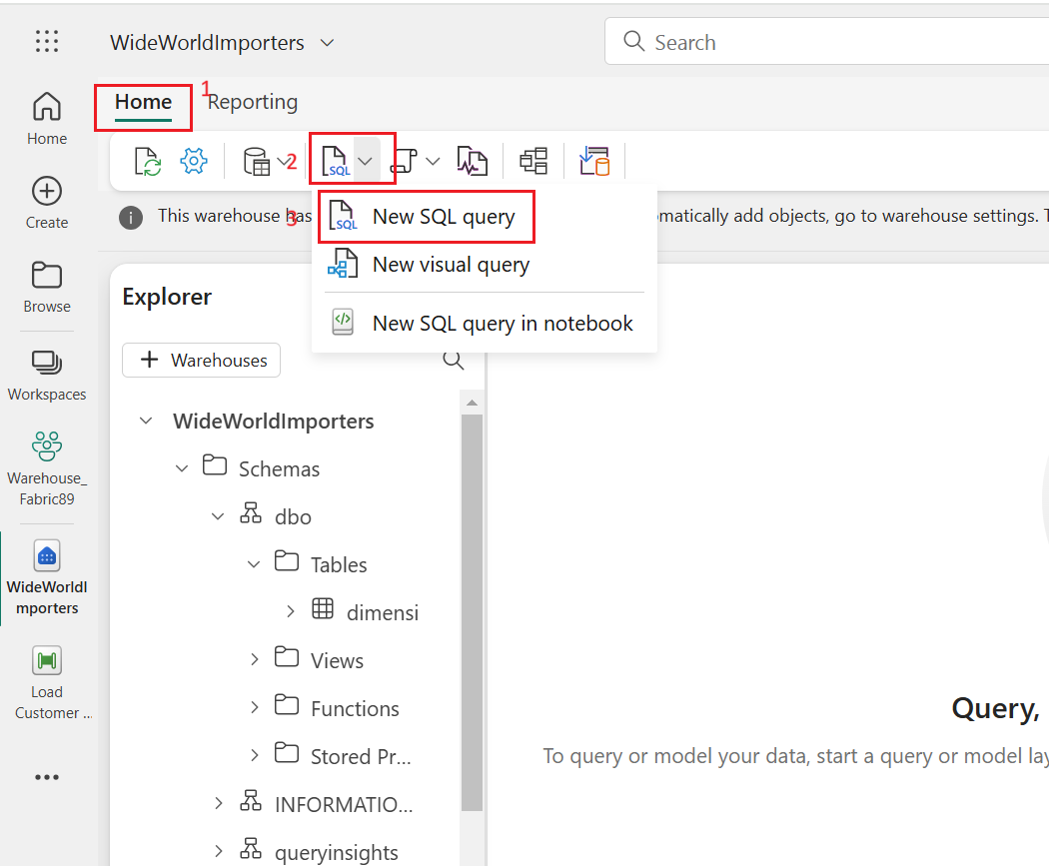On the **WideWorldImporters** page, go to the **Home**tab, select **SQL** from the drop down, and click on **New SQL query**.
2. In the query editor, paste the following code and select **Run** to execute the query

SQLCopy

/*

1. Drop the dimension_city table if it already exists.

2. Create the dimension_city table.

3. Drop the fact_sale table if it already exists.

4. Create the fact_sale table.

*/

--dimension_city

DROP TABLE IF EXISTS [dbo].[dimension_city];

CREATE TABLE [dbo].[dimension_city]

(

[CityKey] [int] NULL,

[WWICityID] [int] NULL,

[City] [varchar](8000) NULL,

[StateProvince] [varchar](8000) NULL,

[Country] [varchar](8000) NULL,

[Continent] [varchar](8000) NULL,

[SalesTerritory] [varchar](8000) NULL,

[Region] [varchar](8000) NULL,

[Subregion] [varchar](8000) NULL,

[Location] [varchar](8000) NULL,

[LatestRecordedPopulation] [bigint] NULL,

[ValidFrom] [datetime2](6) NULL,

[ValidTo] [datetime2](6) NULL,

[LineageKey] [int] NULL

);

--fact_sale

DROP TABLE IF EXISTS [dbo].[fact_sale];

CREATE TABLE [dbo].[fact_sale]

(

[SaleKey] [bigint] NULL,

[CityKey] [int] NULL,

[CustomerKey] [int] NULL,

[BillToCustomerKey] [int] NULL,

[StockItemKey] [int] NULL,

[InvoiceDateKey] [datetime2](6) NULL,

[DeliveryDateKey] [datetime2](6) NULL,

[SalespersonKey] [int] NULL,

[WWIInvoiceID] [int] NULL,

[Description] [varchar](8000) NULL,

[Package] [varchar](8000) NULL,

[Quantity] [int] NULL,

[UnitPrice] [decimal](18, 2) NULL,

[TaxRate] [decimal](18, 3) NULL,

[TotalExcludingTax] [decimal](29, 2) NULL,

[TaxAmount] [decimal](38, 6) NULL,

[Profit] [decimal](18, 2) NULL,

[TotalIncludingTax] [decimal](38, 6) NULL,

[TotalDryItems] [int] NULL,

[TotalChillerItems] [int] NULL,

[LineageKey] [int] NULL,

[Month] [int] NULL,

[Year] [int] NULL,

[Quarter] [int] NULL

);

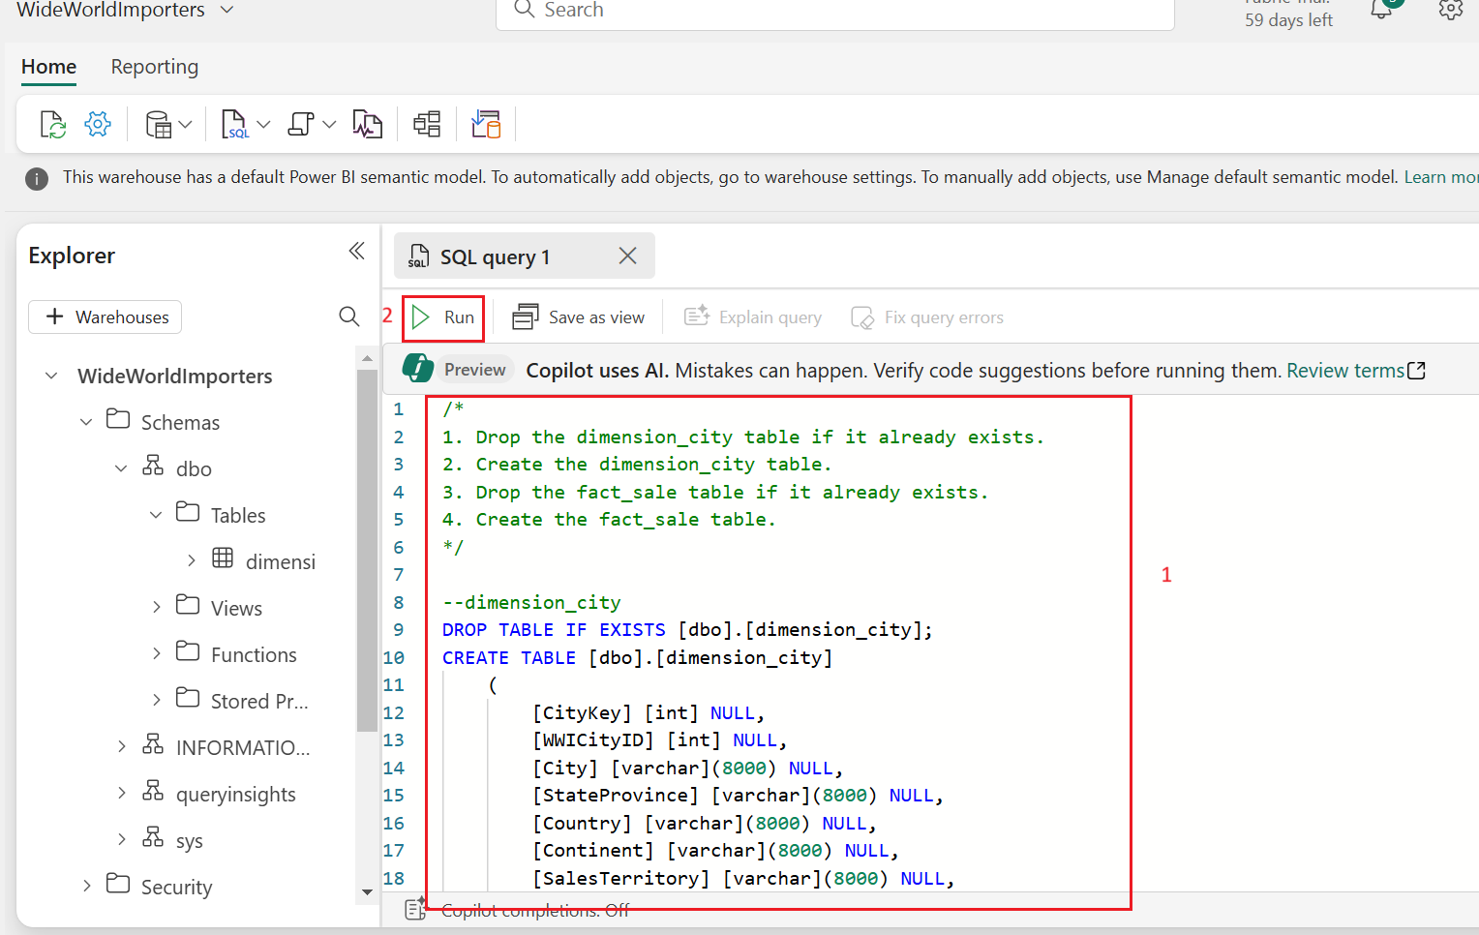

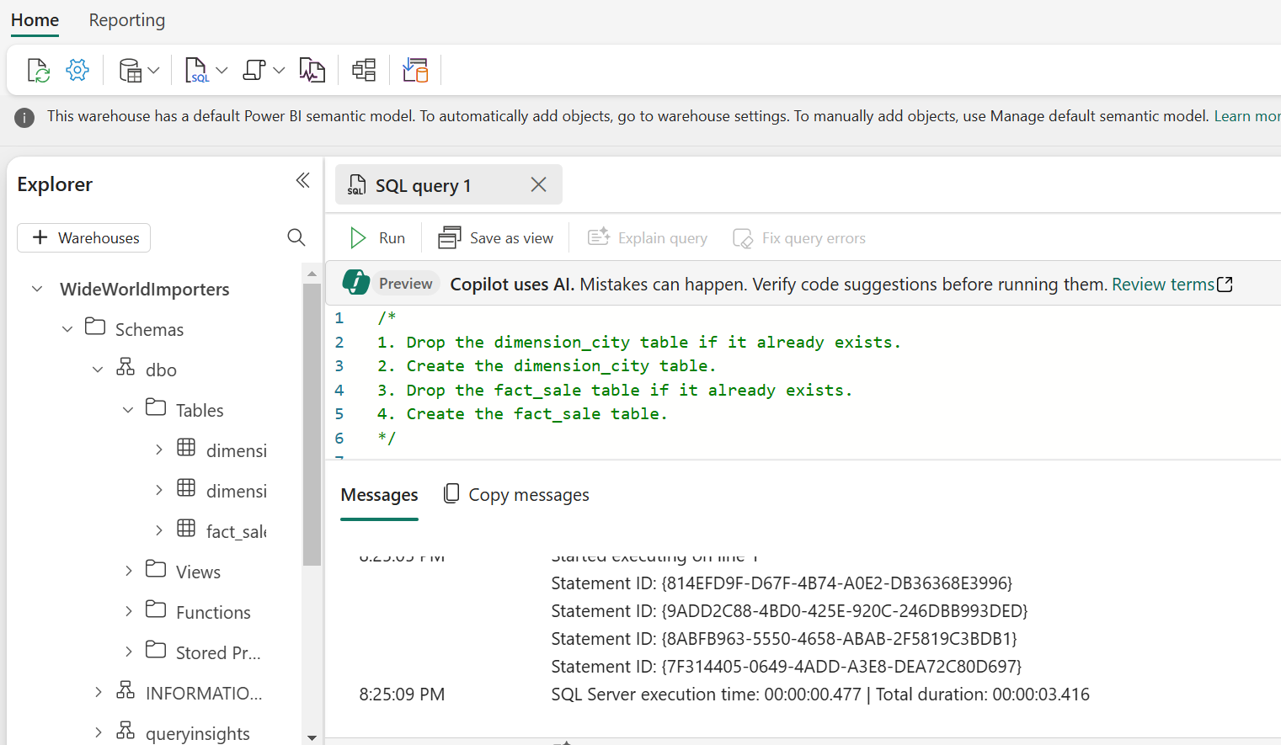

1. 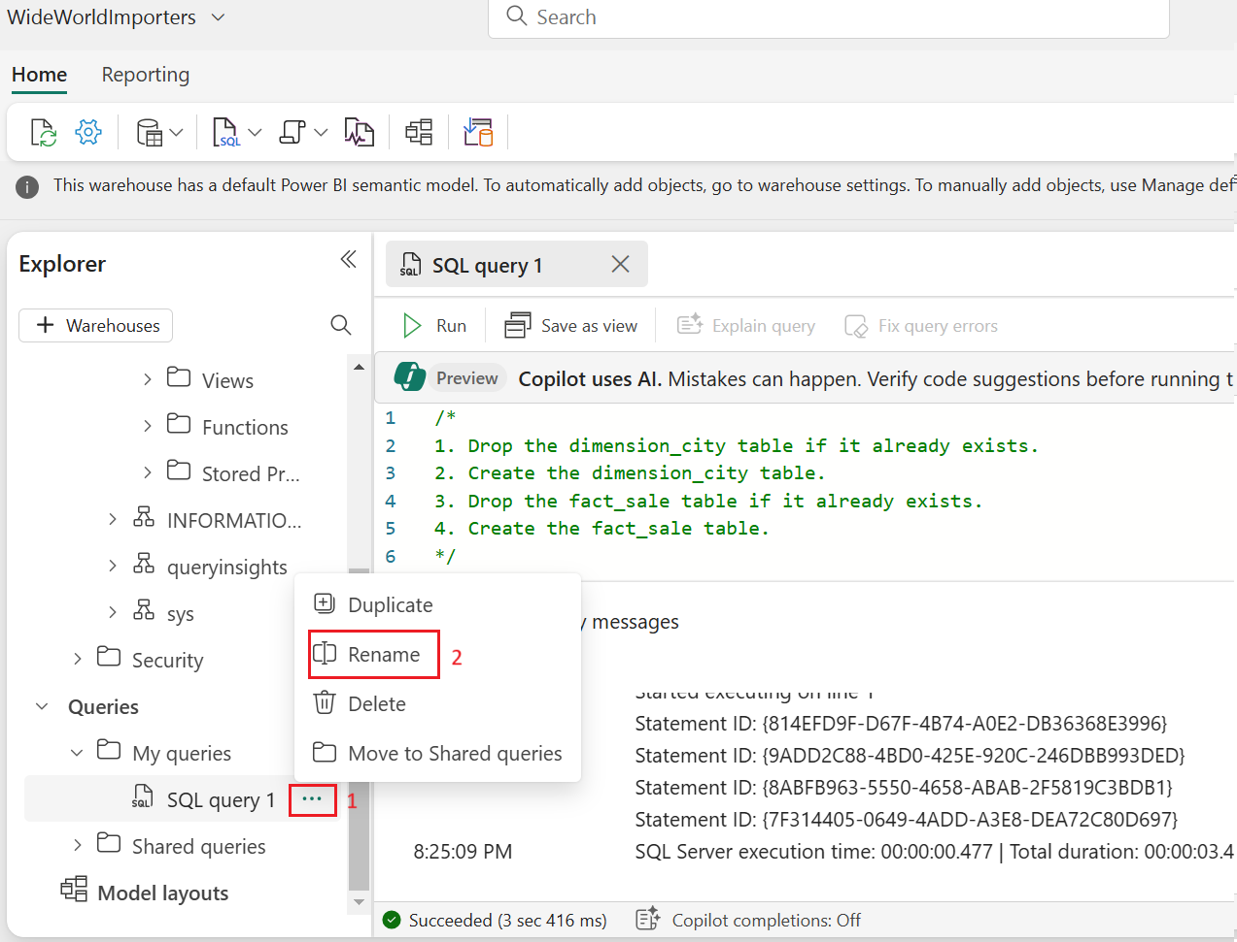To save this query, right-click on the **SQL query 1** tab just above the editor and select **Rename**.
2. 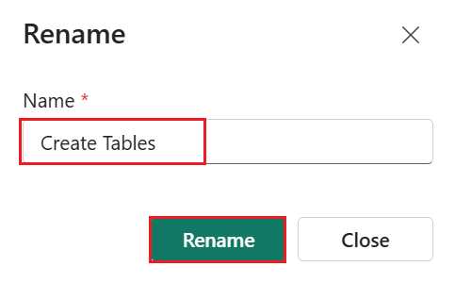In the **Rename** dialog box, under **Name** field, enter +++**Create Tables+++** to change the name of **SQL query 1**. Then, click on the **Rename** button.
3. Validate the table was created successfully by selecting the **refresh icon** button on the ribbon.

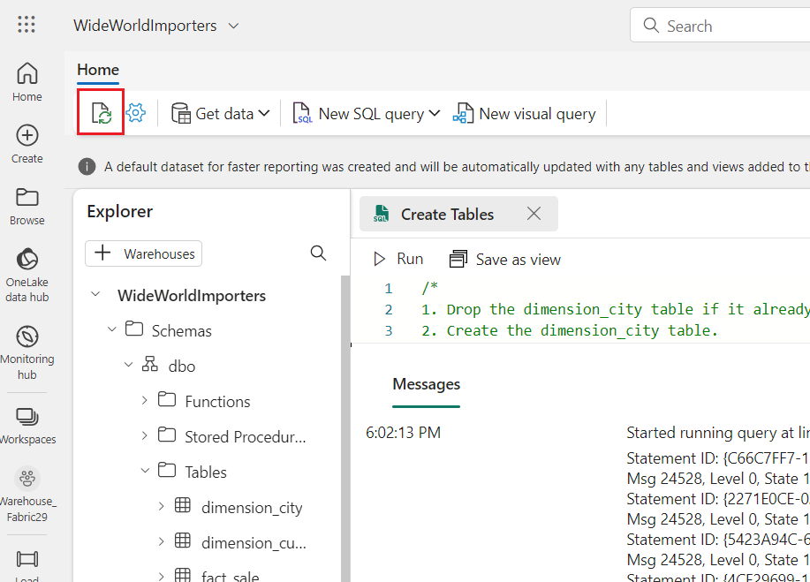

1. In the **Explorer pane**, you’ll see the **fact_sale** table and **dimension_city** table.

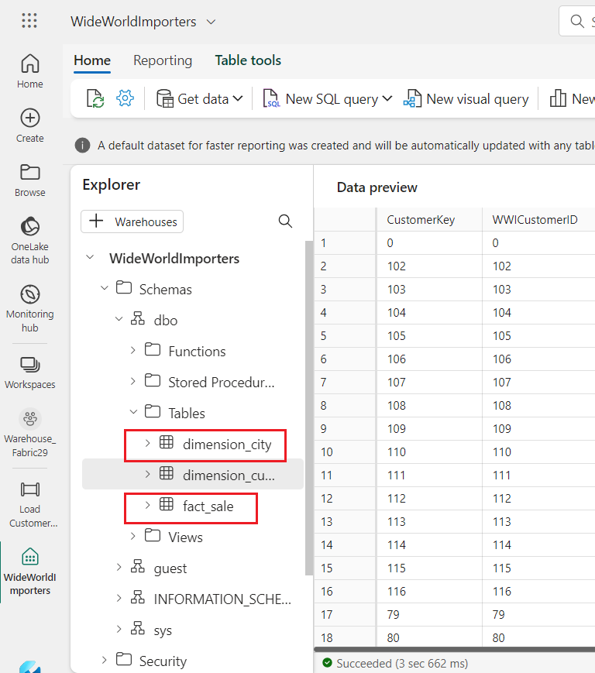

## Task 2: Load data using T-SQL

Now that you know how to build a data warehouse, load a table, and generate a report, it's time to extend the solution by exploring other methods for loading data.

1. On the **WideWorldImporters** page, go to the **Home** tab, select **SQL** from the dropdown, and click on **New SQL query**.

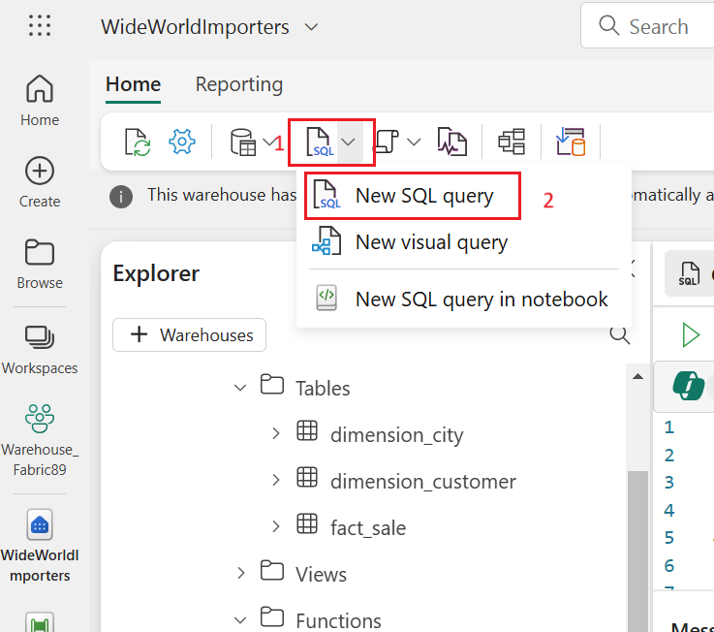

1. In the query editor, **paste** the following code, then click on **Run** to execute the query.

**SQL**

--Copy data from the public Azure storage account to the dimension_city table.

COPY INTO [dbo].[dimension_city]

FROM 'https://fabrictutorialdata.blob.core.windows.net/sampledata/WideWorldImportersDW/tables/dimension_city.parquet'

WITH (FILE_TYPE = 'PARQUET');

--Copy data from the public Azure storage account to the fact_sale table.

COPY INTO [dbo].[fact_sale]

FROM 'https://fabrictutorialdata.blob.core.windows.net/sampledata/WideWorldImportersDW/tables/fact_sale.parquet'

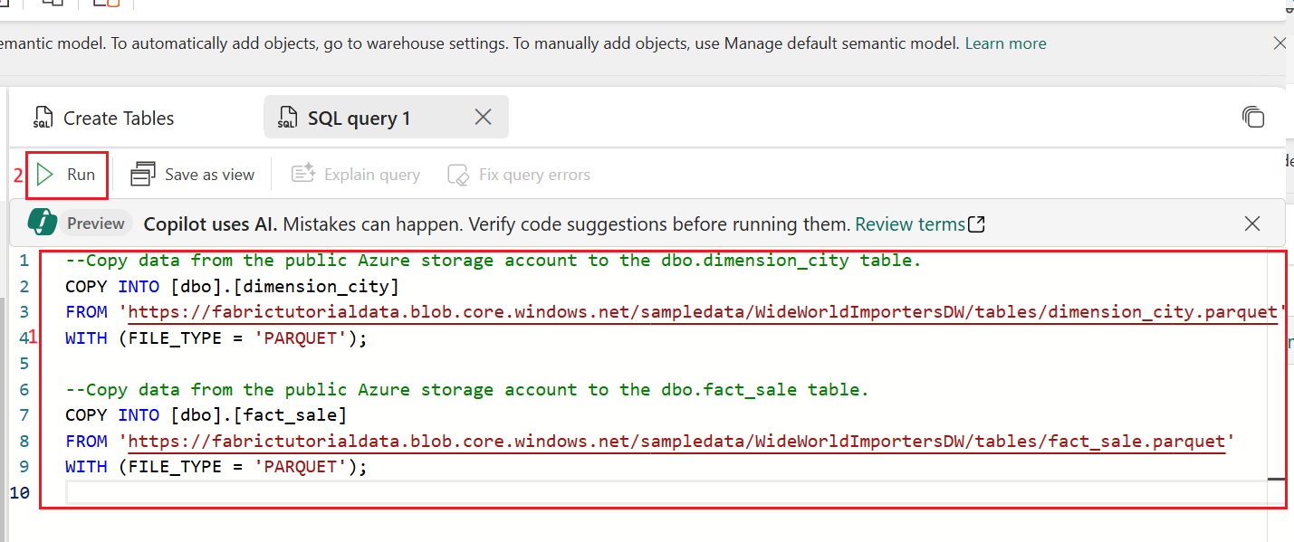 WITH (FILE_TYPE = 'PARQUET');

1. 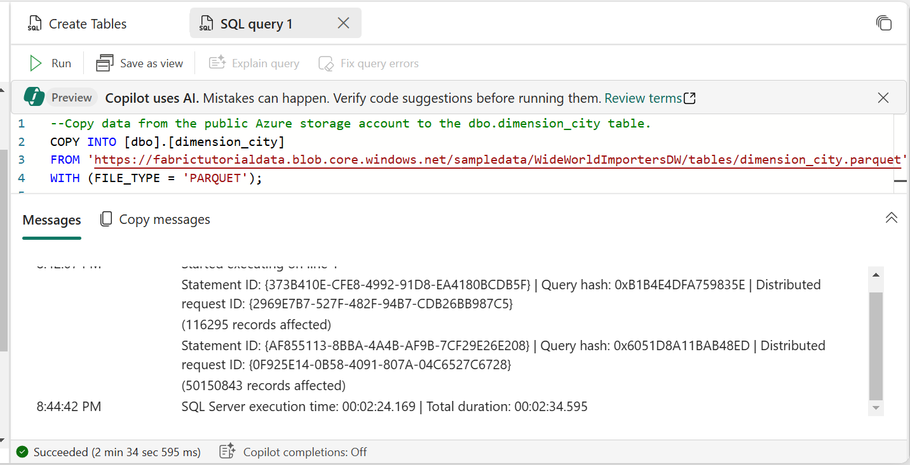After the query is completed, review the messages, which indicates the number of rows that were loaded into the **dimension_city** and **fact_sale** tables respectively.
2. Load the data preview to validate the data loaded successfully by selecting on the **fact_sale** table in the **Explorer**.

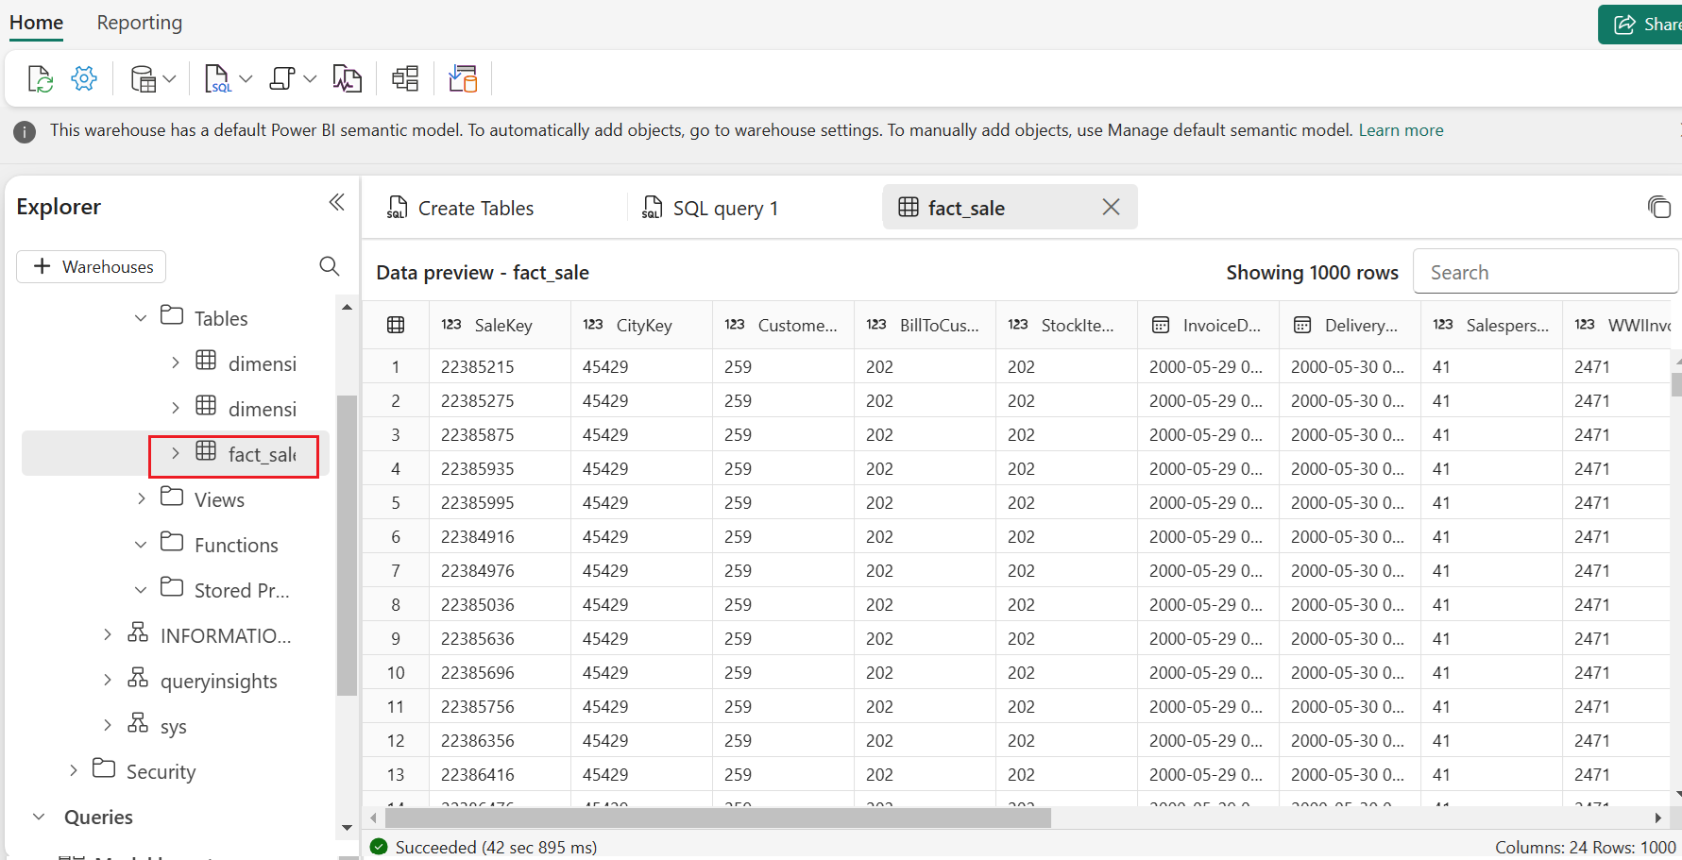

1. 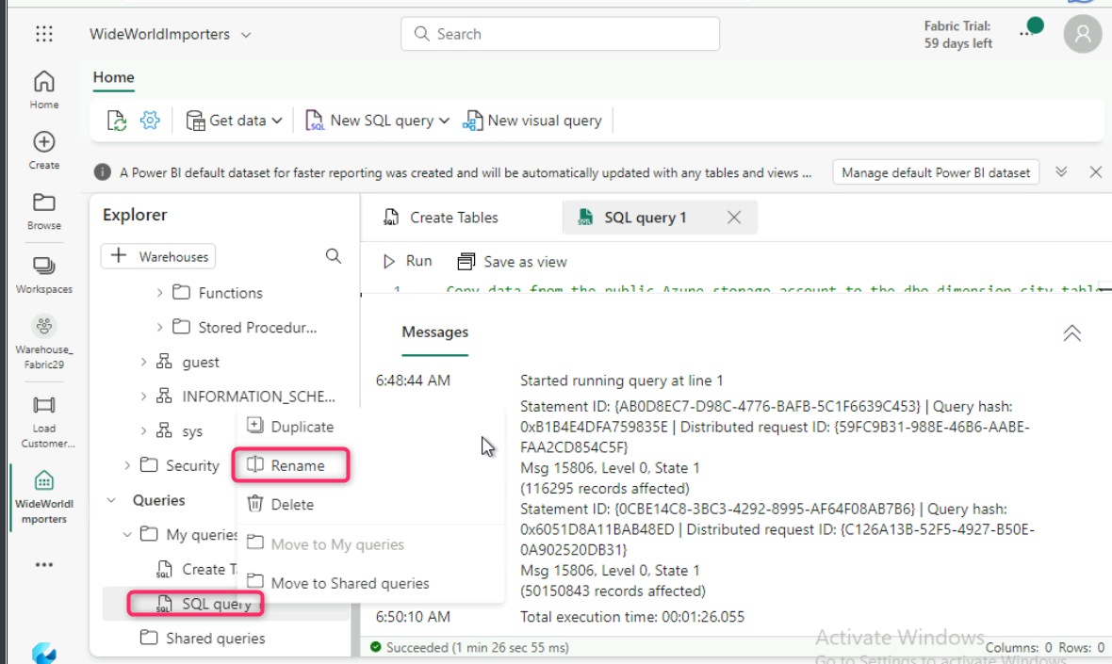Rename the query. Right-click on **SQL query 1** in the **Explorer**, then select **Rename**.
2. 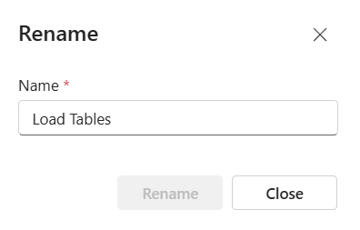In the **Rename** dialog box, under the **Name** field, enter +++**Load Tables+++**. Then, click on **Rename** button.
3. 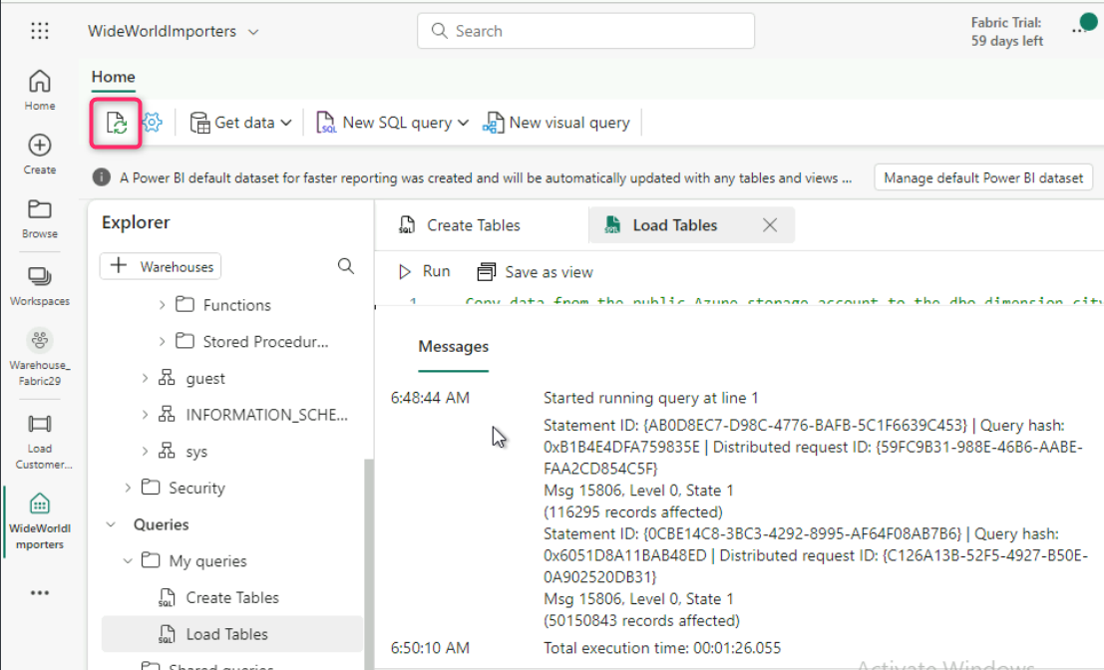Click on the **Refresh** icon in the command bar below the **Home** tab.

# **Exercise 4: Clone a table using T-SQL in Microsoft Fabric**

## Task 1: Create a table clone within the same schema in a warehouse

This task guides you through creating a [table clone](https://learn.microsoft.com/en-in/fabric/data-warehouse/clone-table) in Warehouse in Microsoft Fabric, using the [CREATE TABLE AS CLONE OF](https://learn.microsoft.com/en-us/sql/t-sql/statements/create-table-as-clone-of-transact-sql?view=fabric&preserve-view=true) T-SQL syntax.

1. Create a table clone within the same schema in a warehouse.
2. On the **WideWorldImporters** page, go to the **Home** tab, select **SQL** from the dropdown, and click on **New SQL query**.
3. In the query editor, paste the following code to create clones of the **dbo.dimension_city** and **dbo.fact_sale** tables.

**SQL**

--Create a clone of the dbo.dimension_city table.

CREATE TABLE [dbo].[dimension_city1] AS CLONE OF [dbo].[dimension_city];

--Create a clone of the dbo.fact_sale table.

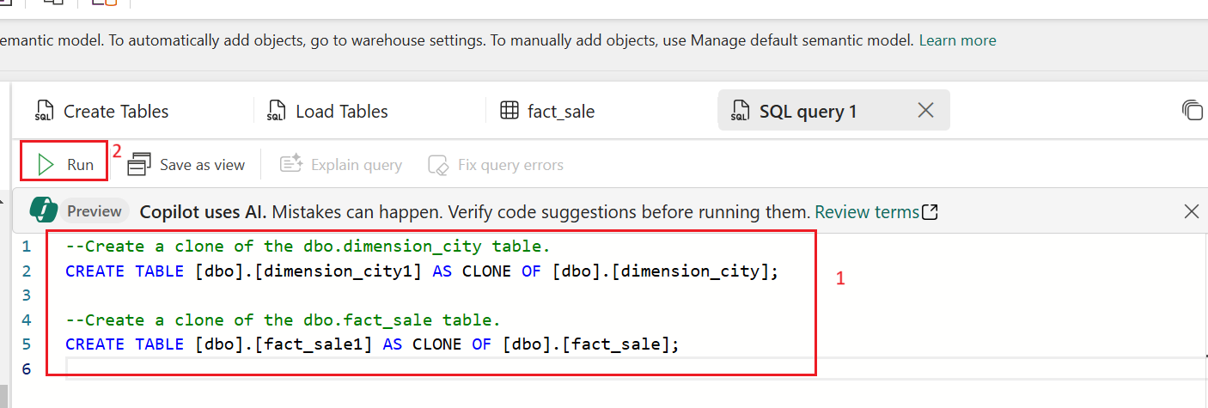CREATE TABLE [dbo].[fact_sale1] AS CLONE OF [dbo].[fact_sale];

1. Select **Run** to execute the query. The query takes a few seconds to execute. After the query is completed, the table clones **dimension_city1** and **fact_sale1** will be created.

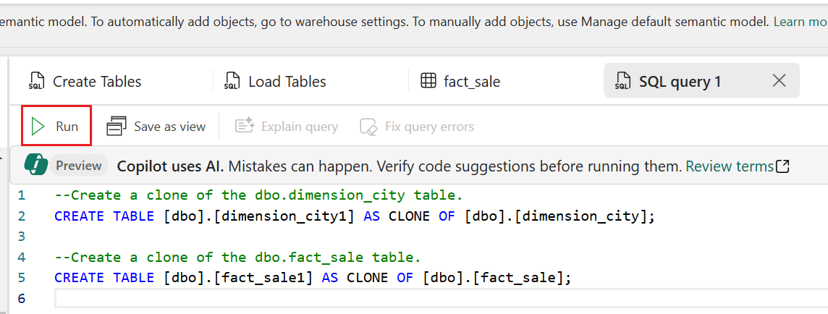

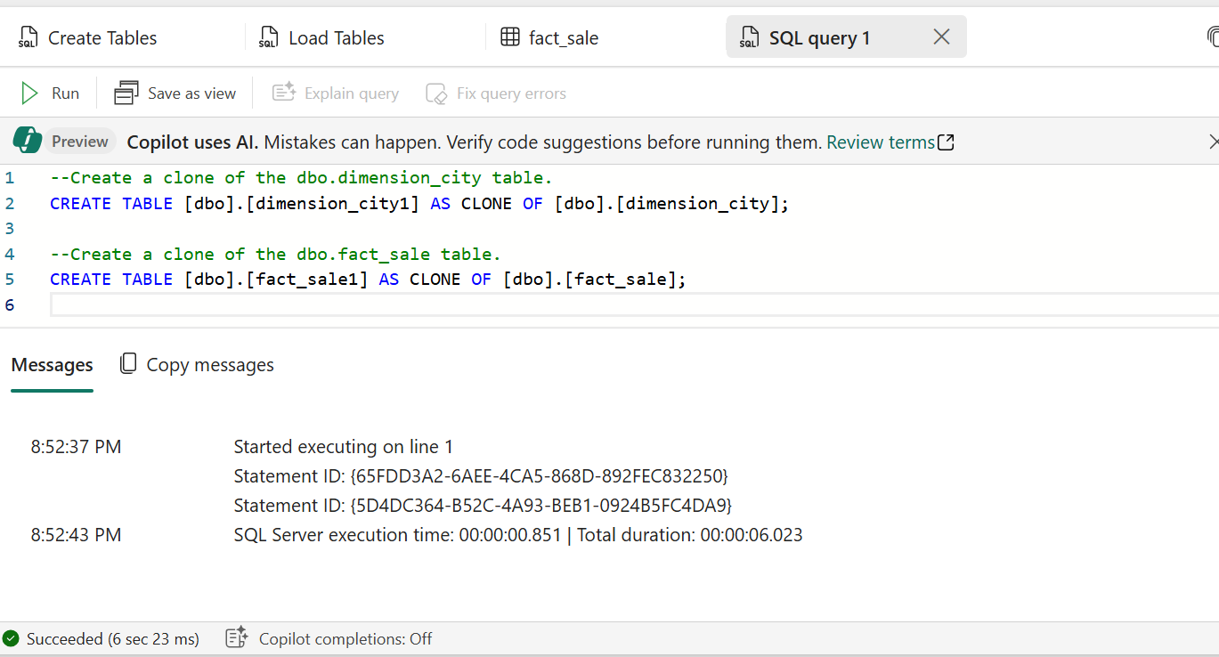

1. Load the data preview to validate the data loaded successfully by selecting on the **dimension_city1** table in the **Explorer**.

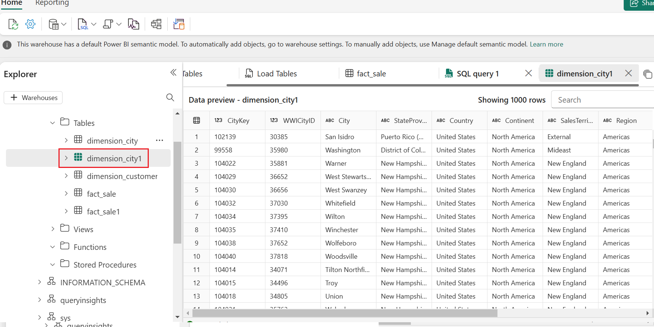

1. Right-click on **SQL query that you’ve created to clone the tables** in the **Explorer** and select **Rename**.

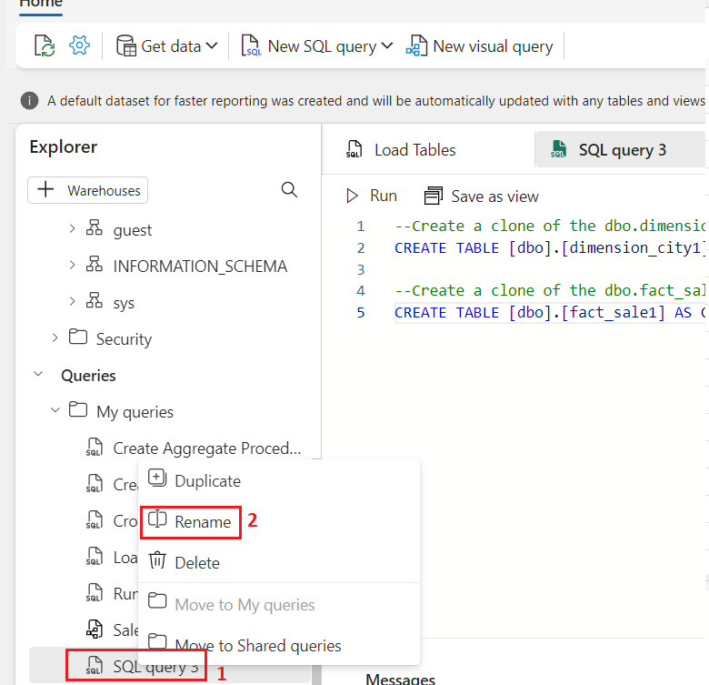

1. 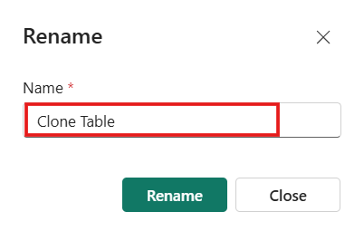In the **Rename** dialog box, under the **Name** field, enter +++**Clone Table+++**, then click on the **Rename** button.
2. 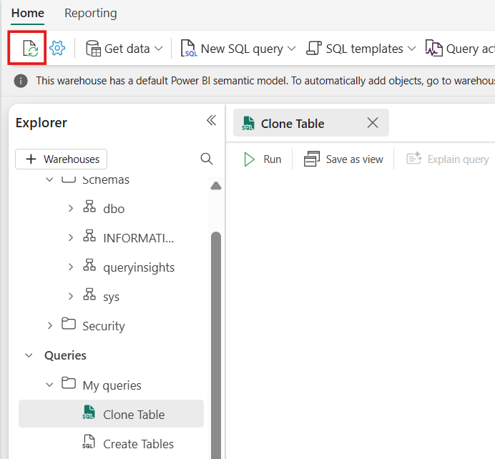Click on the **Refresh** icon in the command bar below the **Home** tab.

## Task 2: Create a table clone across schemas within the same warehouse

1. 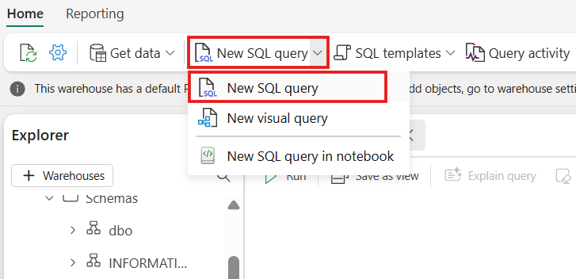On the **WideWorldImporters** page, go to the **Home** tab, select **SQL** from the dropdown, and click on **New SQL query**.
2. Create a new schema within the **WideWorldImporter** warehouse named **dbo1**. **Copy paste** and **run** the following T-SQL code as shown in the below image:

**SQL**

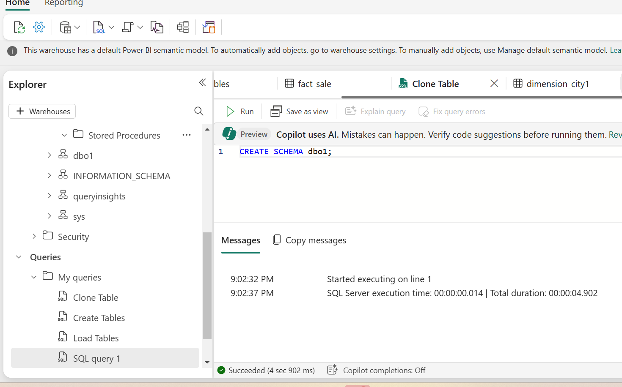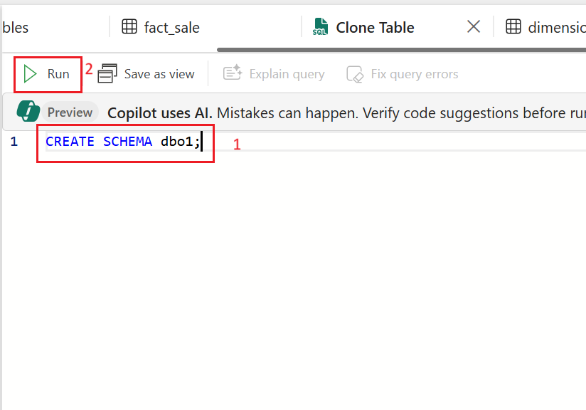CREATE SCHEMA dbo1;

1. In the query editor, remove the existing code and paste the following to create clones of the **dbo.dimension_city** and dbo.**fact_sale tables** in the **dbo1** schema.

**SQL**

--Create a clone of the dbo.dimension_city table in the dbo1 schema.

CREATE TABLE [dbo1].[dimension_city1] AS CLONE OF [dbo].[dimension_city];

--Create a clone of the dbo.fact_sale table in the dbo1 schema.

CREATE TABLE [dbo1].[fact_sale1] AS CLONE OF [dbo].[fact_sale];

1. Select **Run** to execute the query. The query takes a few seconds to execute.

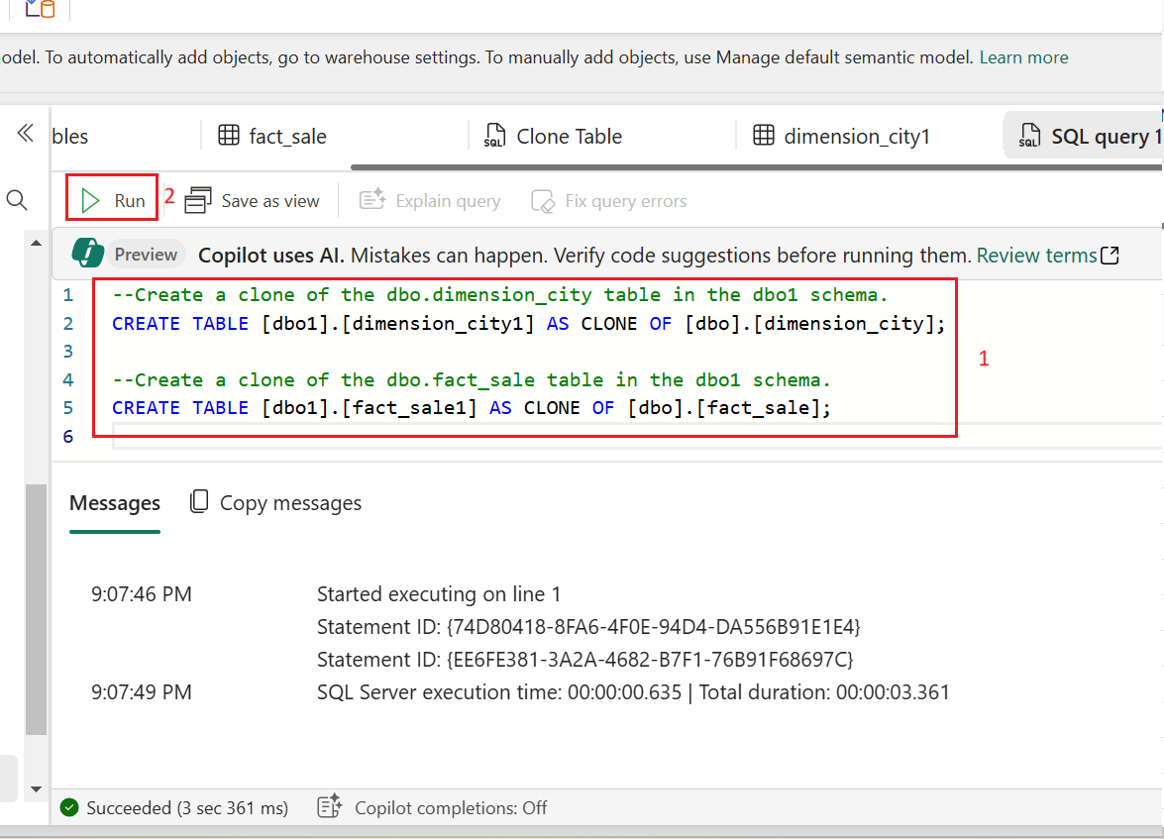

1. After the query is completed, clones **dimension_city1** and **fact_sale1** are created in the **dbo1** schema.

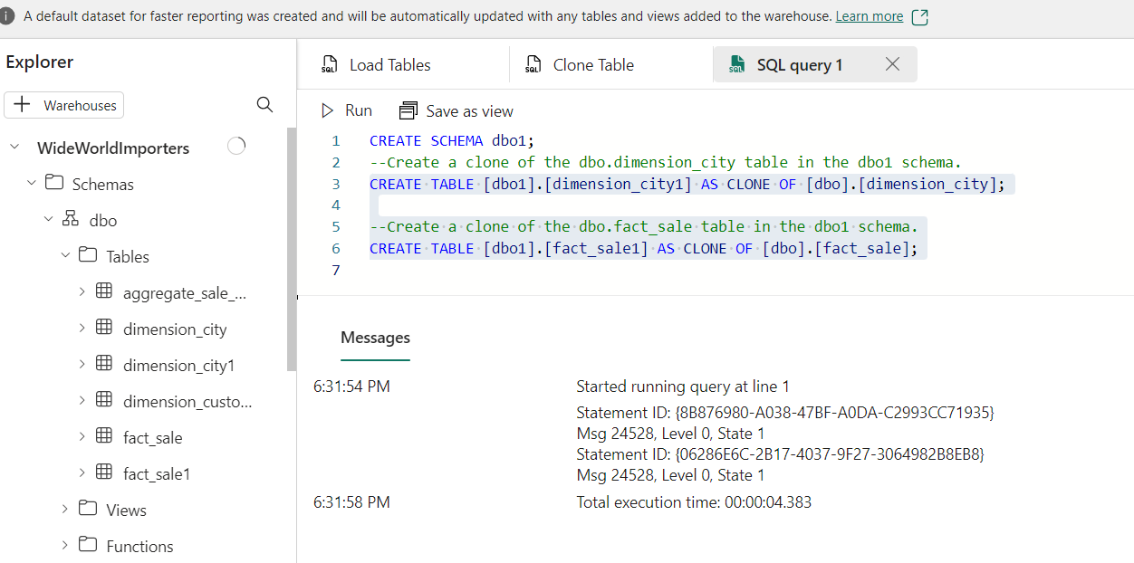

1. Load the data preview to validate the data loaded successfully by selecting on the **dimension_city1** table under **dbo1** schema in the **Explorer**.

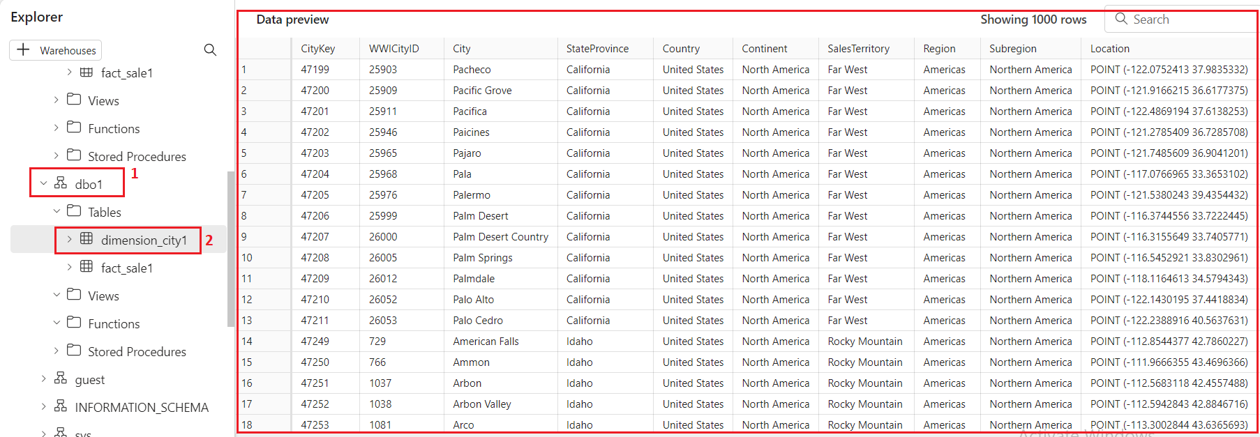

1. **To rename this query,** right-click on **SQL query 1** in the **Explorer** and select **Rename**.

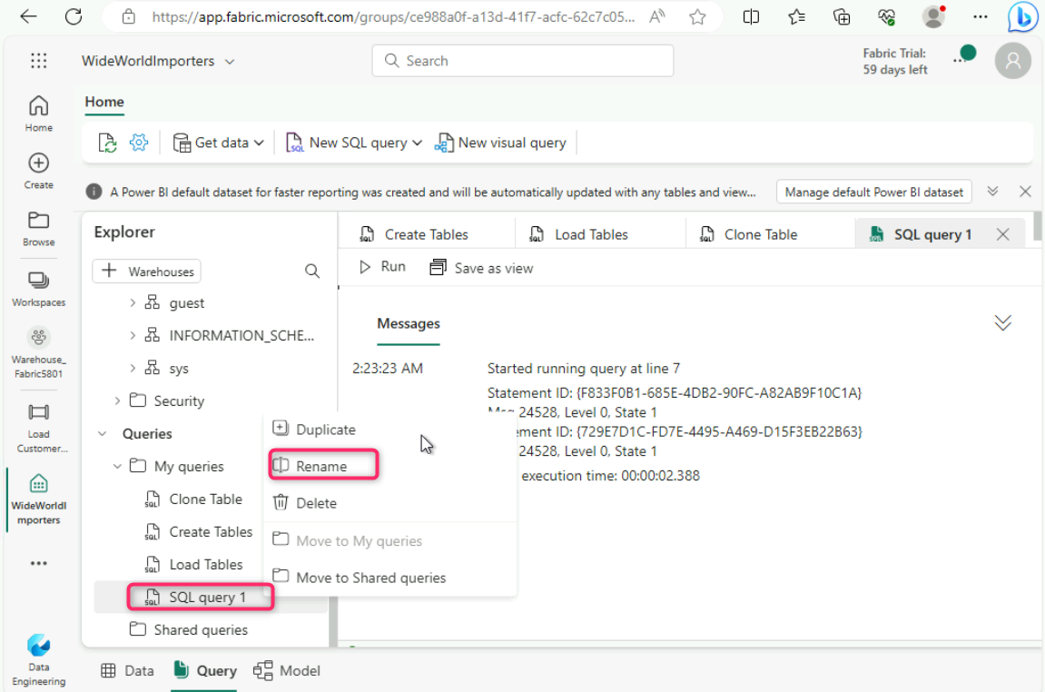

1. 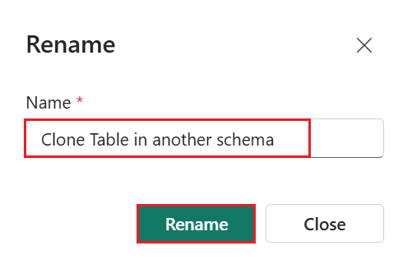In the **Rename** dialog box, under the **Name** field, enter +++**Clone Table in another schema+++**. Then, click on **Rename** button.
2. Click on the **Refresh** icon in the command bar below the **Home** tab.

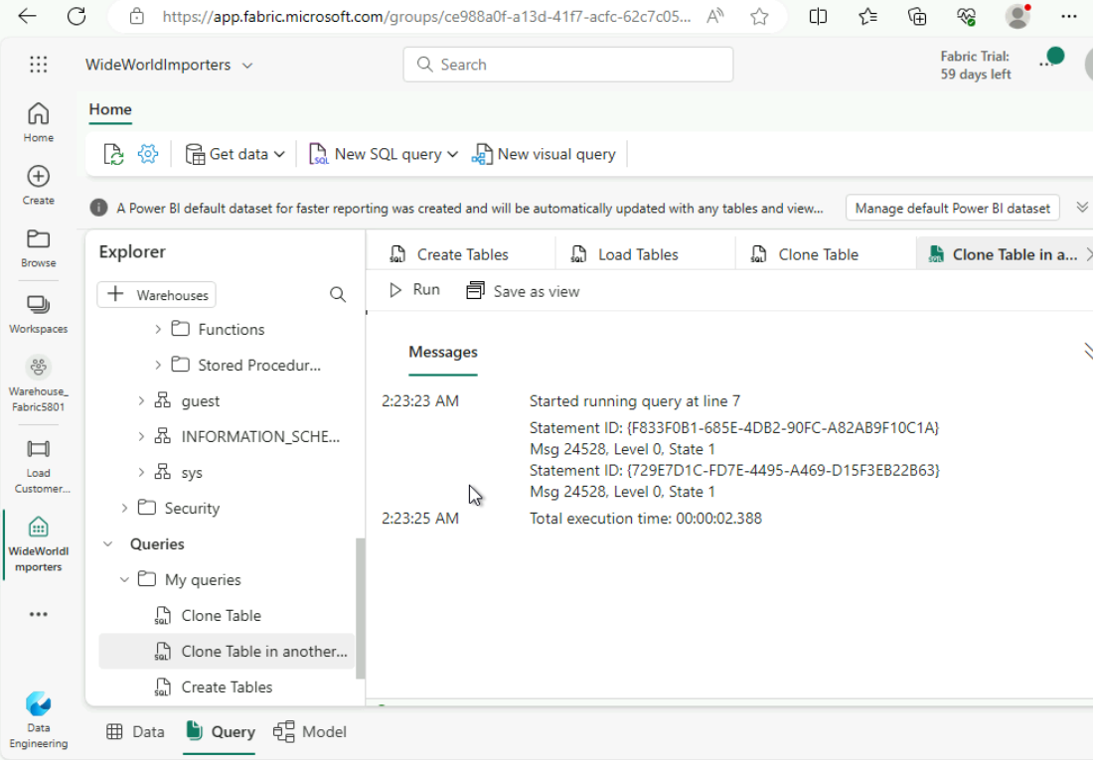

# **Exercise 5: Transform data using a stored procedure**

Learn how to create and save a new stored procedure to transform data.

1. 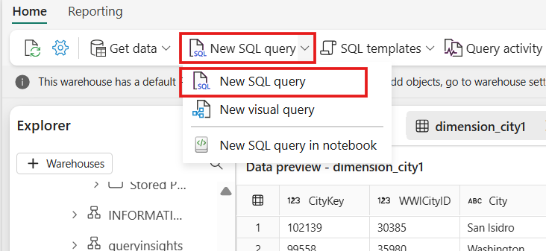On the **WideWorldImporters** page, go to the **Home** tab, select **SQL** from the dropdown, and click on **New SQL query**.
2. In the query editor, **paste** the following code to create the stored procedure **dbo.populate_aggregate_sale_by_city**. This stored procedure will create and load the **dbo.aggregate_sale_by_date_city** table in a later step.

**SQL**

--Drop the stored procedure if it already exists.

DROP PROCEDURE IF EXISTS [dbo].[populate_aggregate_sale_by_city]

GO

--Create the populate_aggregate_sale_by_city stored procedure.

CREATE PROCEDURE [dbo].[populate_aggregate_sale_by_city]

AS

BEGIN

--If the aggregate table already exists, drop it. Then create the table.

DROP TABLE IF EXISTS [dbo].[aggregate_sale_by_date_city];

CREATE TABLE [dbo].[aggregate_sale_by_date_city]

(

[Date] [DATETIME2](6),

[City] [VARCHAR](8000),

[StateProvince] [VARCHAR](8000),

[SalesTerritory] [VARCHAR](8000),

[SumOfTotalExcludingTax] [DECIMAL](38,2),

[SumOfTaxAmount] [DECIMAL](38,6),

[SumOfTotalIncludingTax] [DECIMAL](38,6),

[SumOfProfit] [DECIMAL](38,2)

);

--Reload the aggregated dataset to the table.

INSERT INTO [dbo].[aggregate_sale_by_date_city]

SELECT

FS.[InvoiceDateKey] AS [Date],

DC.[City],

DC.[StateProvince],

DC.[SalesTerritory],

SUM(FS.[TotalExcludingTax]) AS [SumOfTotalExcludingTax],

SUM(FS.[TaxAmount]) AS [SumOfTaxAmount],

SUM(FS.[TotalIncludingTax]) AS [SumOfTotalIncludingTax],

SUM(FS.[Profit]) AS [SumOfProfit]

FROM [dbo].[fact_sale] AS FS

INNER JOIN [dbo].[dimension_city] AS DC

ON FS.[CityKey] = DC.[CityKey]

GROUP BY

FS.[InvoiceDateKey],

DC.[City],

DC.[StateProvince],

DC.[SalesTerritory]

ORDER BY

FS.[InvoiceDateKey],

DC.[StateProvince],

DC.[City];

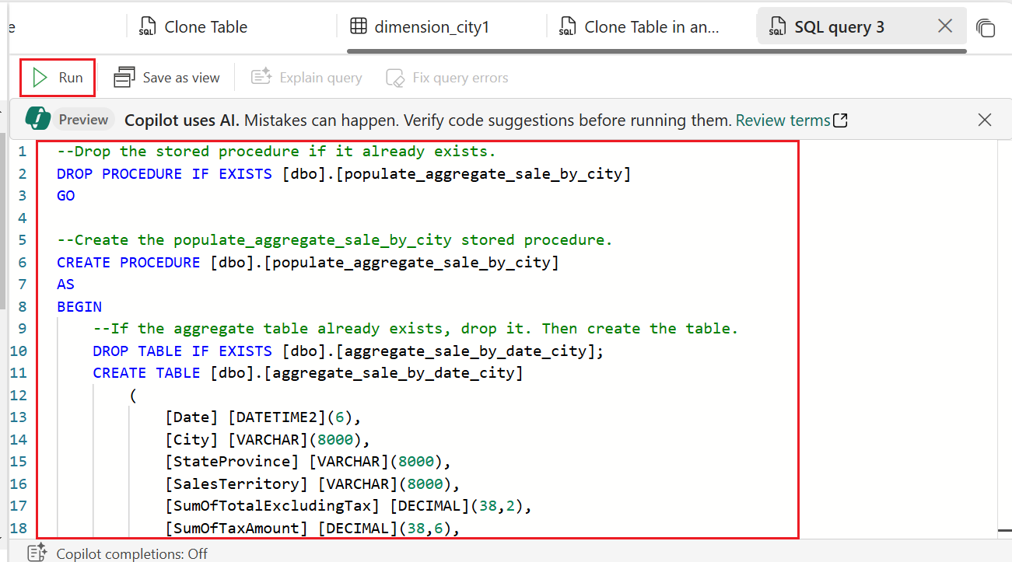END;

1. 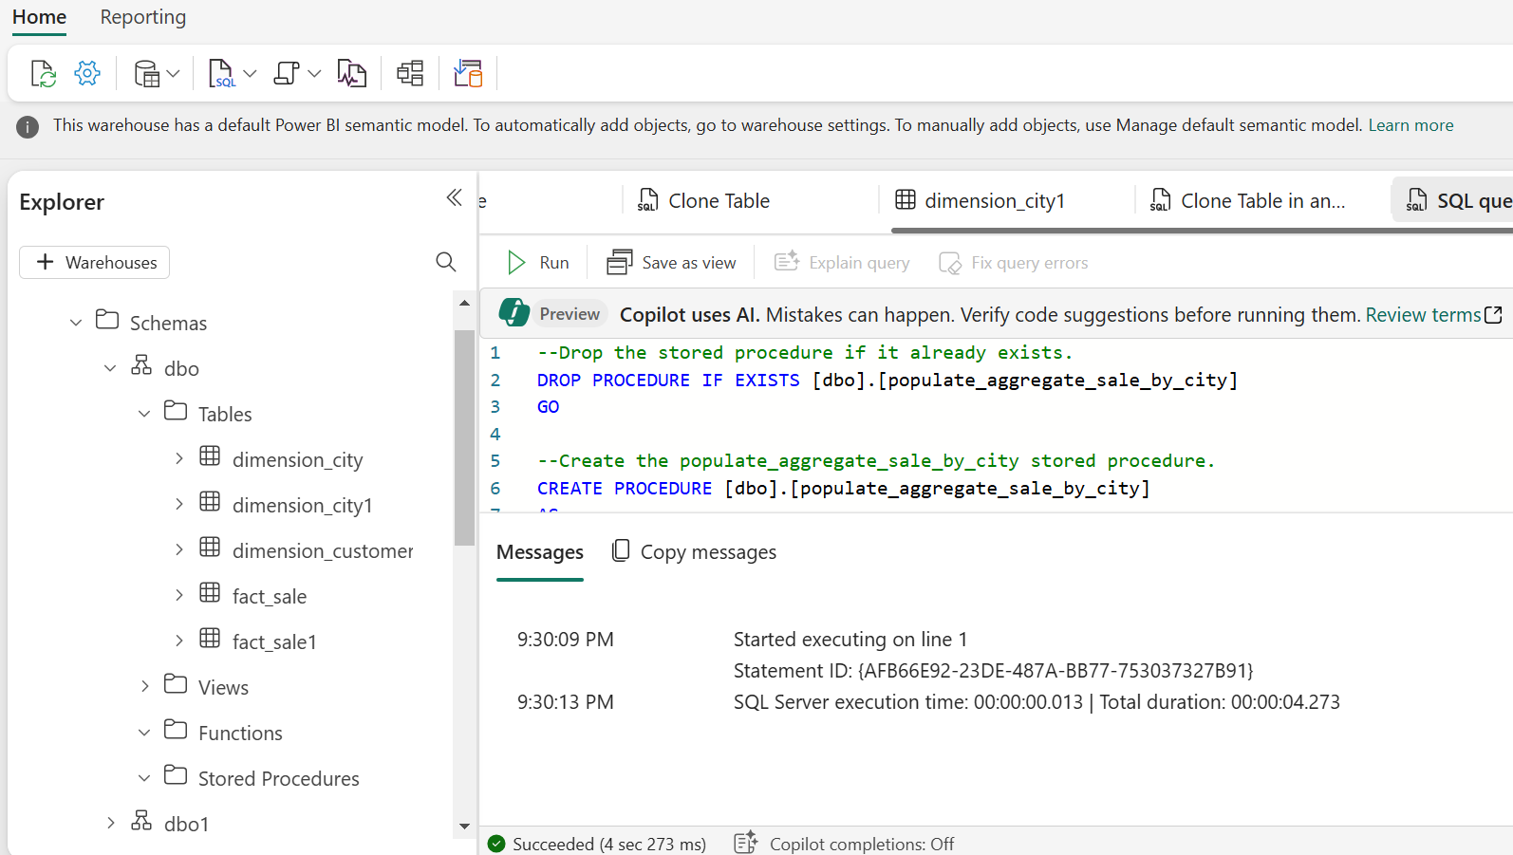To execute the query, on the query designer ribbon, select **Run**.
2. 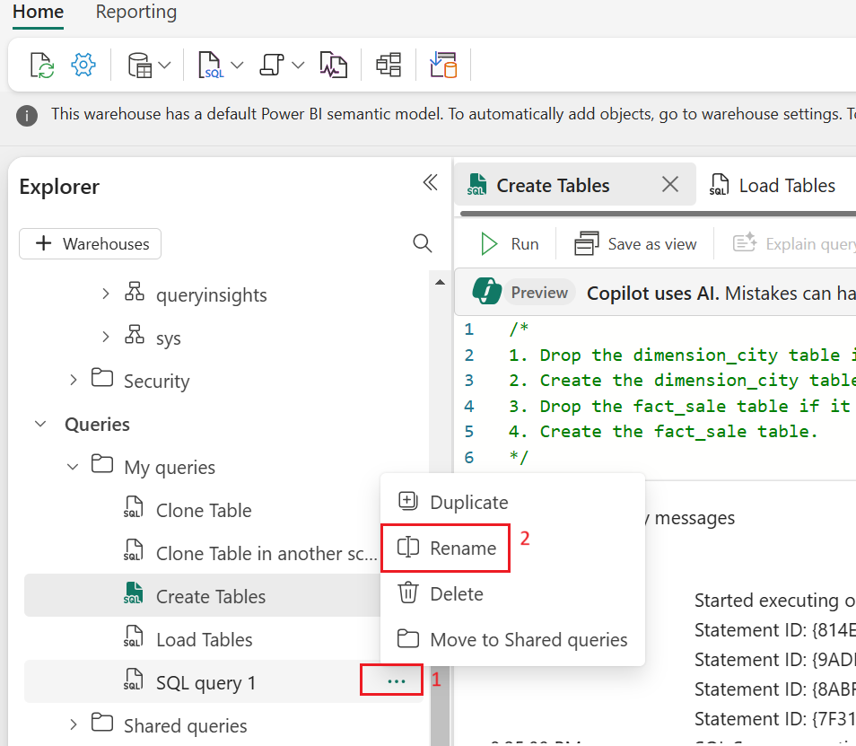Right-click on SQL query that you’ve created to clone the tables in the Explorer and select **Rename**.
3. 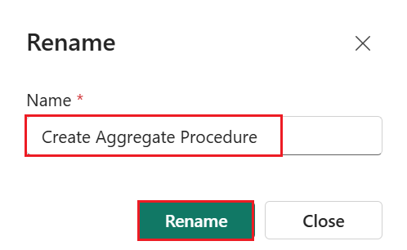In the **Rename** dialog box, under the **Name** field, enter +++**Create Aggregate Procedure+++**, then click on the **Rename** button.
4. 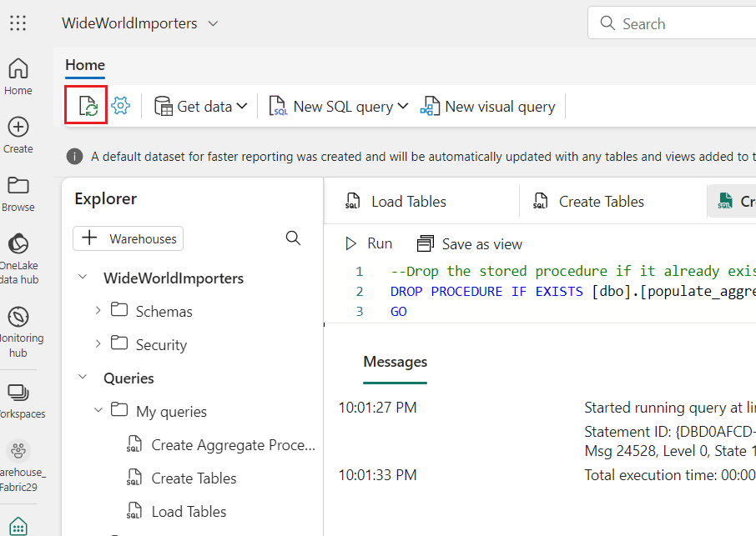Click on the **Refresh icon** below the **Home** tab.
5. 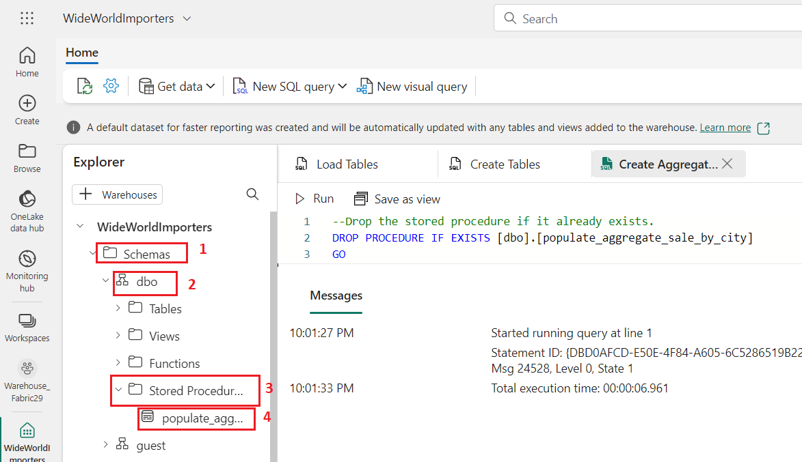In the **Explorer tab**, verify that you can see the newly created stored procedure by expanding the **StoredProcedures** node under the **dbo** schema.
6. On the **WideWorldImporters** page, go to the **Home** tab, select **SQL** from the dropdown, and click on **New SQL query**.
7. In the query editor, paste the following code. This T-SQL executes **dbo.populate_aggregate_sale_by_city** to create the **dbo.aggregate_sale_by_date_city** table.Run the query

**SQL**

--Execute the stored procedure to create the aggregate table.

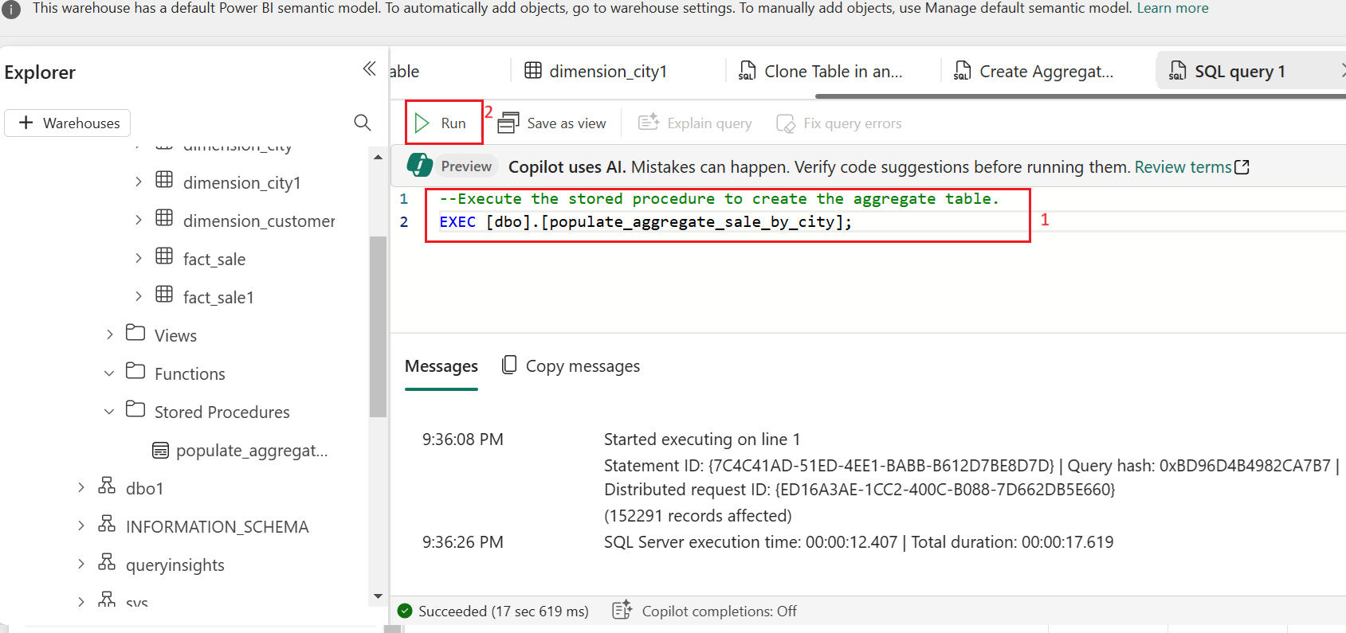EXEC [dbo].[populate_aggregate_sale_by_city];

1. To save this query for reference later, right-click on the query tab just above the editor and select **Rename.**

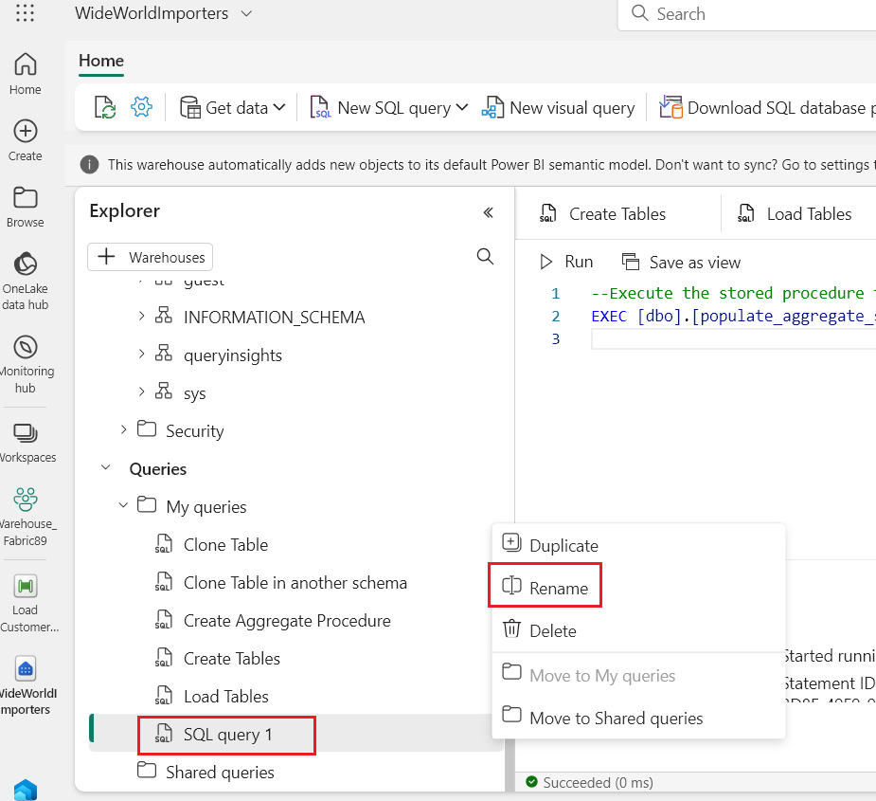

1. In the **Rename** dialog box, under the **Name** field, enter +++**Run** **Create Aggregate Procedure+++**, then click on the **Rename** button.

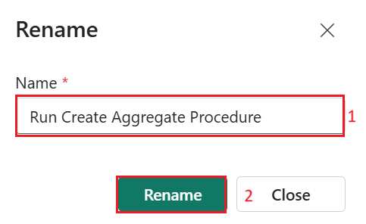

1. Select the **Refresh** icon on the ribbon.

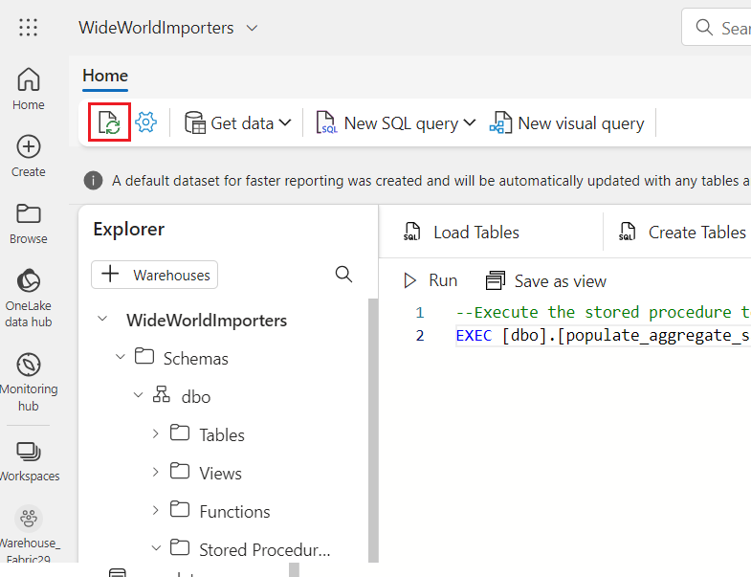

1. In the **Object Explorer tab**, load the data preview to validate the data loaded successfully by selecting on the **aggregate_sale_by_city** table in the **Explorer**.

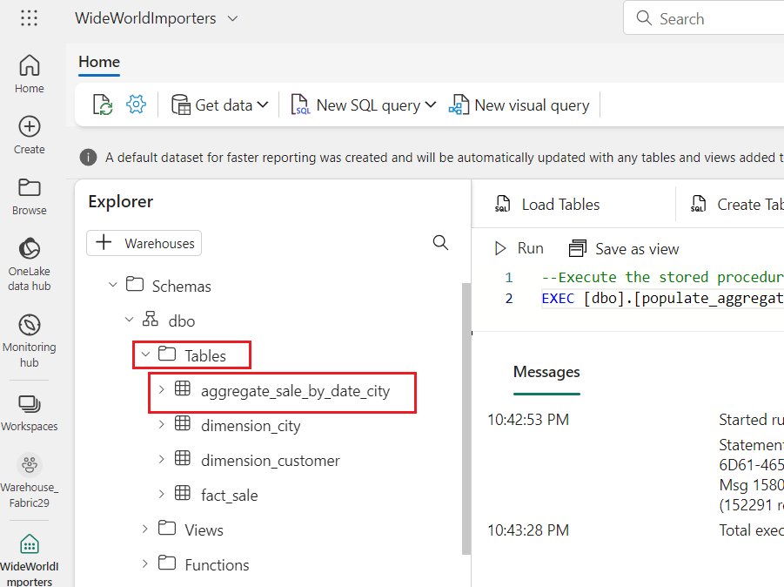

# **Exercise 6: Time travel using T-SQL at statement level**

1. 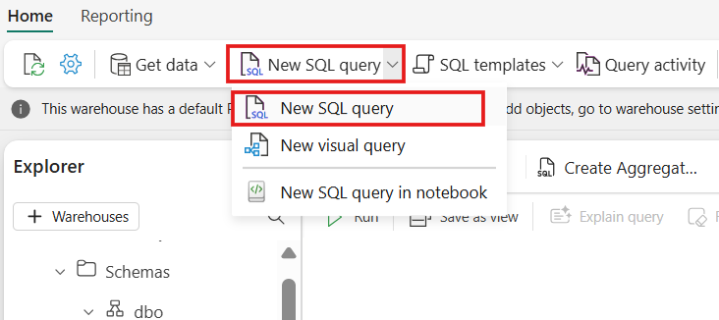On the **WideWorldImporters** page, go to the **Home** tab, select **SQL** from the dropdown, and click on **New SQL query**.
2. In the query editor, paste the following code to create the view Top10CustomerView. Select **Run** to execute the query.

CREATE VIEW dbo.Top10CustomersView

AS

SELECT TOP (10)

    FS.[CustomerKey],

    DC.[Customer],

    SUM(FS.TotalIncludingTax) AS TotalSalesAmount

FROM

    [dbo].[dimension_customer] AS DC

INNER JOIN

    [dbo].[fact_sale] AS FS ON DC.[CustomerKey] = FS.[CustomerKey]

GROUP BY

    FS.[CustomerKey],

    DC.[Customer]

ORDER BY

    TotalSalesAmount DESC;

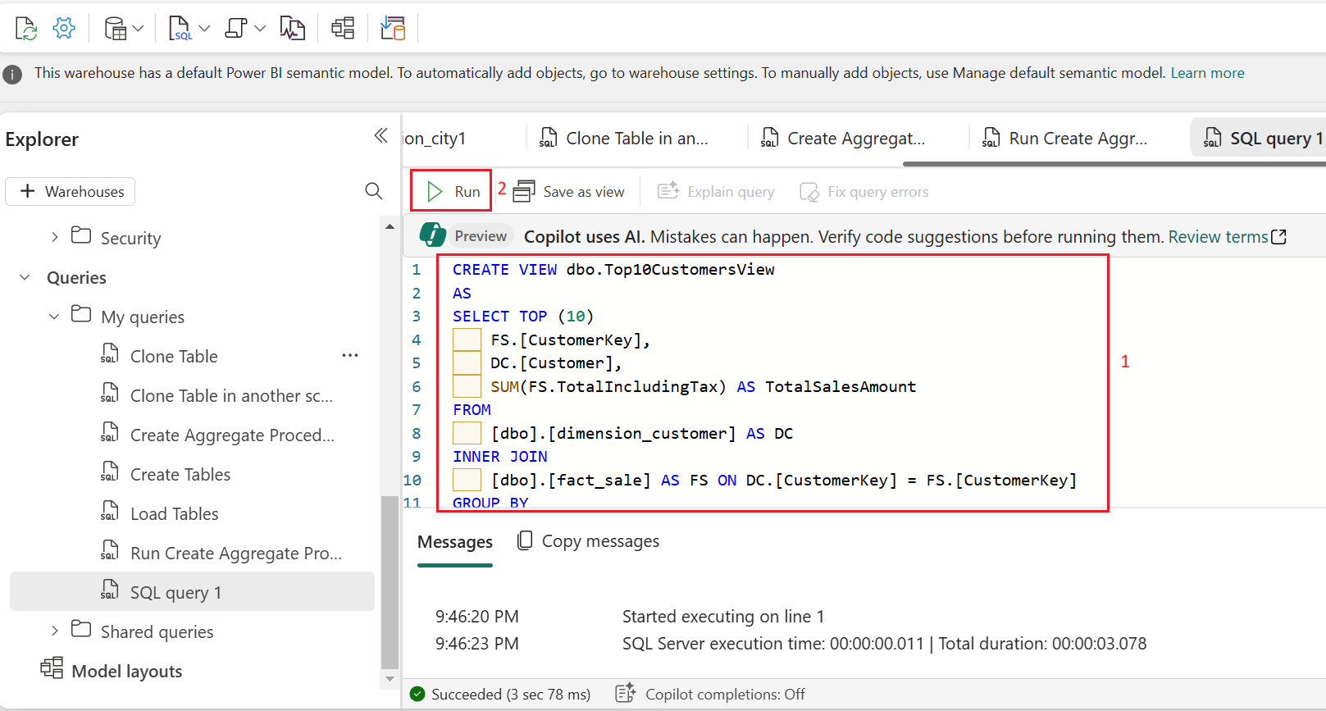

1. 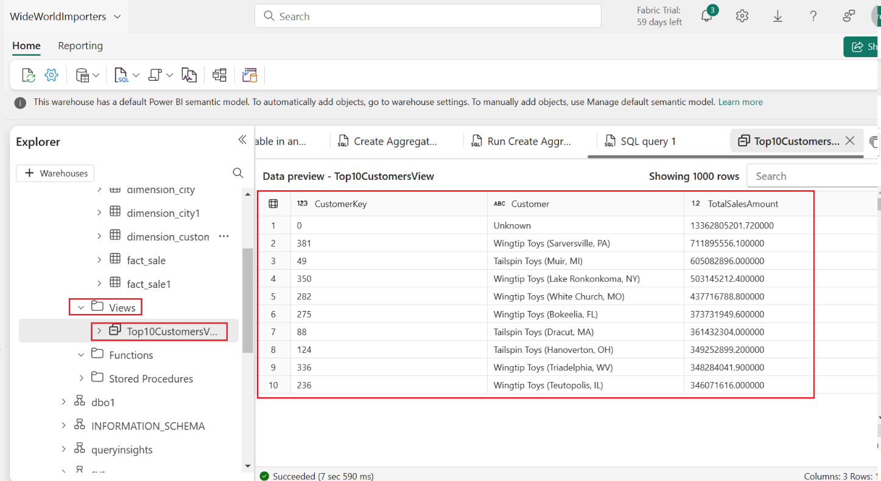In the **Explorer**, verify that you can see the newly created view **Top10CustomersView** by expanding the **View** node under dbo schema.
2. To save this query for reference later, right-click on the query tab just above the editor and select **Rename.**

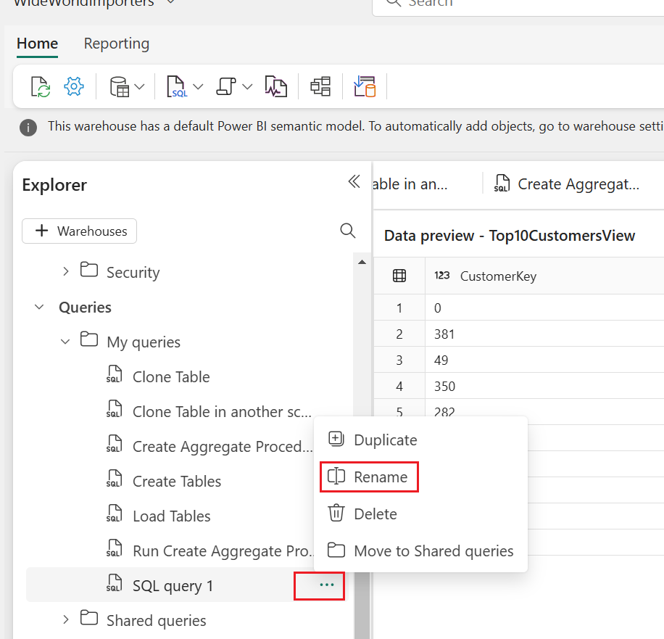

1. 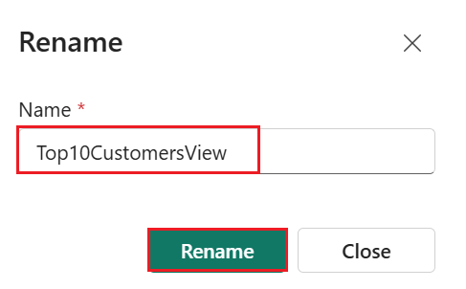In the **Rename** dialog box, under the **Name** field, enter +++**Top10CustomersView+++**, then click on the **Rename** button.
2. Create another new query, similar to Step 1. From the **Home** tab of the ribbon, select **New SQL query**.



1. In the query editor, paste the following code. This updates the **TotalIncludingTax** column value to **200000000** for the record which has the **SaleKey**value of **22632918.** Select **Run** to execute the query.

**SQL**

/*Update the TotalIncludingTax value of the record with SaleKey value of 22632918*/

UPDATE [dbo].[fact_sale]

SET TotalIncludingTax = 200000000

WHERE SaleKey = 22632918;

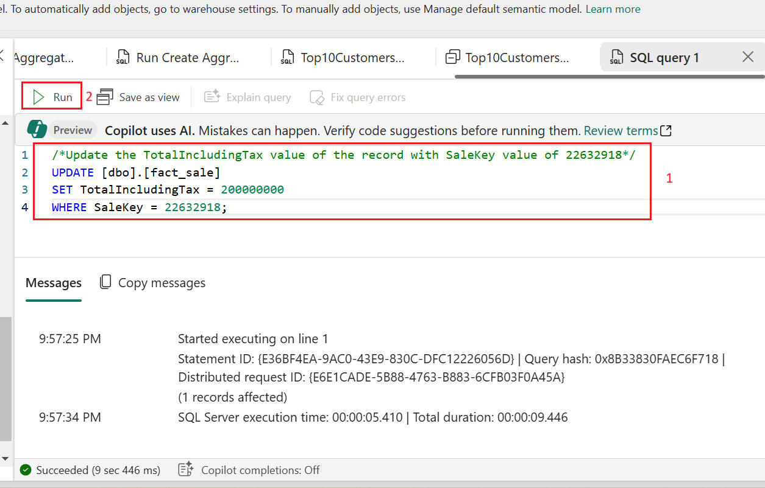

1. In the query editor, paste the following code. The CURRENT_TIMESTAMP T-SQL function returns the current UTC timestamp as a **datetime**. Select **Run** to execute the query.

**SQL**

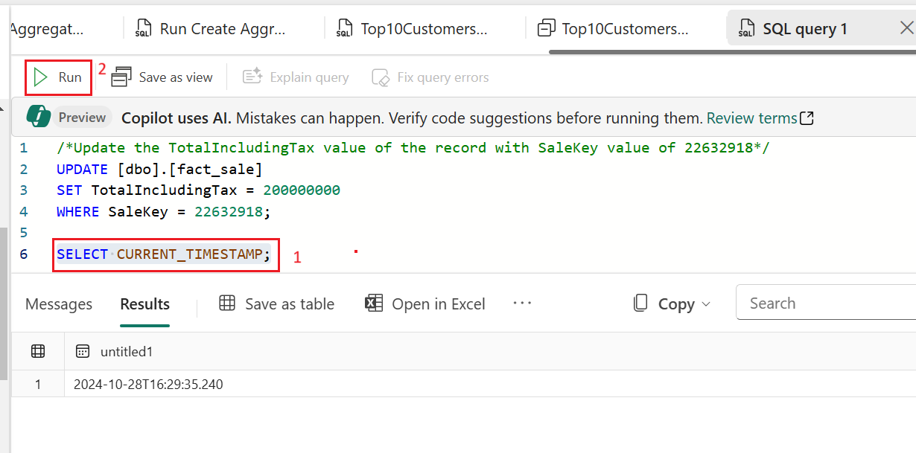SELECT CURRENT_TIMESTAMP;

1. 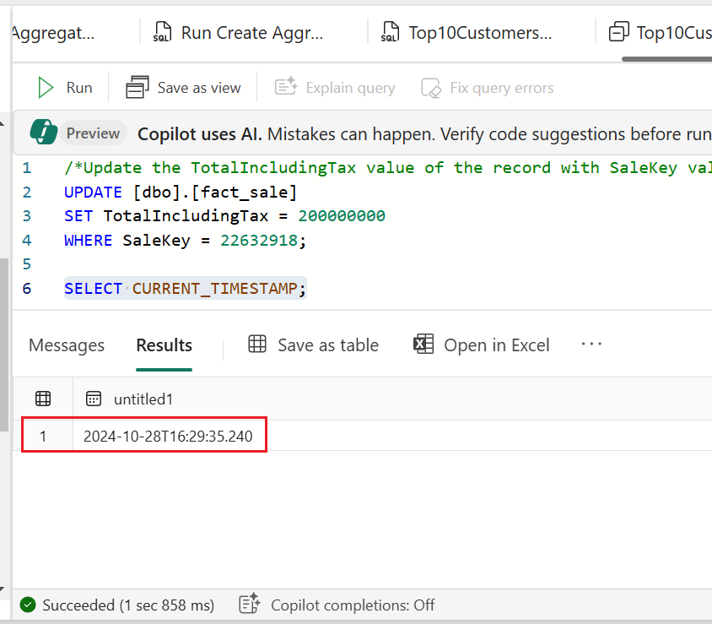Copy the timestamp value returned to your clipboard.
2. Paste the following code **(Step-12)** in the query editor and replace the timestamp value with the current timestamp value obtained from the prior step. The timestamp syntax format is **YYYY-MM-DDTHH:MM:SS[.FFF].**
3. Remove the trailing zeroes, for example: **2024-04-24T20:59:06.097**.
4. The following example returns the list of top ten customers by **TotalIncludingTax**, including the new value for **SaleKey** 22632918. Replace the existing code and paste the following code and select **Run** to execute the query.

**SQL**

/*View of Top10 Customers as of today after record updates*/

SELECT *

FROM [WideWorldImporters].[dbo].[Top10CustomersView]

OPTION (FOR TIMESTAMP AS OF '2024-04-24T20:59:06.097');

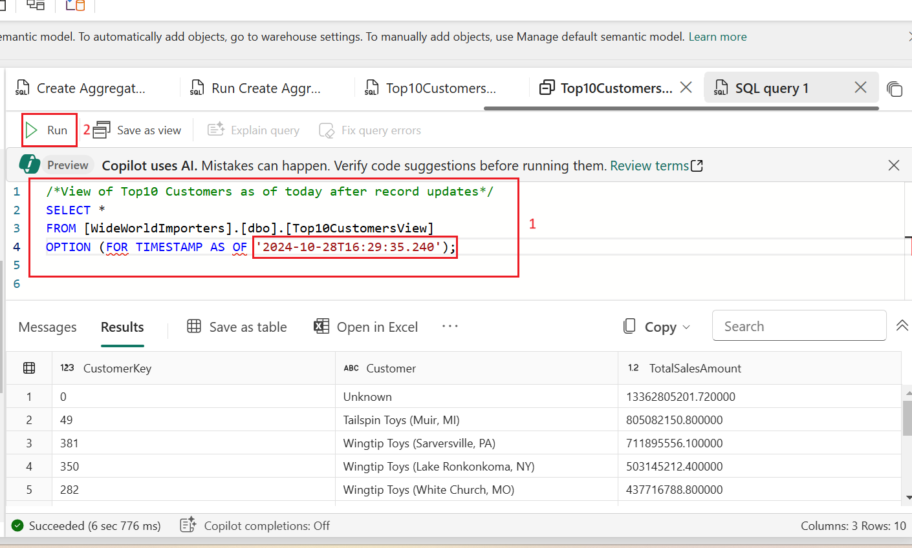

1. Paste the following code in the query editor and replace the timestamp value to a time prior to executing the update script to update the **TotalIncludingTax** value. This would return the list of top ten customers *before* the **TotalIncludingTax** was updated for **SaleKey** 22632918. Select **Run** to execute the query.

**SQL**

/*View of Top10 Customers as of today before record updates*/

SELECT *

FROM [WideWorldImporters].[dbo].[Top10CustomersView]

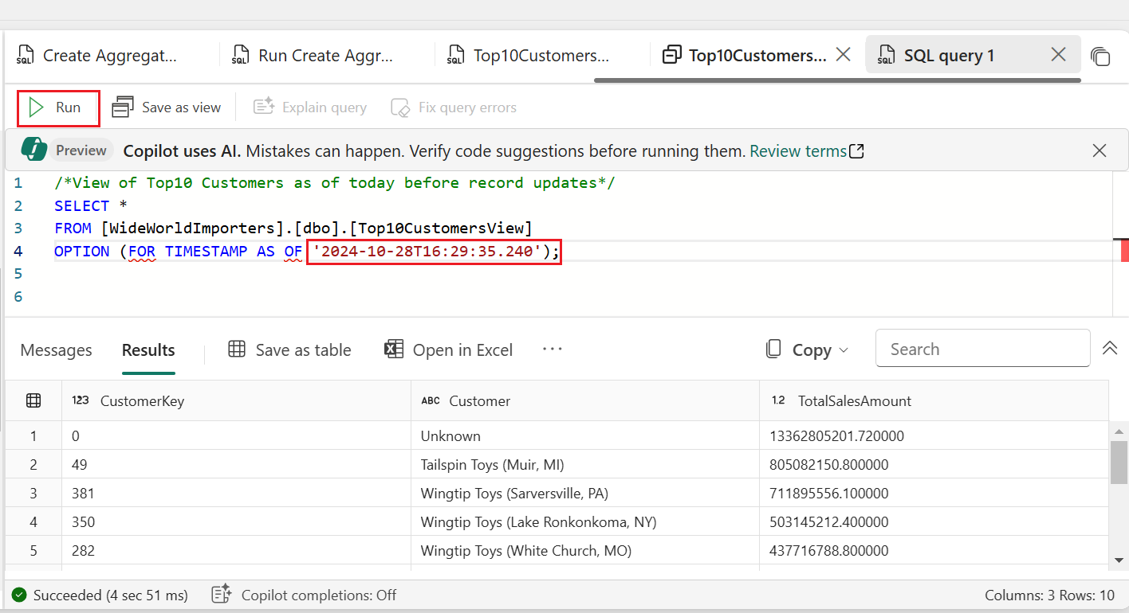OPTION (FOR TIMESTAMP AS OF '2024-04-24T20:49:06.097');

1. Rename this query as **Time Travel Now**.

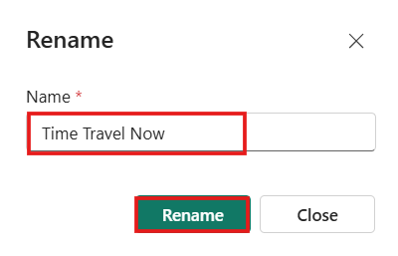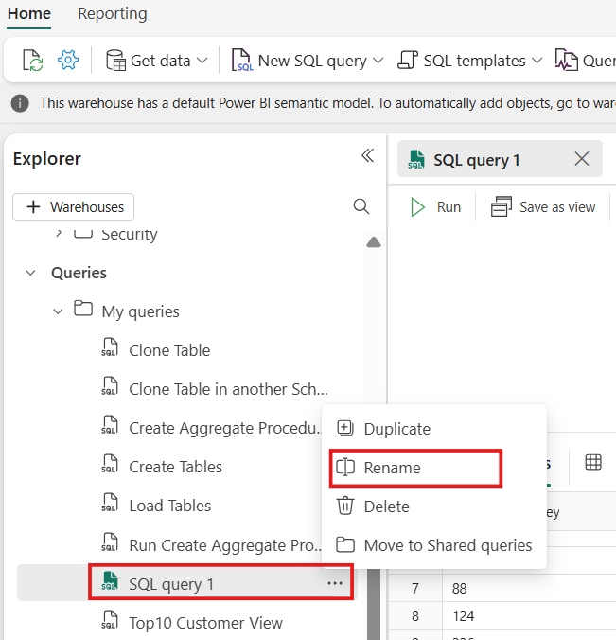

# **Exercise 7: Create a query with the visual query builder**

## Task 1: Use the visual query builder

Create and save a query with the visual query builder in the Microsoft Fabric portal.

1. In the **WideWorldImporters** page, from the **Home** tab of the ribbon, select **New visual query**.

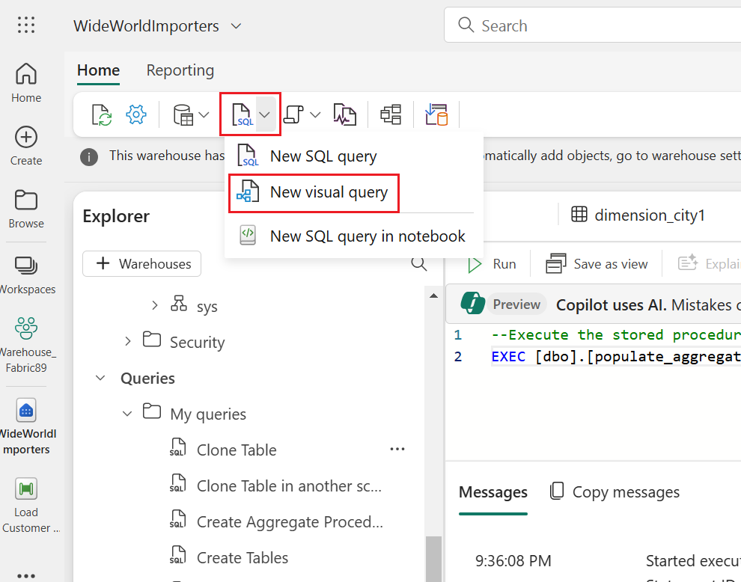

1. Right-click on **fact_sale** and select **Insert into canvas**

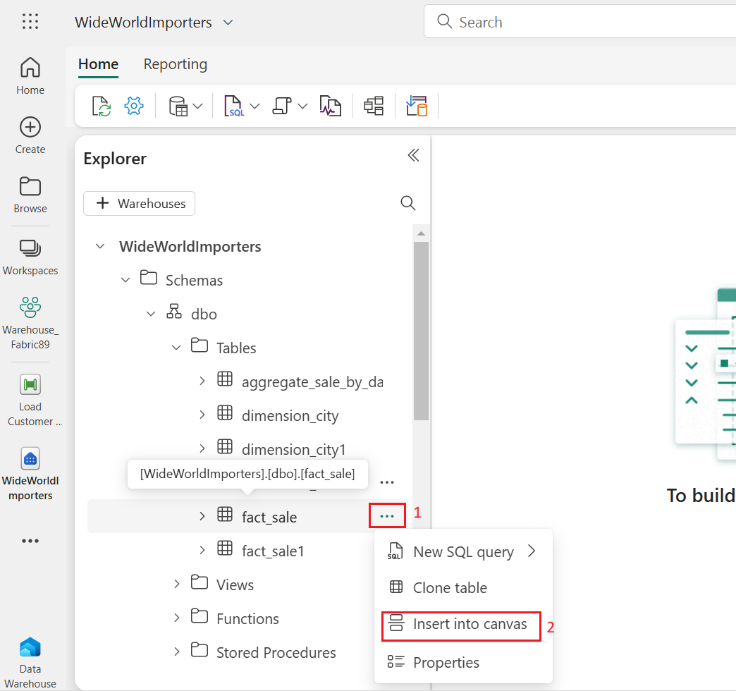

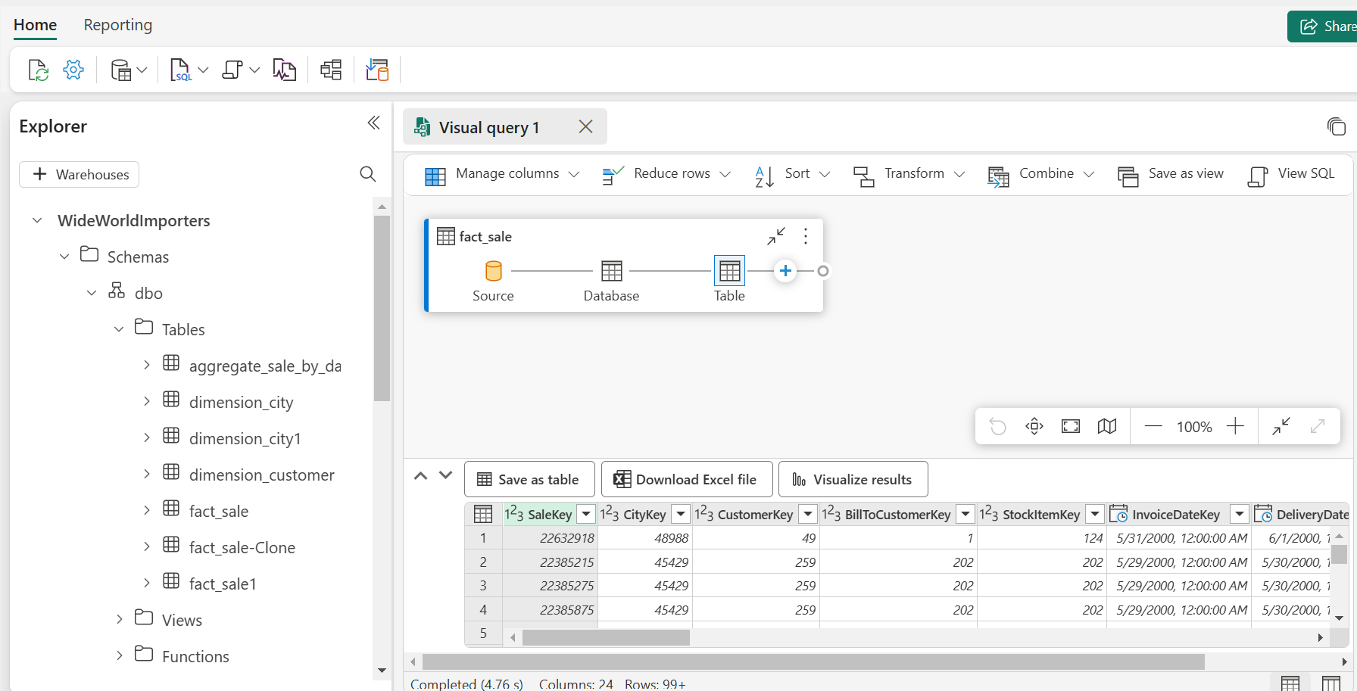

1. Navigate to query design pane **transformations ribbon** and limit the dataset size by clicking on **Reduce rows** dropdown, then click on **Keep top rows** as shown in the below image.

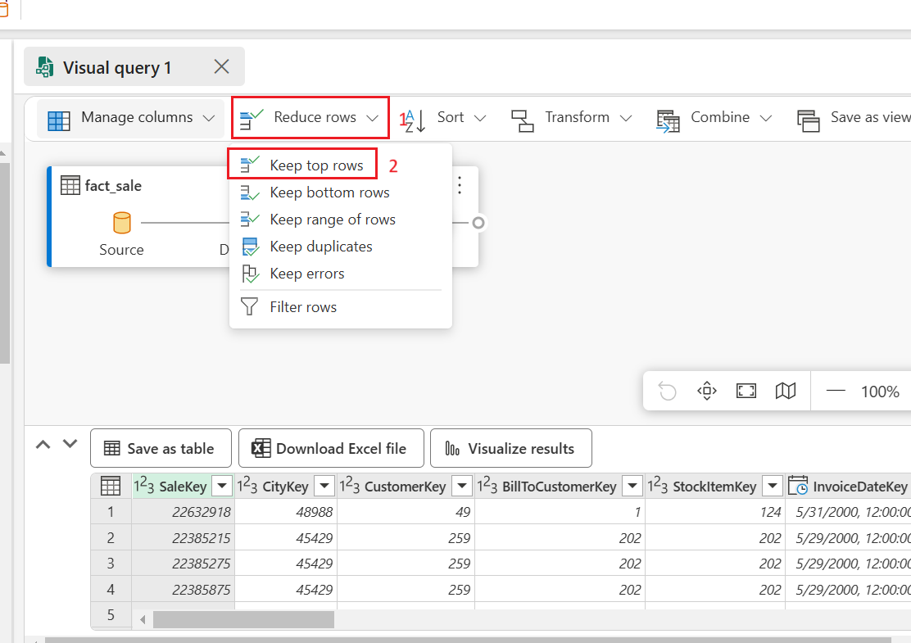

1. In the **Keep top rows** dialog box, enter **10000** and Select **OK**.

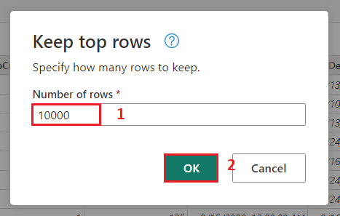

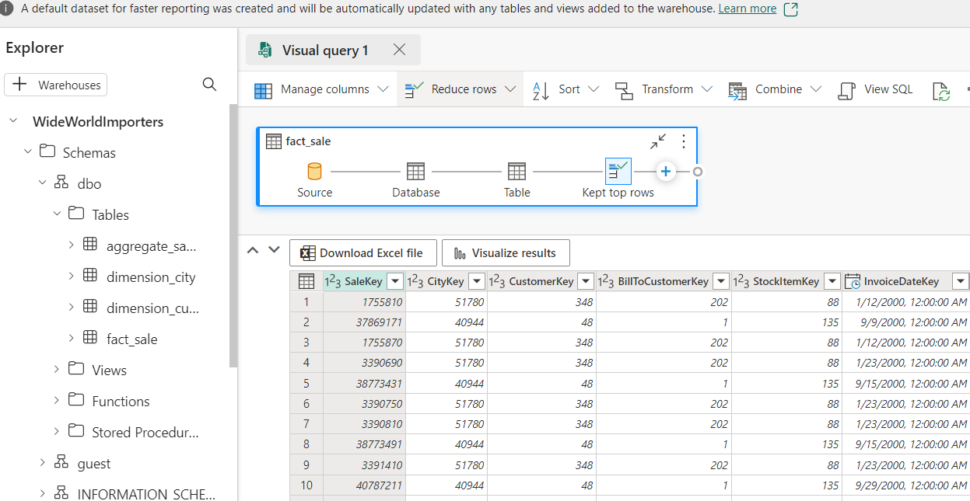

1. 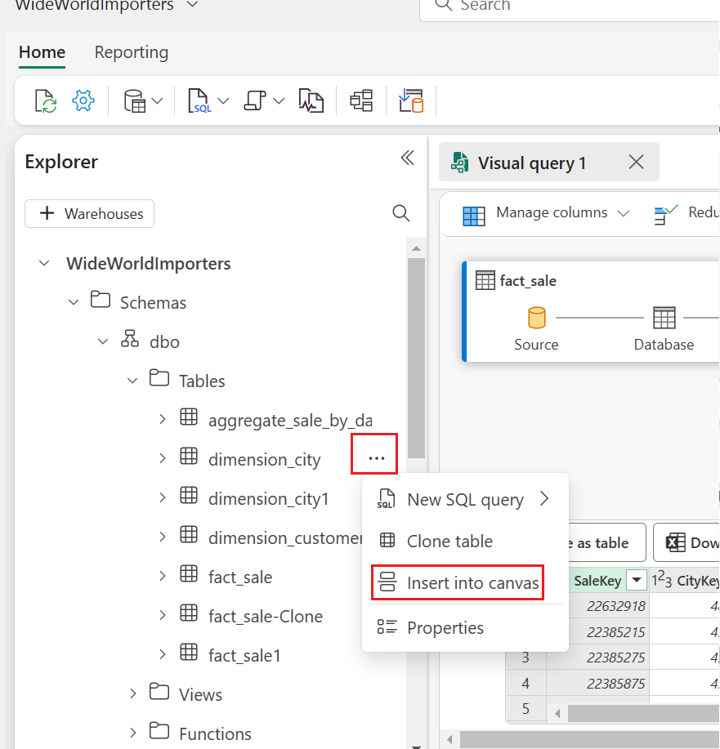Right-click on **dimension_city** and select **Insert into canvas.**

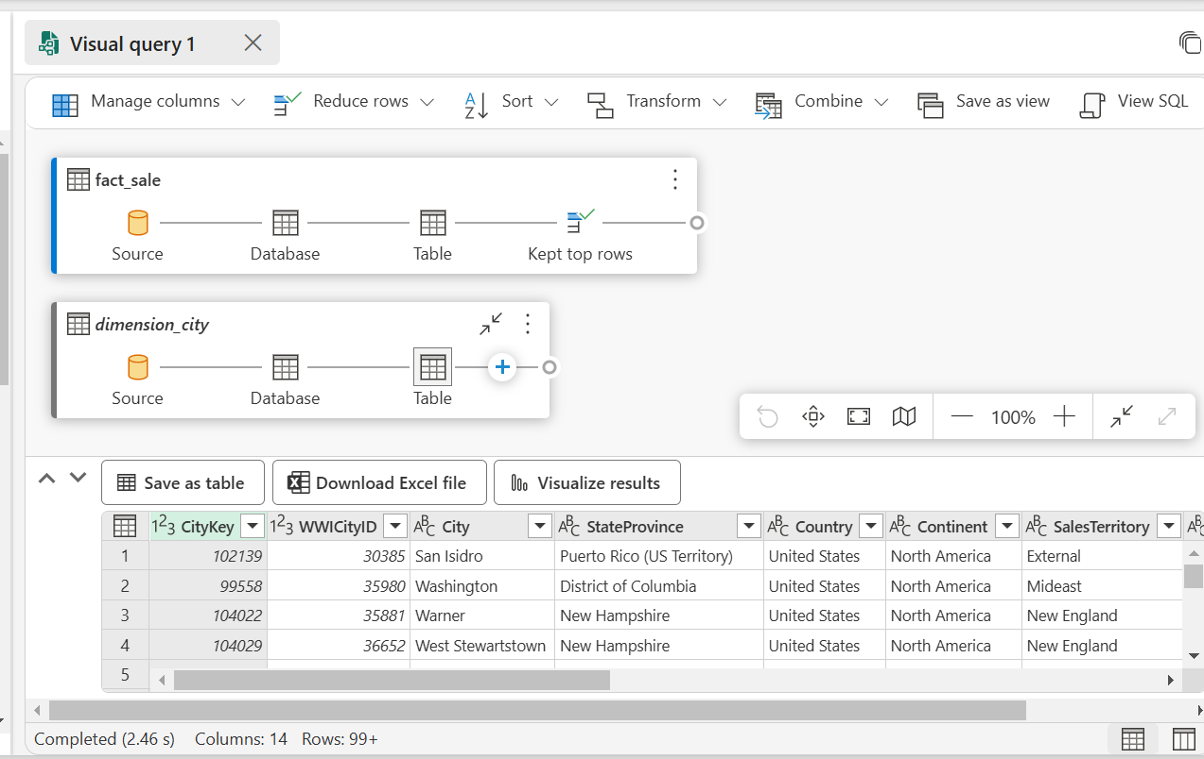

1. 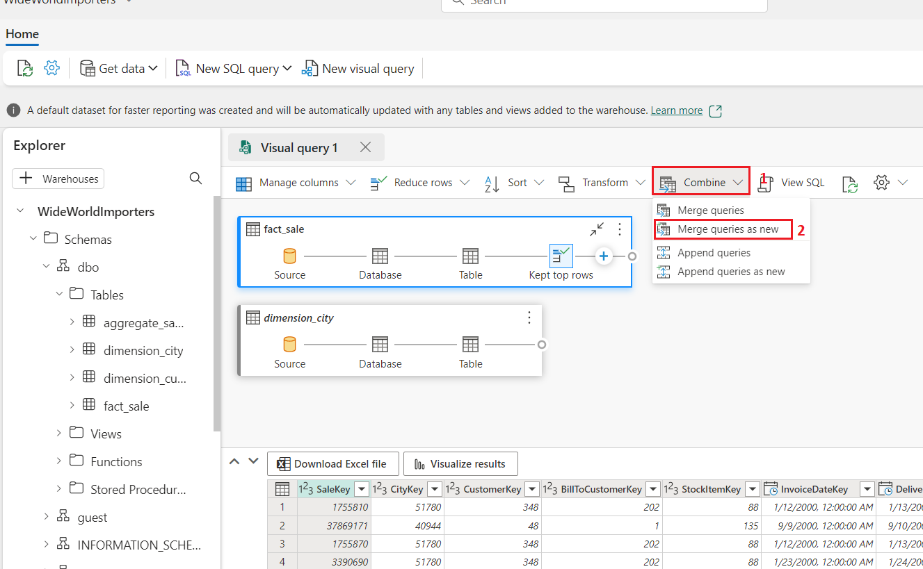From the transformations ribbon, select the dropdown beside **Combine** and select **Merge queries as new** as shown in the below image.
2. On the **Merge** settings page enter the following details.

* In the **Left table for merge** dropdown, choose **dimension_city**
* In the **Right table for merge** dropdown, choose **fact_sale** (use horizontal and vertical scroll bar)
* Select the **CityKey** field in the **dimension_city** table by selecting on the column name in the header row to indicate the join column.
* Select the **CityKey** field in the **fact_sale** table by selecting on the column name in the header row to indicate the join column.
* 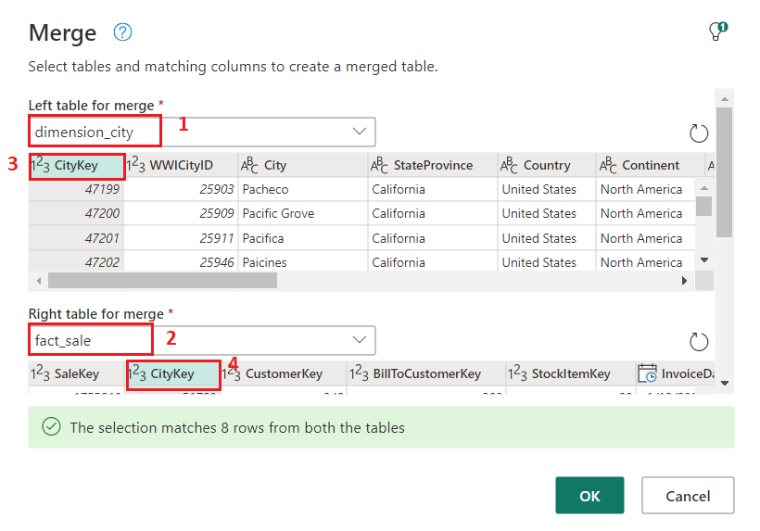In the **Join kind** diagram selection, choose **Inner** and click on the **Ok** button.

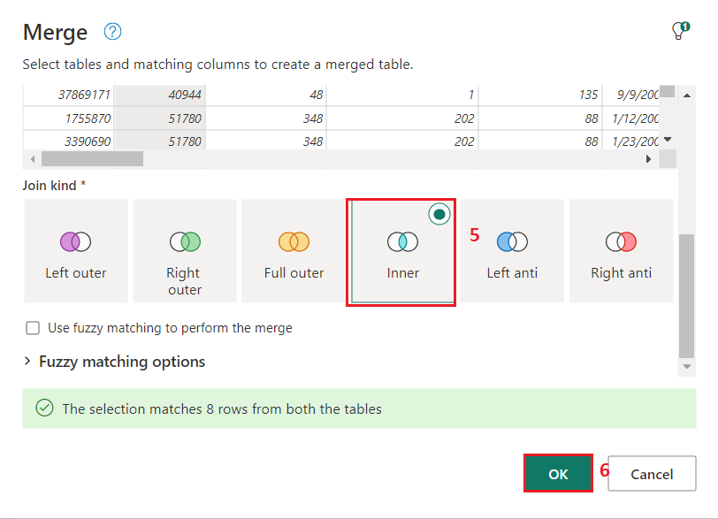

1. 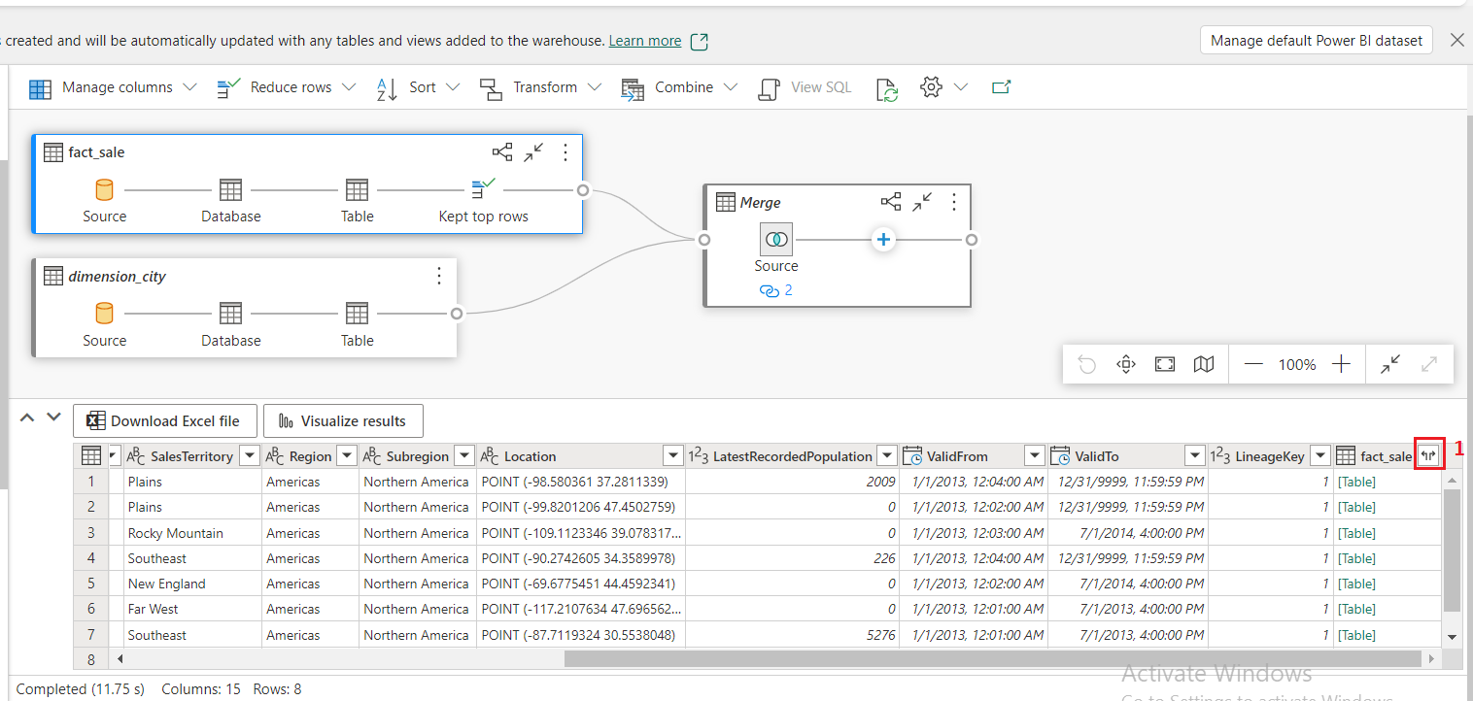In the data preview pane, locate the **fact_sale** column (the last column) and select the **Expand** button beside it.
2. In the column selector dialog, select only these three columns: **TaxAmount**, **Profit**, and **TotalIncludingTax** and then select **OK**.

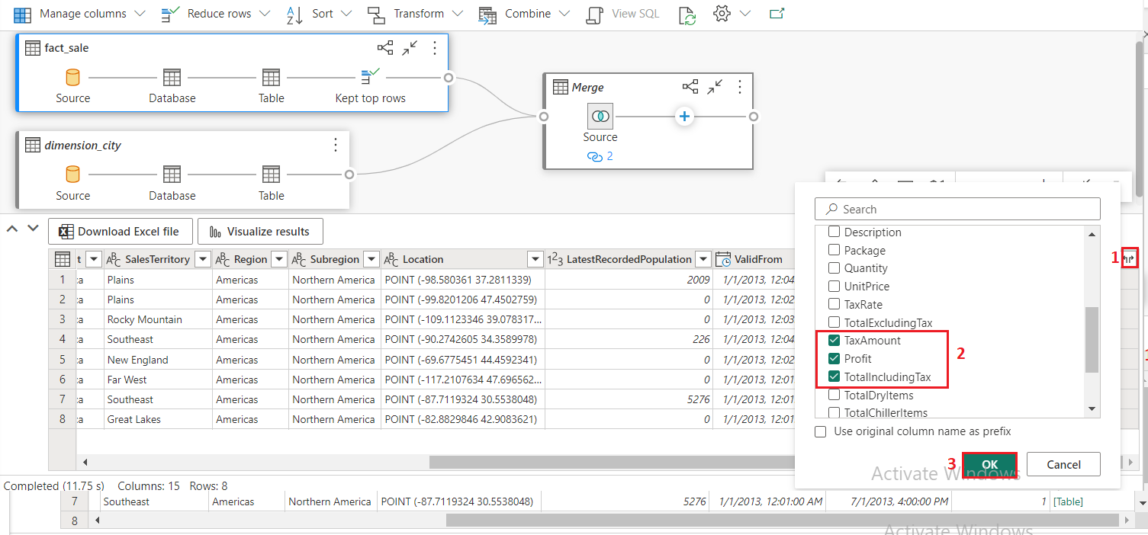

1. 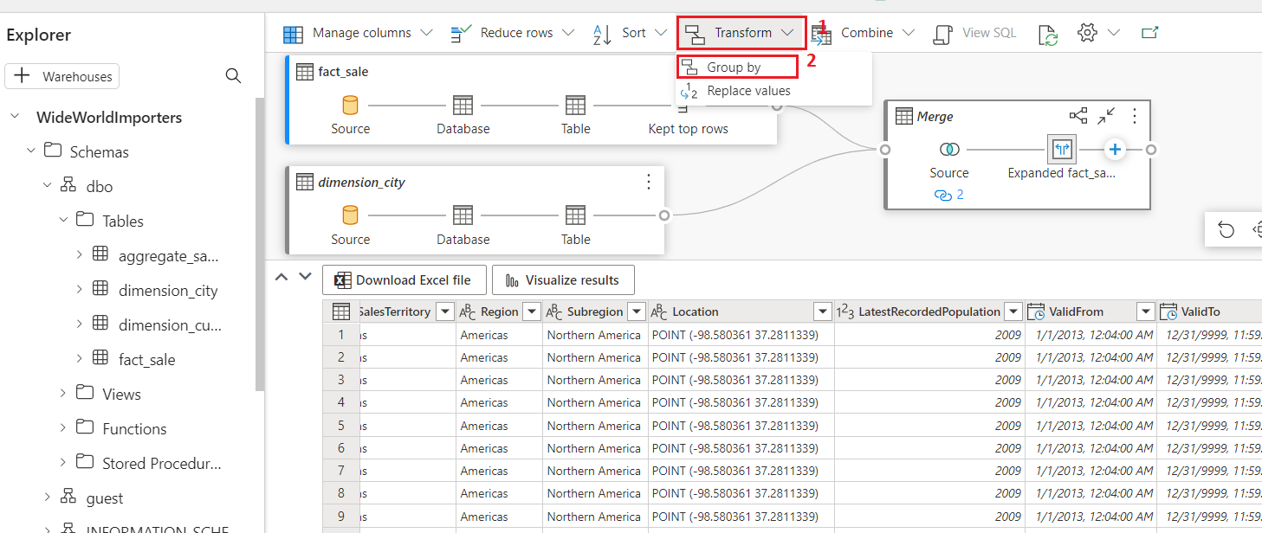In the **transformations ribbon,** click on the dropdown beside **Transform**, then select **Group by**.
2. On the **Group by** settings page, enter the following details.

* Select **Advanced** radio button.
* **Under Group by** select the following:
  + 1. **Country**
    2. **StateProvince**
    3. **City**
* **In the New column name, enter SumOfTaxAmount in Operation column field, select Sum, then under Column field, select TaxAmount. Click on Add aggregation** to add more aggregate column and operation.
* **In the New column name, enter SumOfProfit in Operation column field, select Sum, then under Column field, select Profit. Click on Add aggregation** to add more aggregate column and operation.
* **In the New column name, enter SumOfTotalIncludingTax in Operation column field, select Sum, then under Column field, TotalIncludingTax.**
* 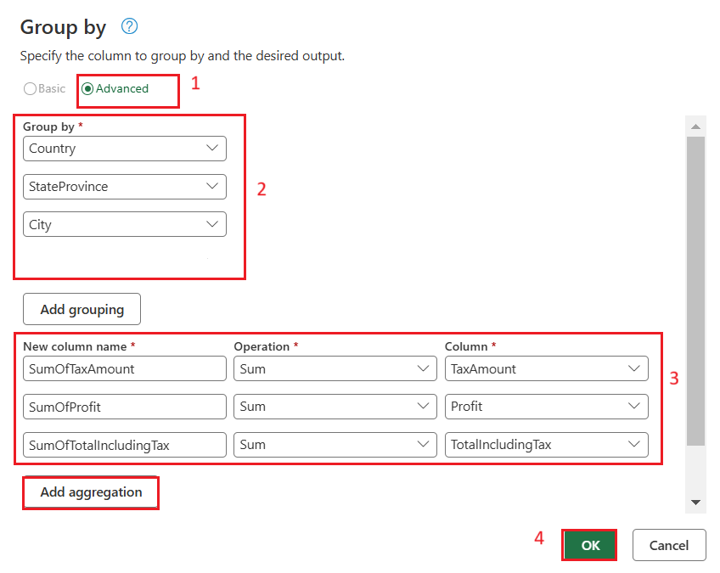**Click on the OK button**

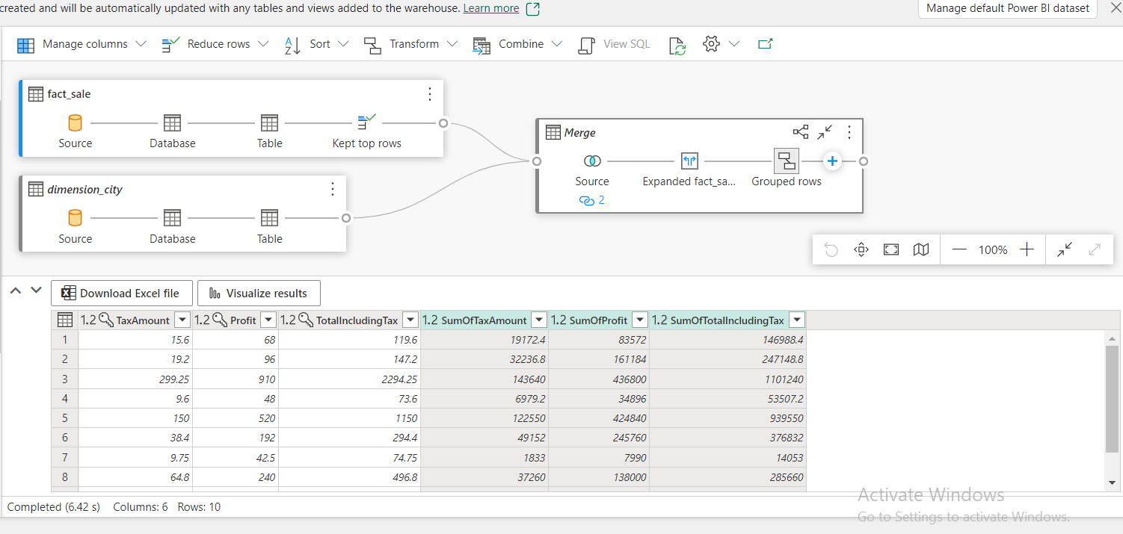

1. 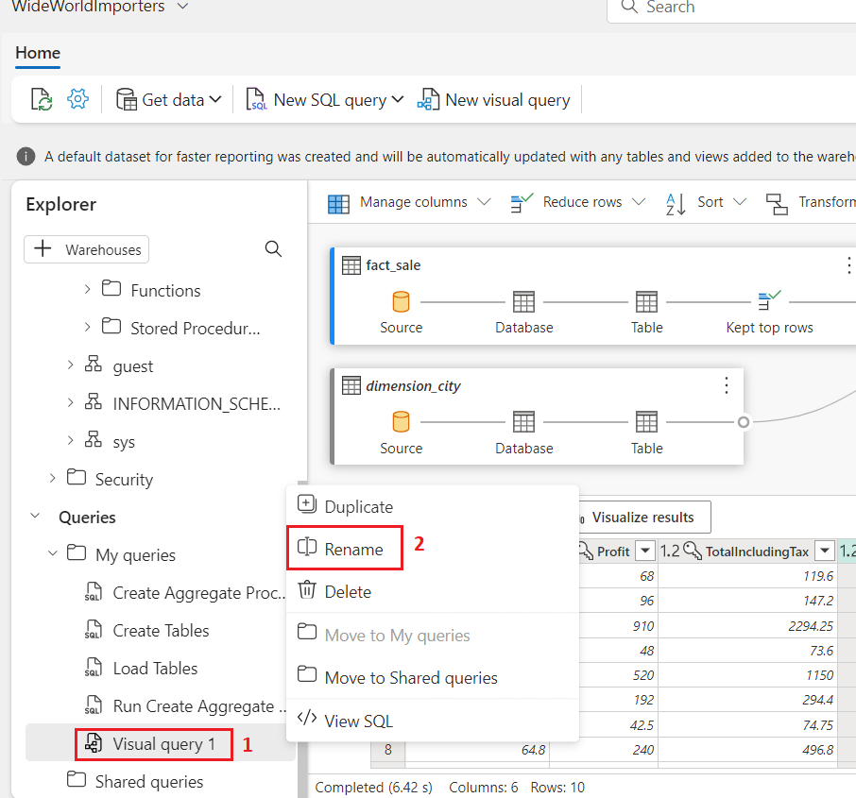In the explorer, navigate to **Queries** and right-click on **Visual query 1 under Queries**. Then, select **Rename**.
2. 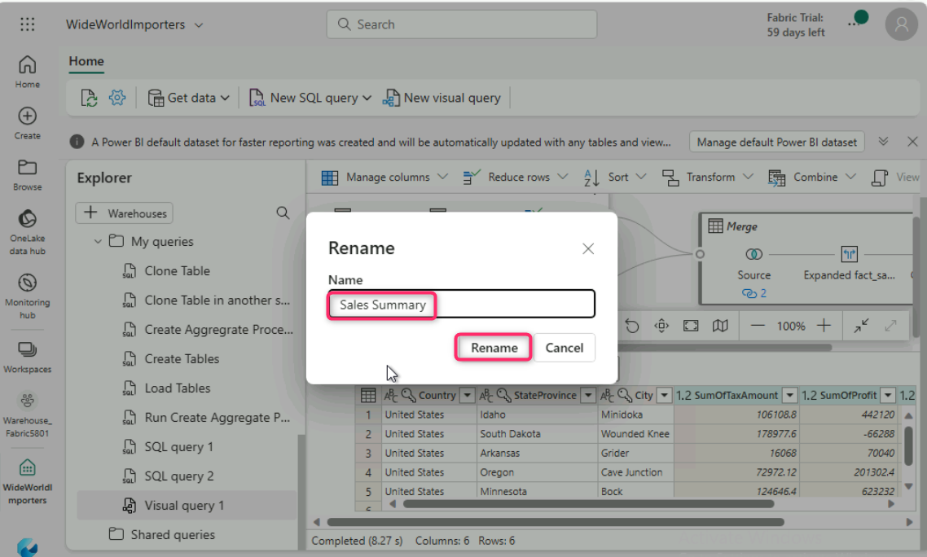Type +++**Sales Summary+++** to change the name of the query. Press **Enter** on the keyboard or select anywhere outside the tab to save the change.
3. 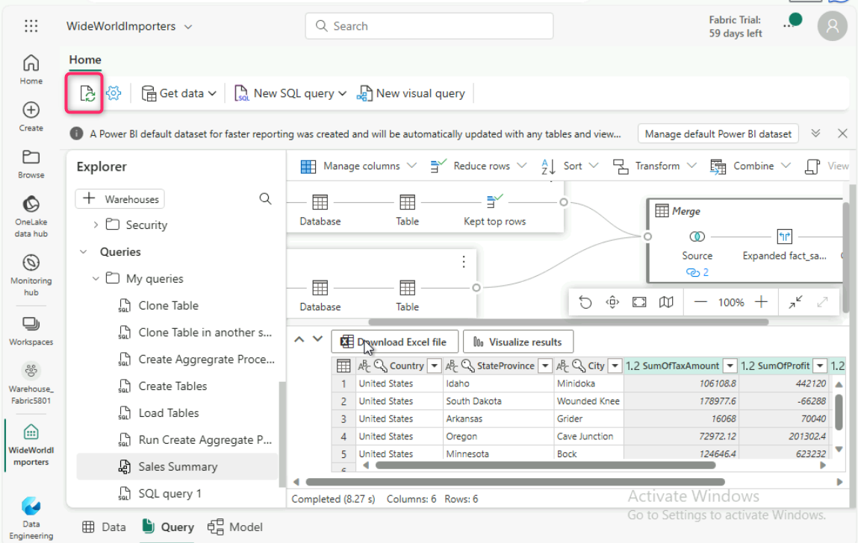Click on the **Refresh** icon below the **Home** tab.

# **Exercise 8: Analyze data with a notebook**

## Task 1: Create a Lakehouse shortcut and Analyze data with an notebook

In this task, learn about how you can save your data once and then use it with many other services. Shortcuts can also be created to data stored in Azure Data Lake Storage and S3 to enable you to directly access delta tables from external systems.

First, we create a new lakehouse. To create a new lakehouse in your Microsoft Fabric workspace:

1. On the **WideWorldImporters** page, click on **Warehouse_FabricXX** Workspace on the left-sided navigation menu.

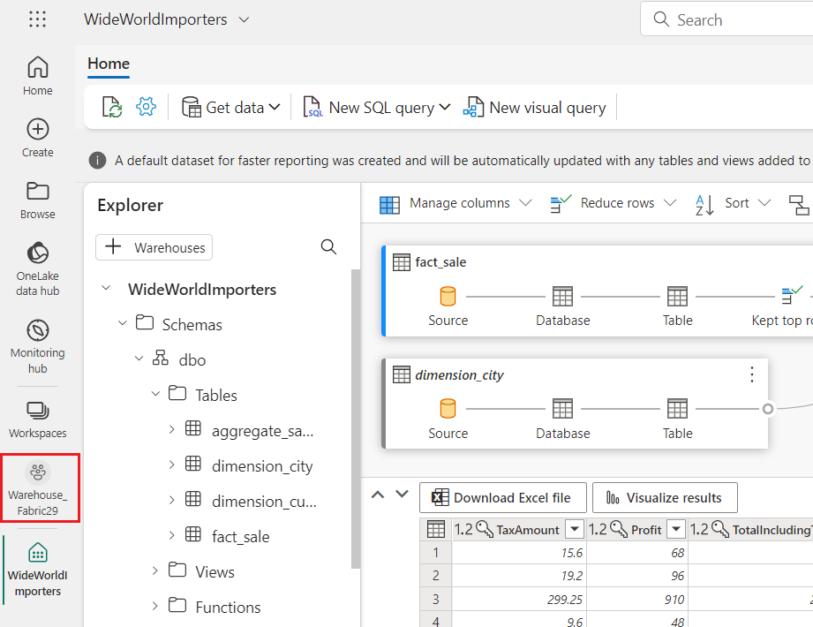

1. On the **Synapse Data Engineering Warehouse_FabricXX** home page, under the **Warehouse_FabricXX** pane, click **+New item**, and then select **Lakehouse**under **Stored data**

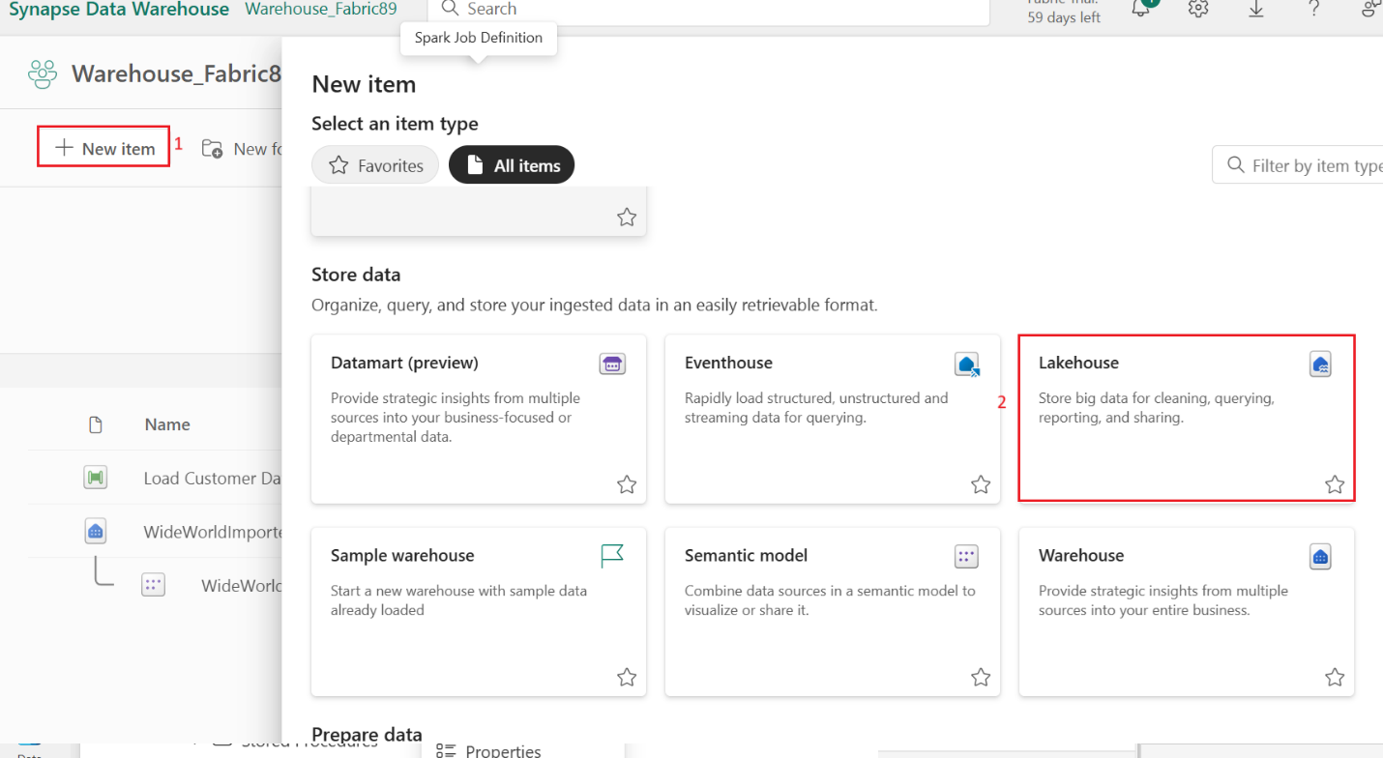

1. 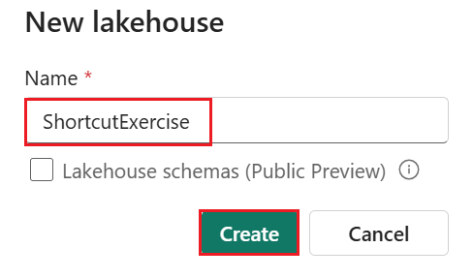In the **Name** field, enter +++**ShortcutExercise+++** and click on the **Create button.**
2. The new lakehouse loads and the **Explorer** view opens up, with the **Get data in your lakehouse** menu. Under **Load data in your lakehouse**, select the **New shortcut** button.

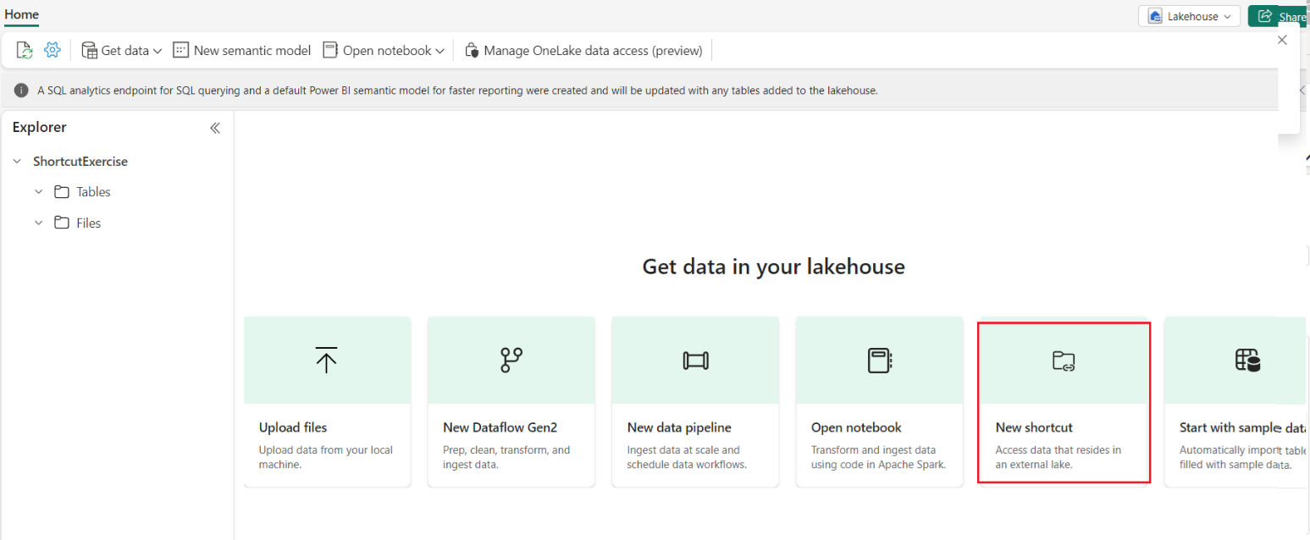

1. 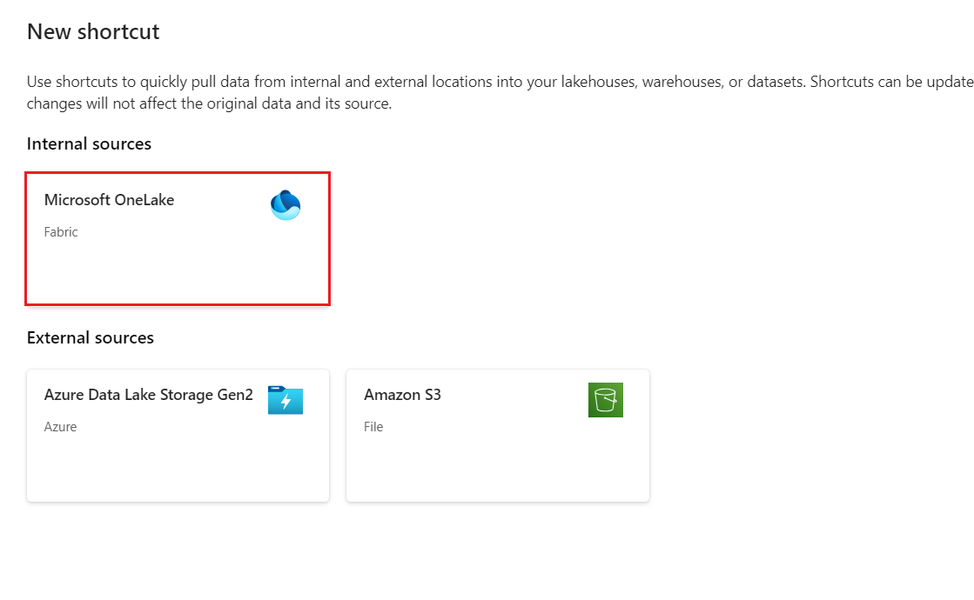In the **New shortcut** window, select **Microsoft OneLake**.
2. In the **Select a data source type** window, carefully navigate and click on the **Warehouse** named **WideWorldImporters** that you’ve created previously, then click on the **Next button.**

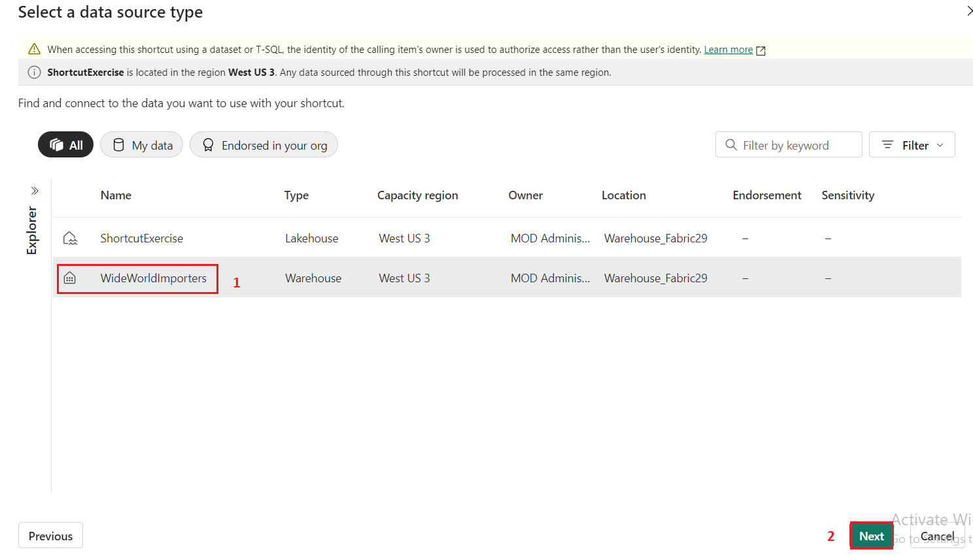

1. 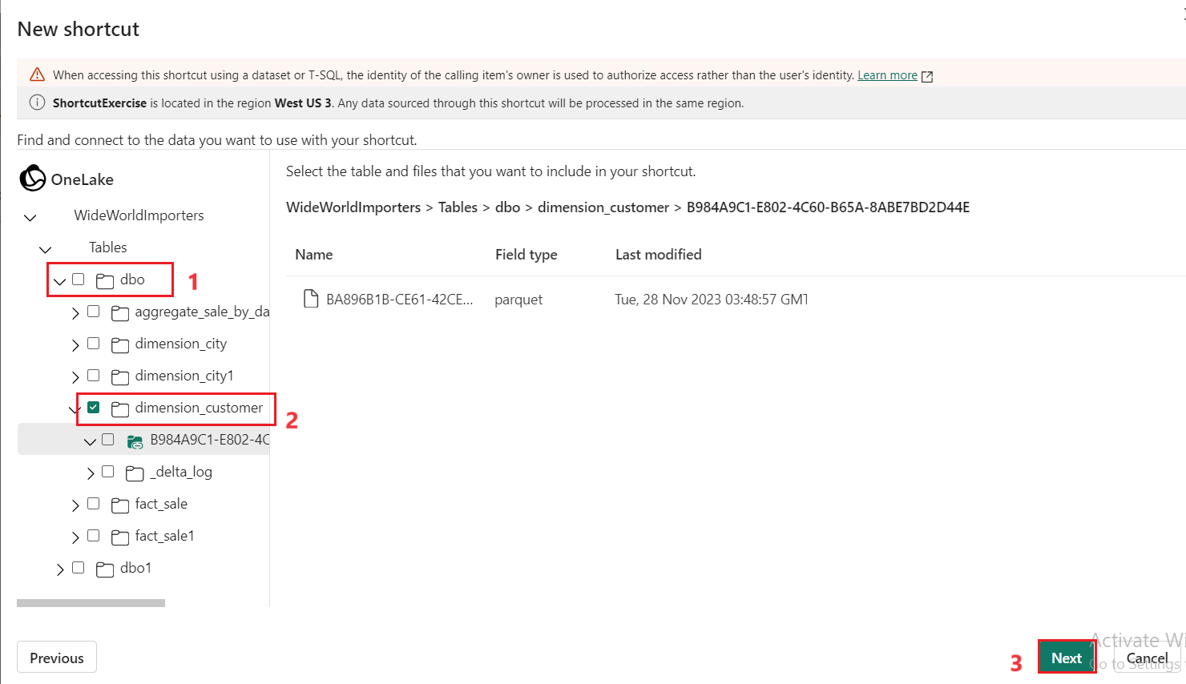In the **OneLake** object browser, expand **Tables**, then expand the **dbo** schema, and select the radio button beside **dimension_customer**. Select the **Next** button.
2. In the **New shortcut** window, click on the **Create** button and click on the **Close** button

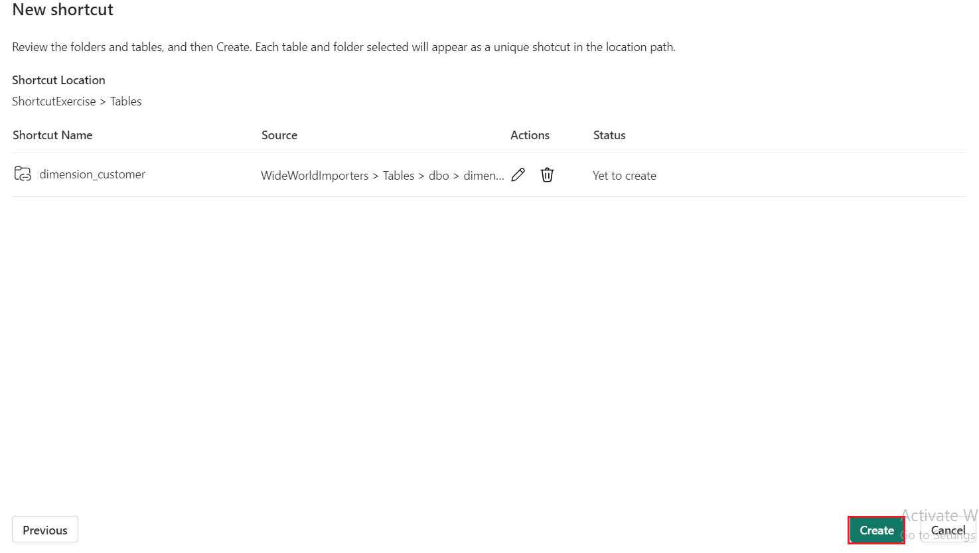

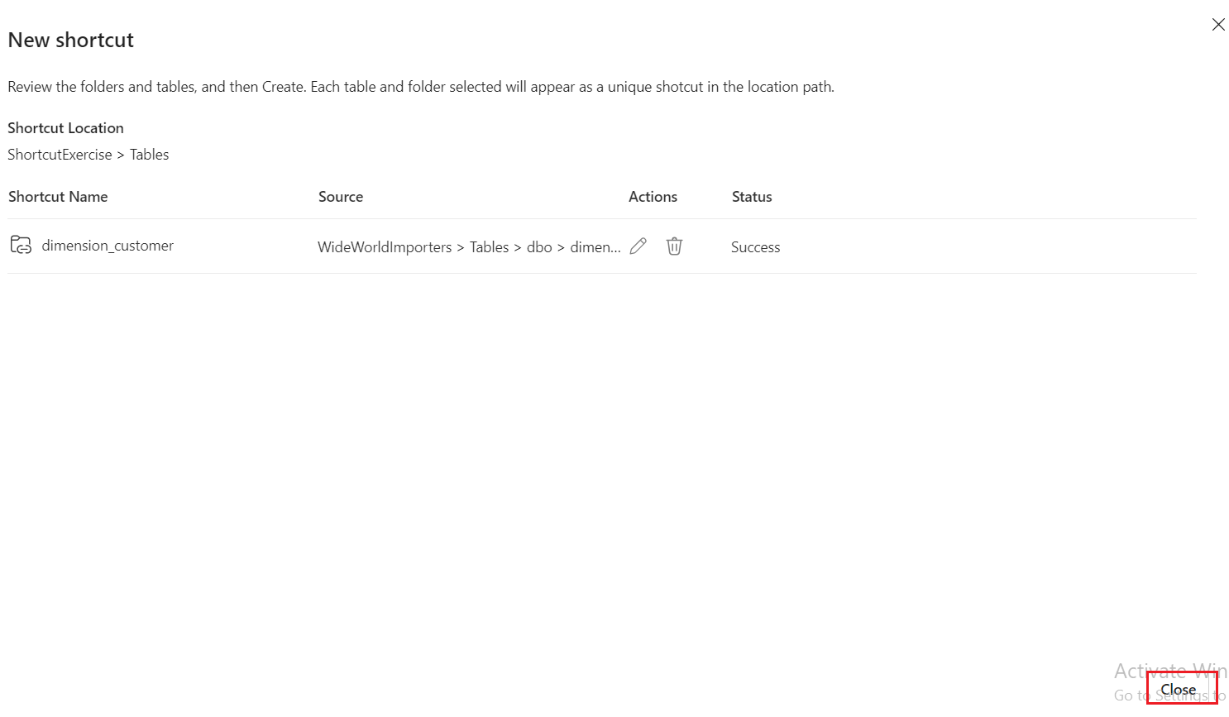

1. Wait for a while and then click on the **Refresh** icon.
2. 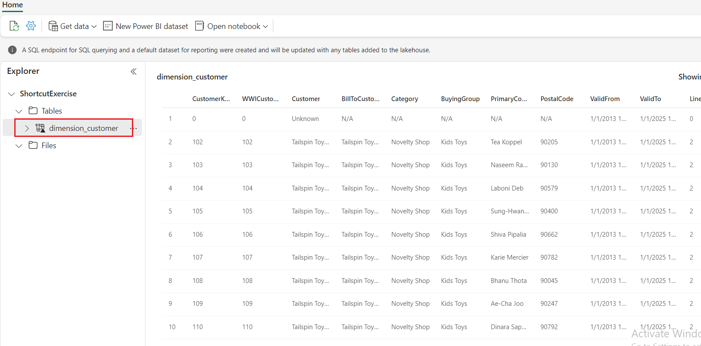Then, select the **dimension_customer**in the **Table** list to preview the data. Notice that the lakehouse is showing the data from the **dimension_customer** table from the Warehouse.
3. 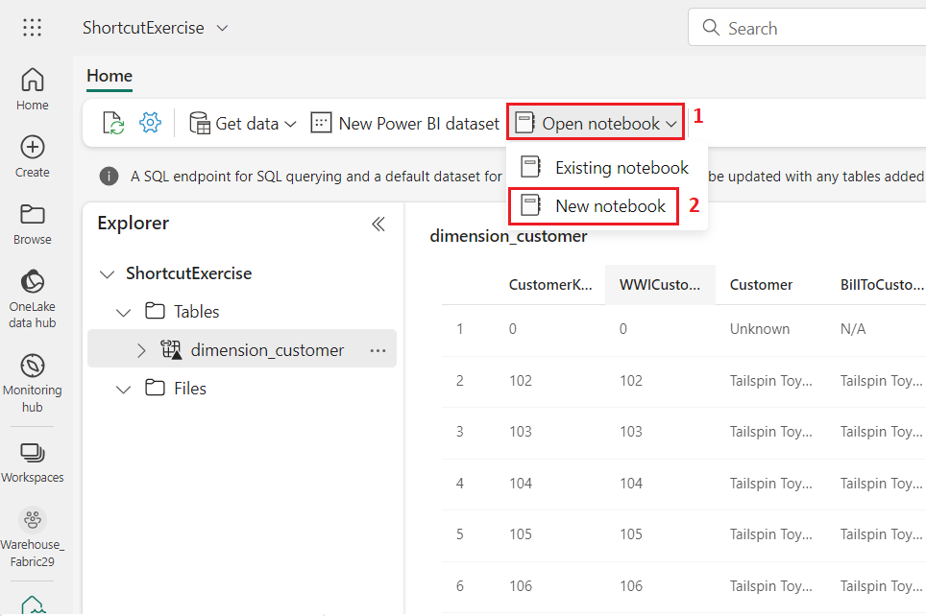Next, create a new notebook to query the **dimension_customer** table. In the **Home** ribbon, select the drop down for **Open notebook** and choose **New notebook**.
4. 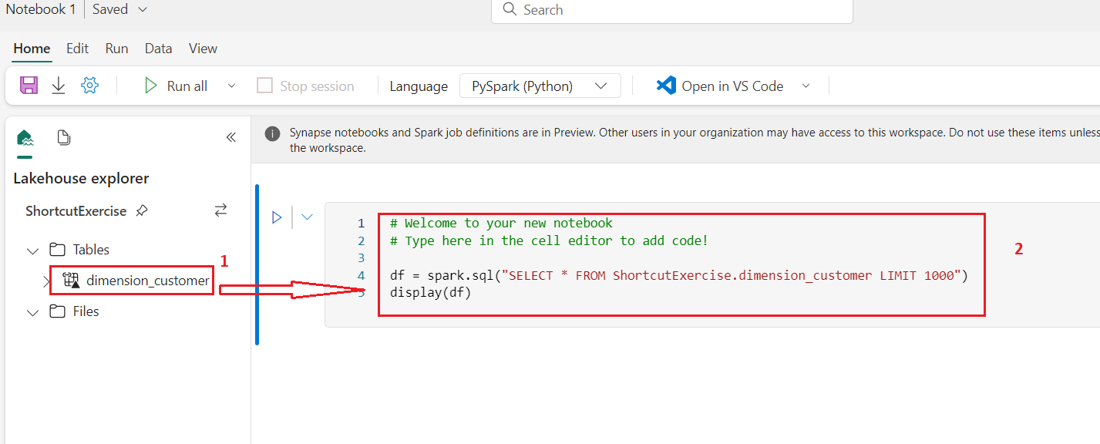Select, then drag the **dimension_customer** from the **Tables** list into the open notebook cell. You can see a **PySpark** query has been written for you to query all the data from **ShortcutExercise.dimension_customer**. This notebook experience is similar to Visual Studio Code Jupyter notebook experience. You can also open the notebook in VS Code.
5. 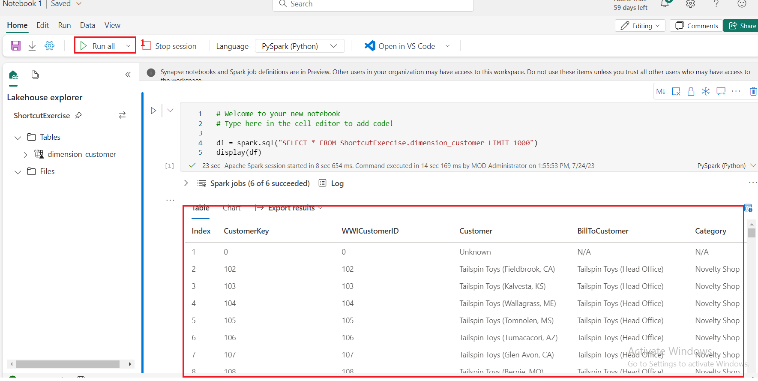In the **Home** ribbon, select the **Run all** button. Once the query is completed, you will see you can easily use PySpark to query the Warehouse tables!

# **Exercise 9: Create cross-warehouse queries with the SQL query editor**

## Task 1: Add multiple warehouses to the Explorer

In this task, learn about how you can easily create and execute T-SQL queries with the SQL query editor across multiple warehouses, including joining together data from a SQL Endpoint and a Warehouse in Microsoft Fabric.

1. From **Notebook1** page, navigate and click on **Warehouse_FabricXX** Workspace on the left-sided navigation menu.

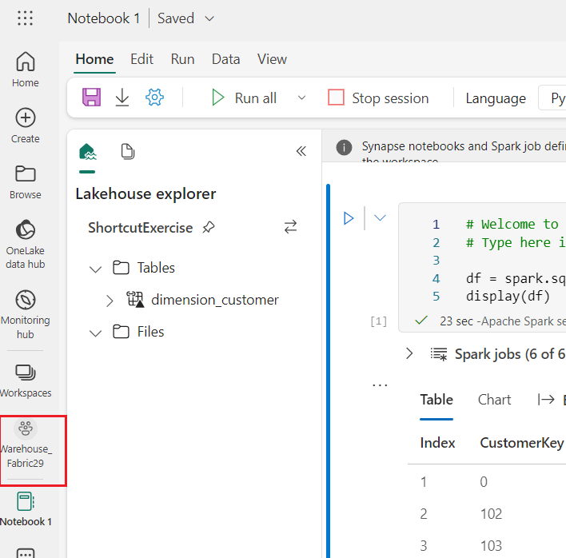

1. In the **Warehouse_FabricXX** view, select the **WideWorldImporters** warehouse.

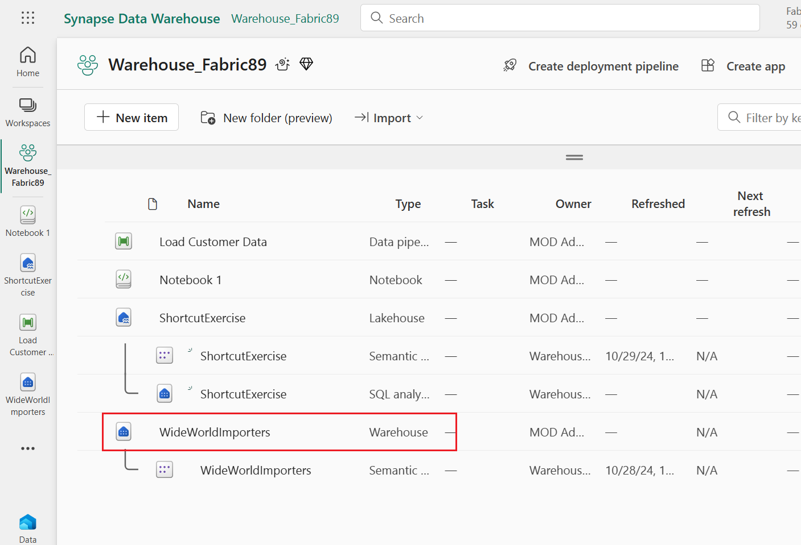

1. 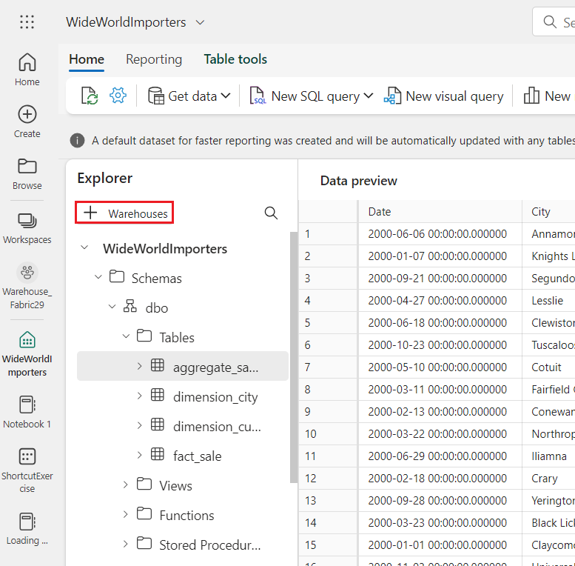In the **WideWorldImporters** page, under **Explorer tab**, select the **+ Warehouses** button.
2. In Add warehouses window, select **ShortcutExercise** and click on the **Confirm** button. Both warehouse experiences are added to the query.

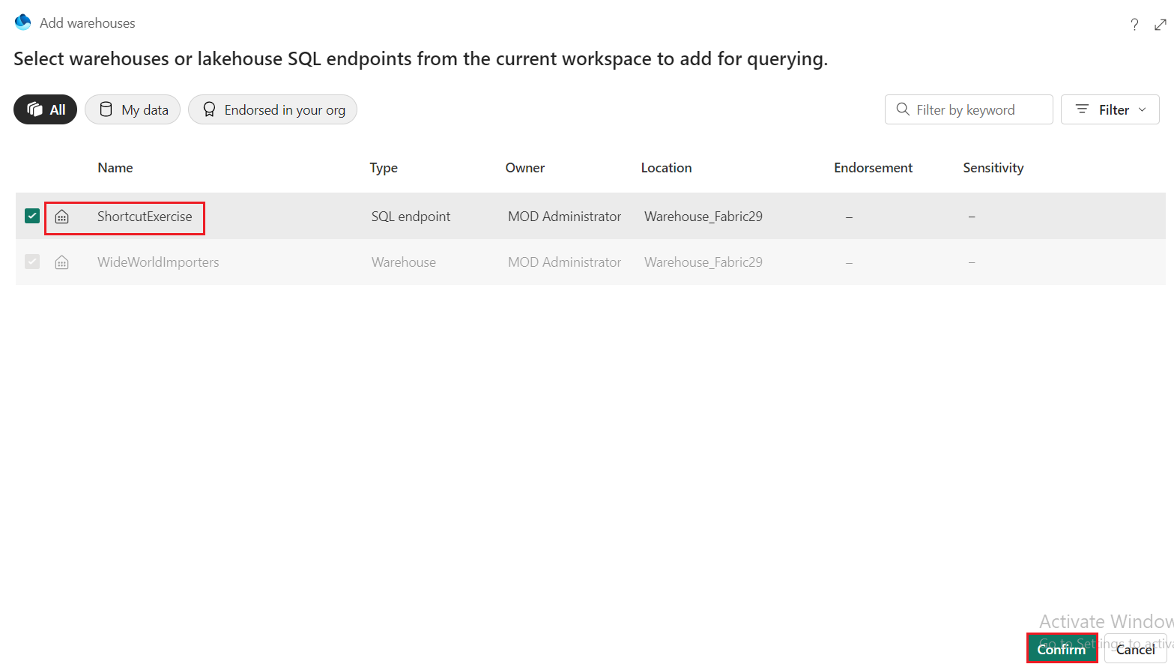

1. 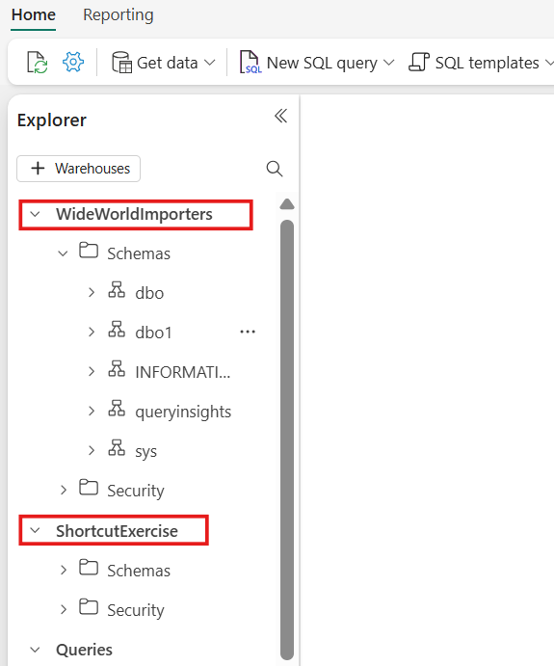Your selected warehouses now show the same **Explorer** pane.

## Task 2: Execute a cross-warehouse query

In this example, you can see how easily you can run T-SQL queries across the WideWorldImporters warehouse and ShortcutExercise SQL Endpoint. You can write cross-database queries using three-part naming to reference the **database.schema.table**, as in SQL Server.

* 1. 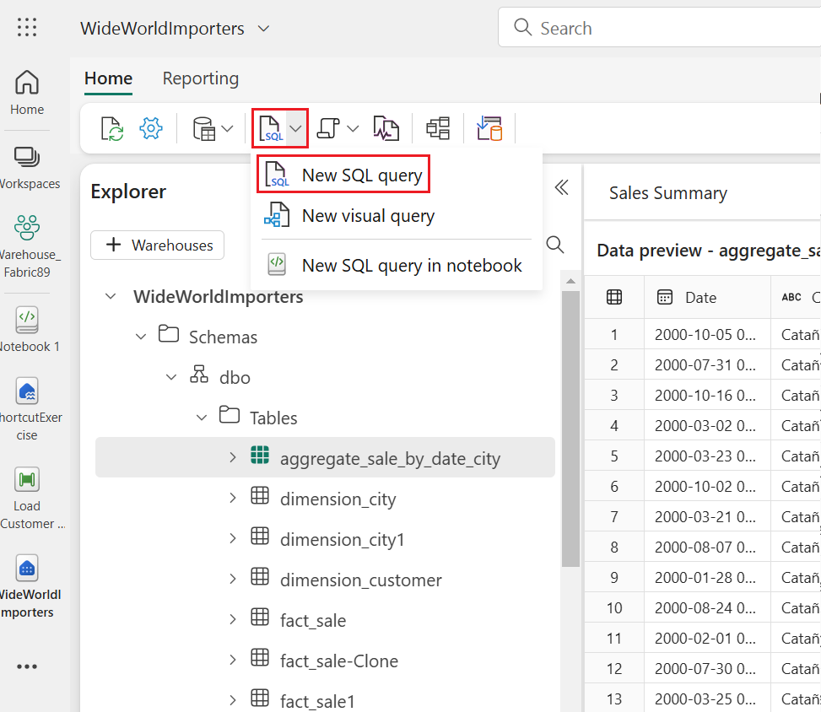From the **Home** tab of the ribbon, select **New SQL query**.
  2. In the query editor, copy and paste the following T-SQL code. Select the **Run** button to execute the query. After the query is completed, you will see the results.

**SQL**

SELECT Sales.StockItemKey,

Sales.Description,

SUM(CAST(Sales.Quantity AS int)) AS SoldQuantity,

c.Customer

FROM [dbo].[fact_sale] AS Sales,

[ShortcutExercise].[dbo].[dimension_customer] AS c

WHERE Sales.CustomerKey = c.CustomerKey

GROUP BY Sales.StockItemKey, Sales.Description, c.Customer;

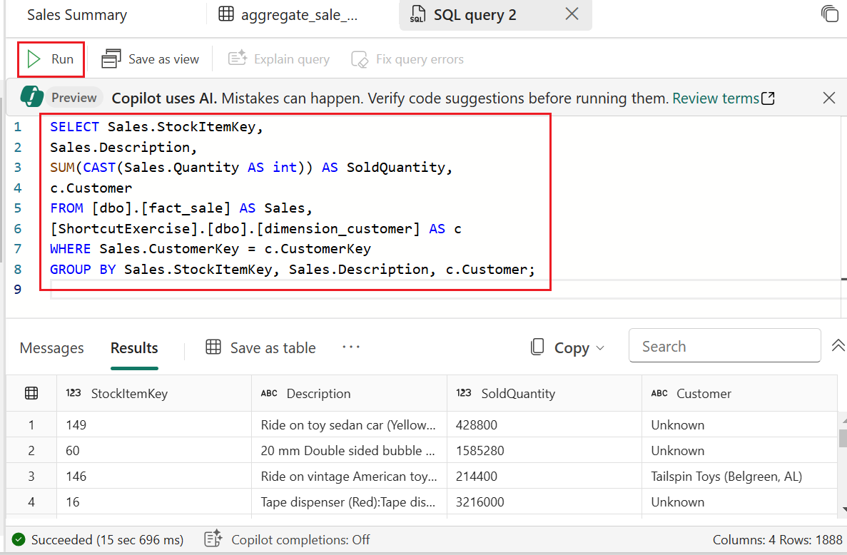

* 1. 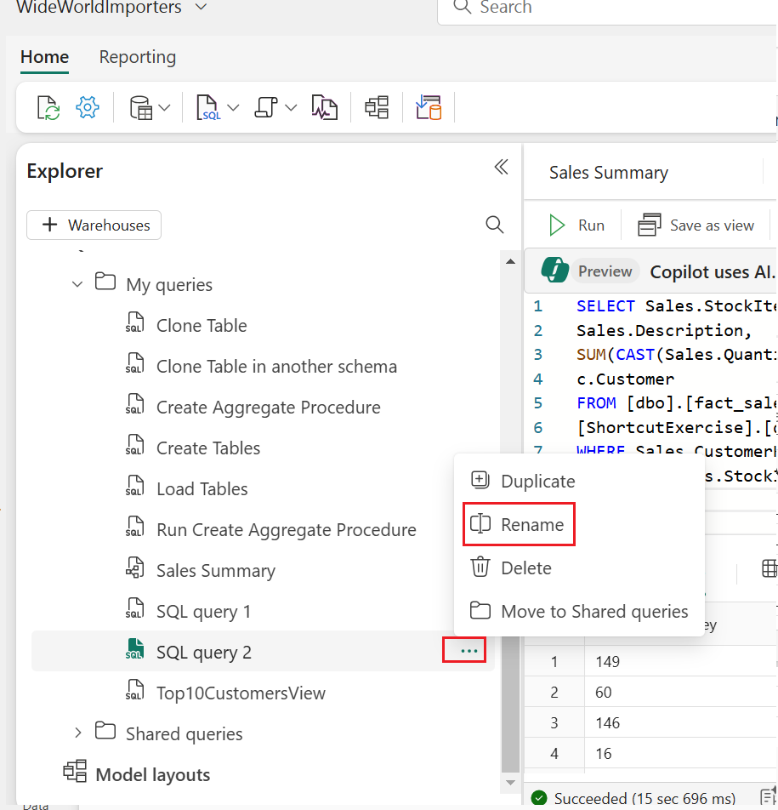Rename the query for reference. Right-click on **SQL query**  in the **Explorer** and select **Rename**.
  2. 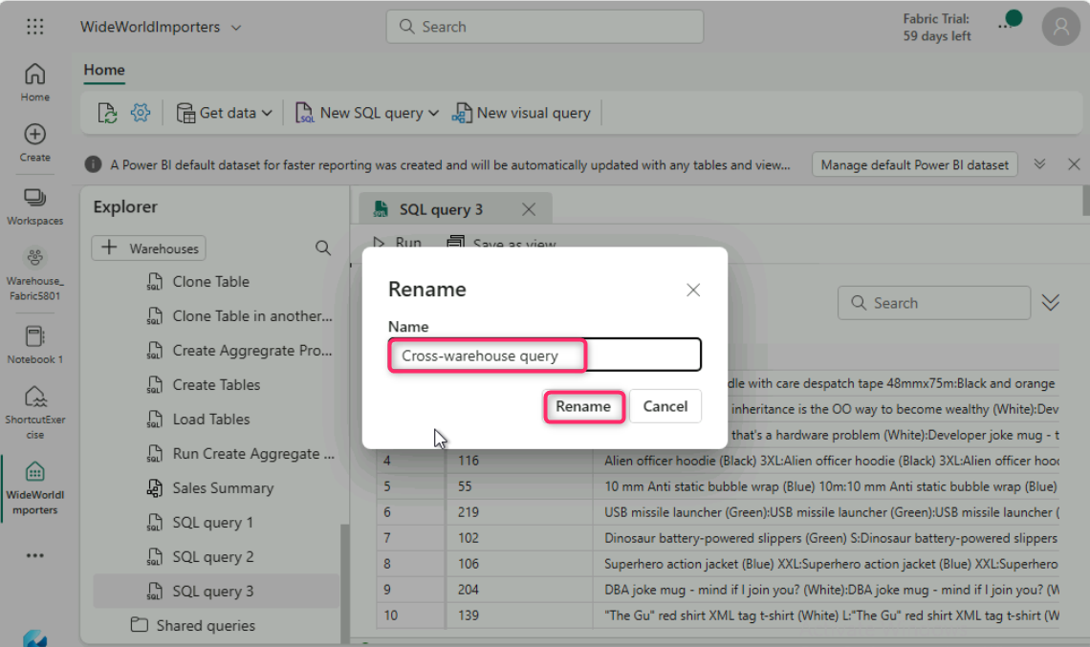In the **Rename** dialog box, under the **Name** field, enter +++**Cross-warehouse query+++**, then click on the **Rename** button.

# **Exercise 10: Create Power BI reports**

## Task 1: Enable azure maps visuals sign in

1. 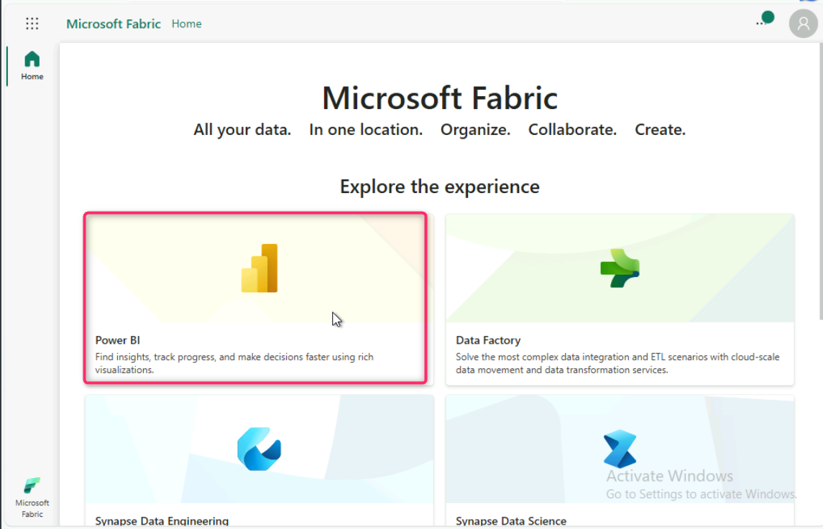Open your browser, navigate to the address bar, and type or paste the following URL: <https://app.fabric.microsoft.com/home> then press the **Enter** button. In Microsoft Fabric page, click on **Power BI**.
2. On right side of Power BI home page, click on the **Settings** icon.

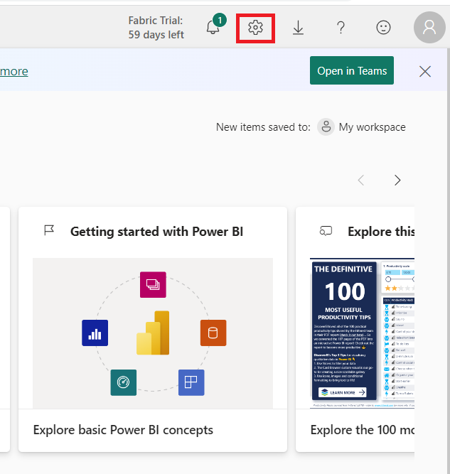

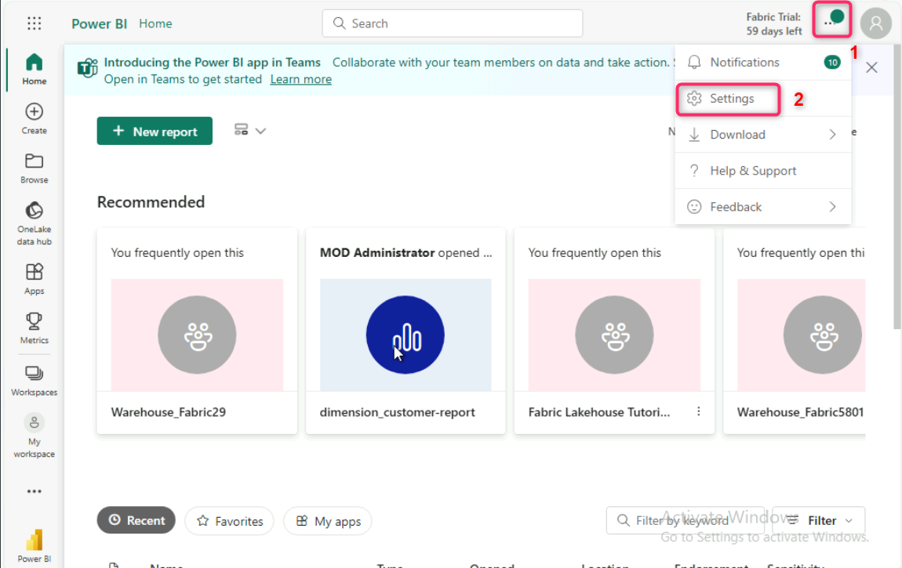In case, you did not see the **Settings** icon, then click on the horizontal ellipsis on the top right side of the page, then navigate and click on **Settings** as shown in the below image.

1. 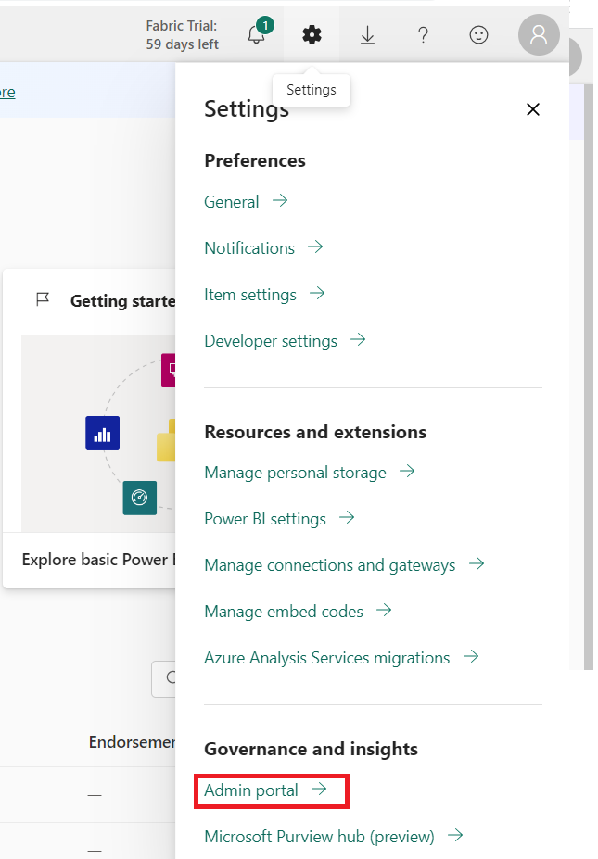In **Settings** pane, scroll down to **Governance and insights**, then click on **Admin portal** .
2. In **Admin portal** pane, select **Tenant settings**, scroll down to **Integration settings** section, click on **Use Azure Maps visual**, then enable it using the **toggle** button. After **Use Azure Maps visual** were Enabled, click on the **Apply** button.

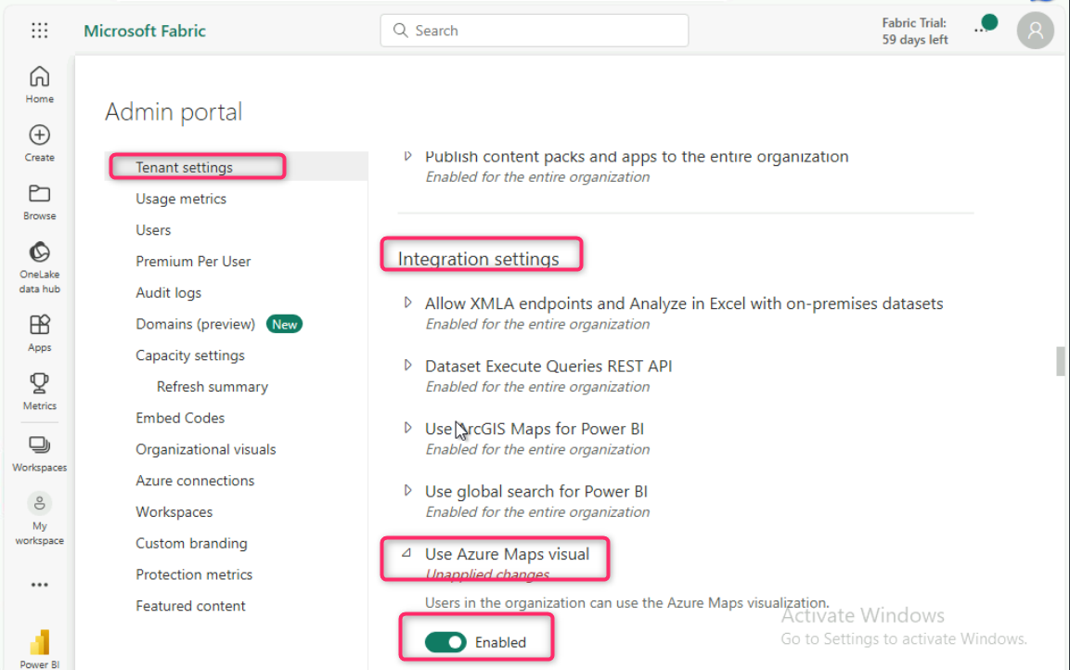

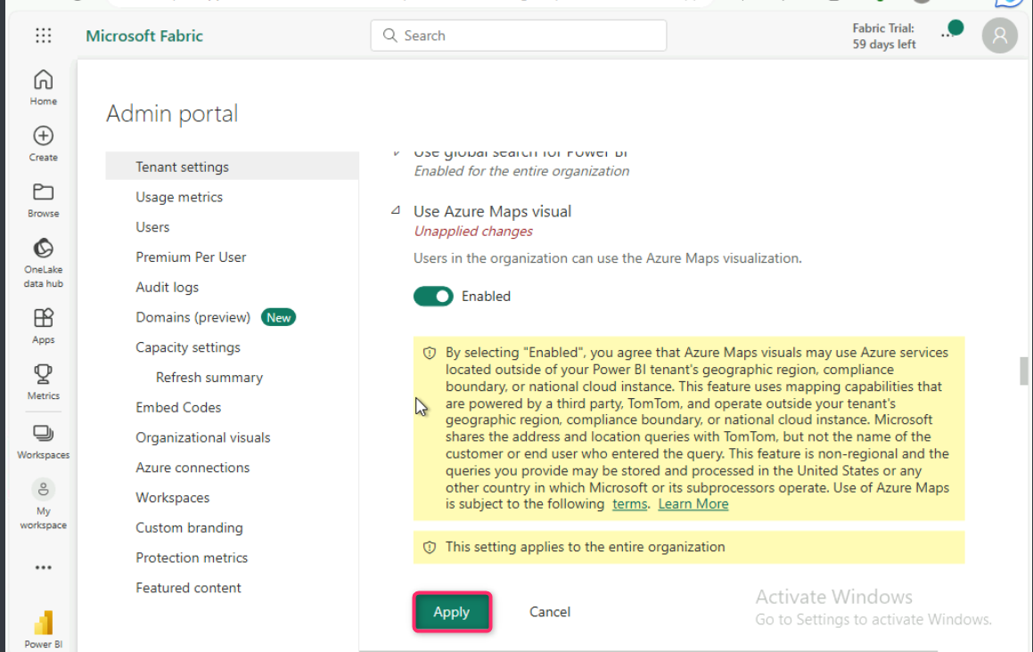

1. 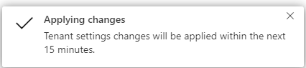You will see a notification stating - **Applying changes.** It will take approximately 15 minutes for implementing the tenant settings.
2. In **Admin portal** pane, select **Tenant settings**, scroll down to **Integration settings** section, click on **Map and filled map visuals**, then enable it using the **toggle** button. After **Use Azure Maps visual** were Enabled, click on the **Apply** button.

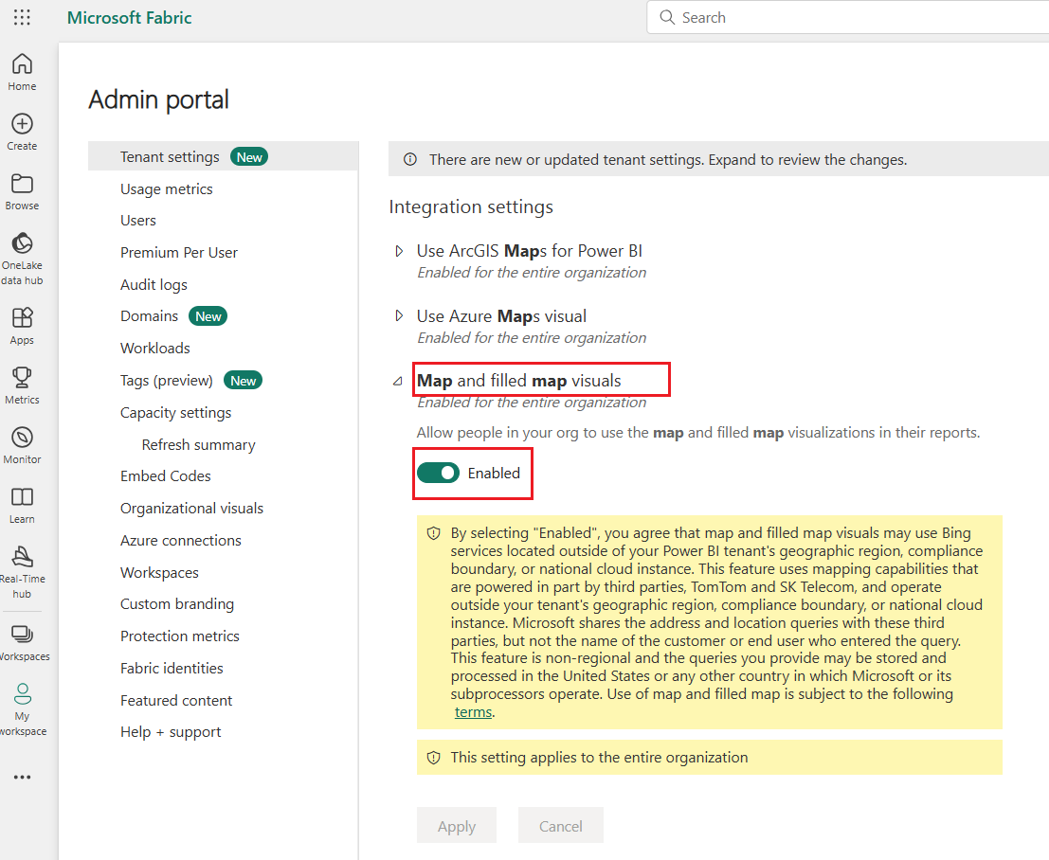

## Task 2: Create Power BI reports

In this task we learn how to create and save several types of Power BI reports.

* 1. 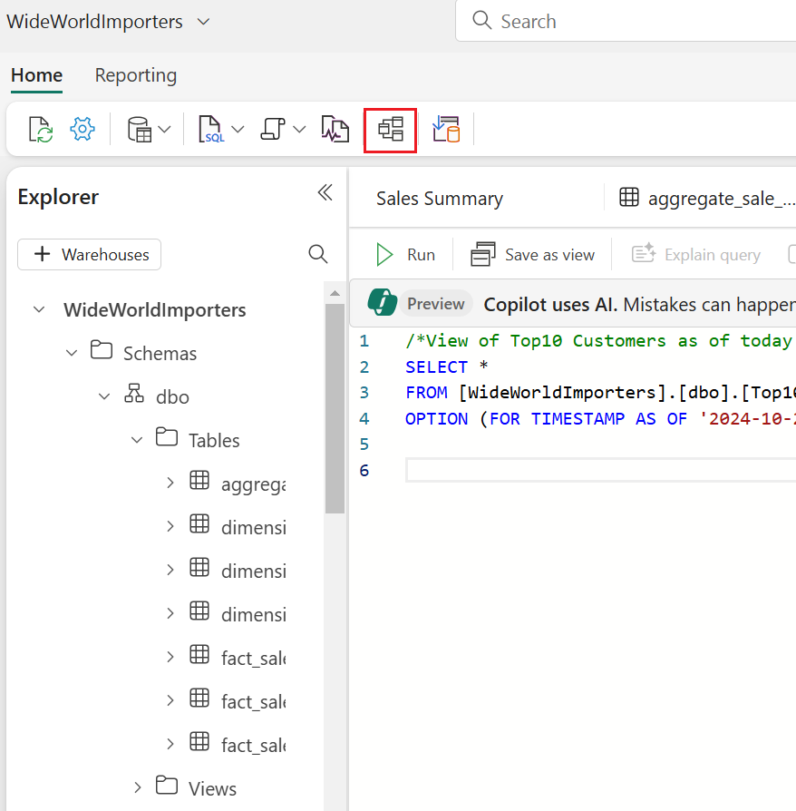In the **WideWorldImporters** page, under the **Home** tab, select the **Model** view .
  2. From the **fact_sale** table, drag the **CityKey** field and drop it onto the **CityKey** field in the **dimension_city** table to create a relationship.

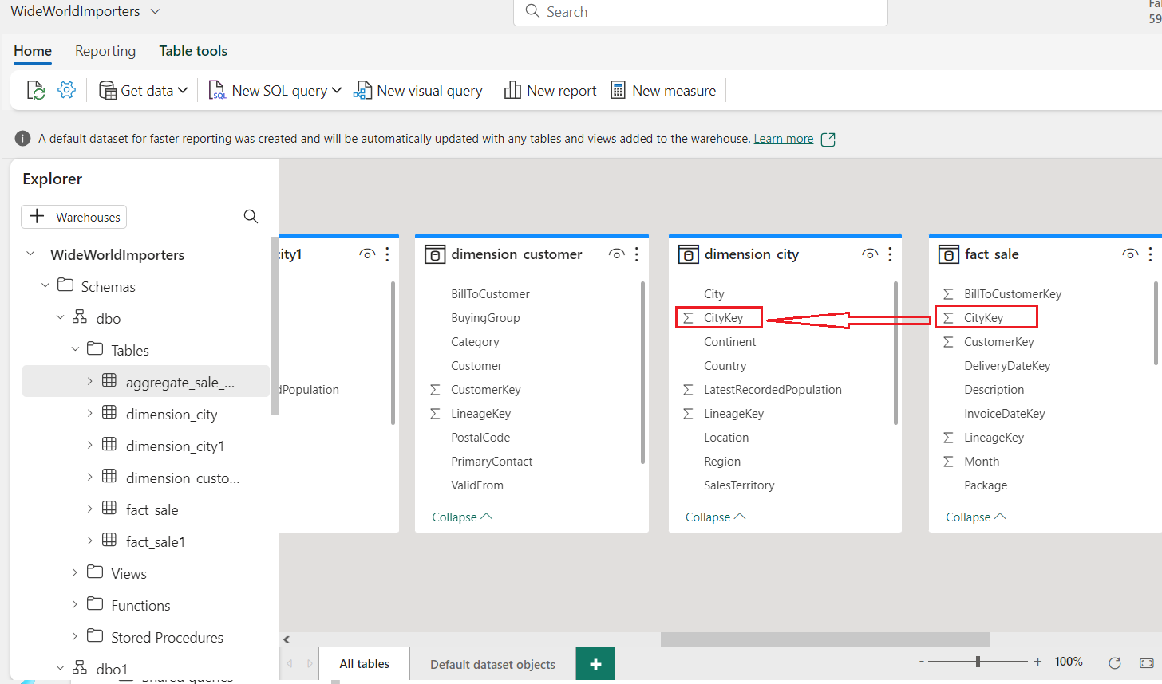

* 1. On the **Create Relationship** settings:
* **Table 1** is populated with **fact_sale** and the column of **CityKey**.
* **Table 2** is populated with **dimension_city** and the column of **CityKey**.
* **Cardinality**: select **Many to one (*:1)**.
* **Cross filter direction**: select **Single**.
* Check the box for **Make this relationship active**.
* Select **Save**.

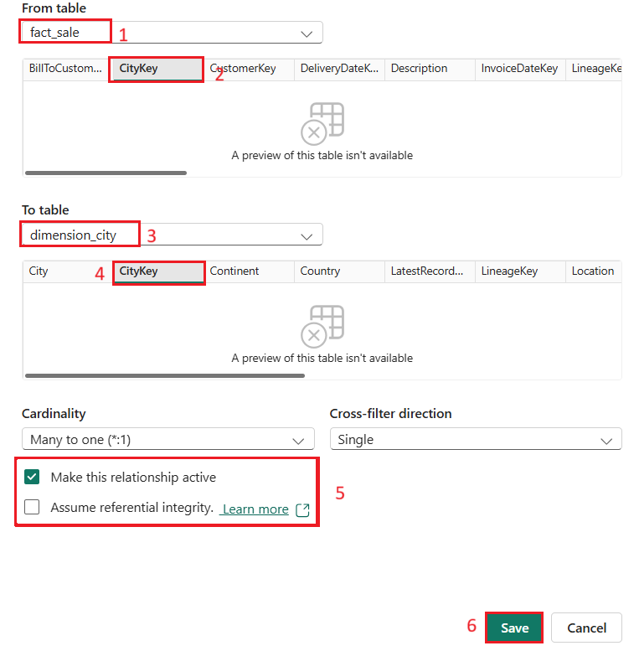

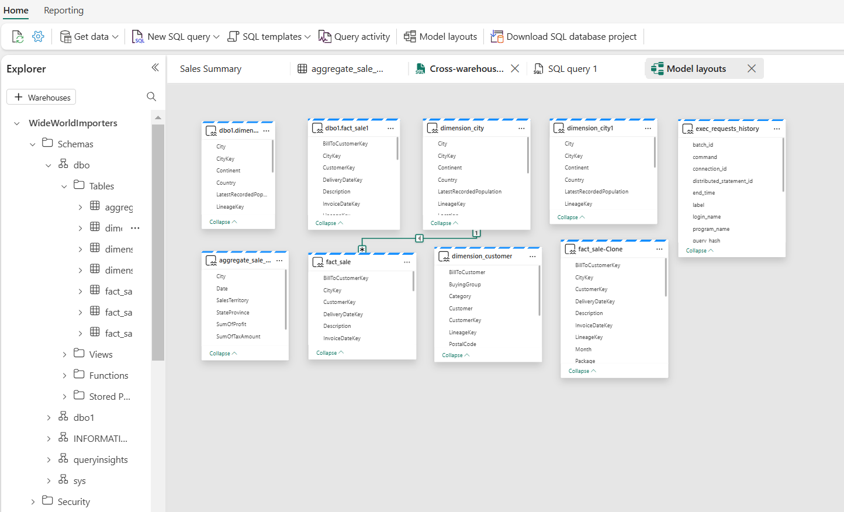

* 1. From the **Reporting** tab of the ribbon, select **New report**.

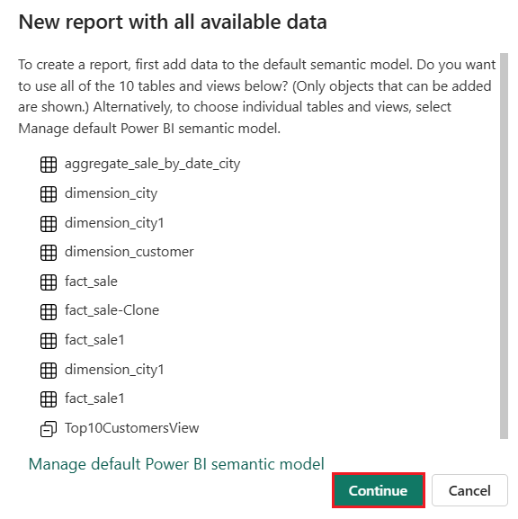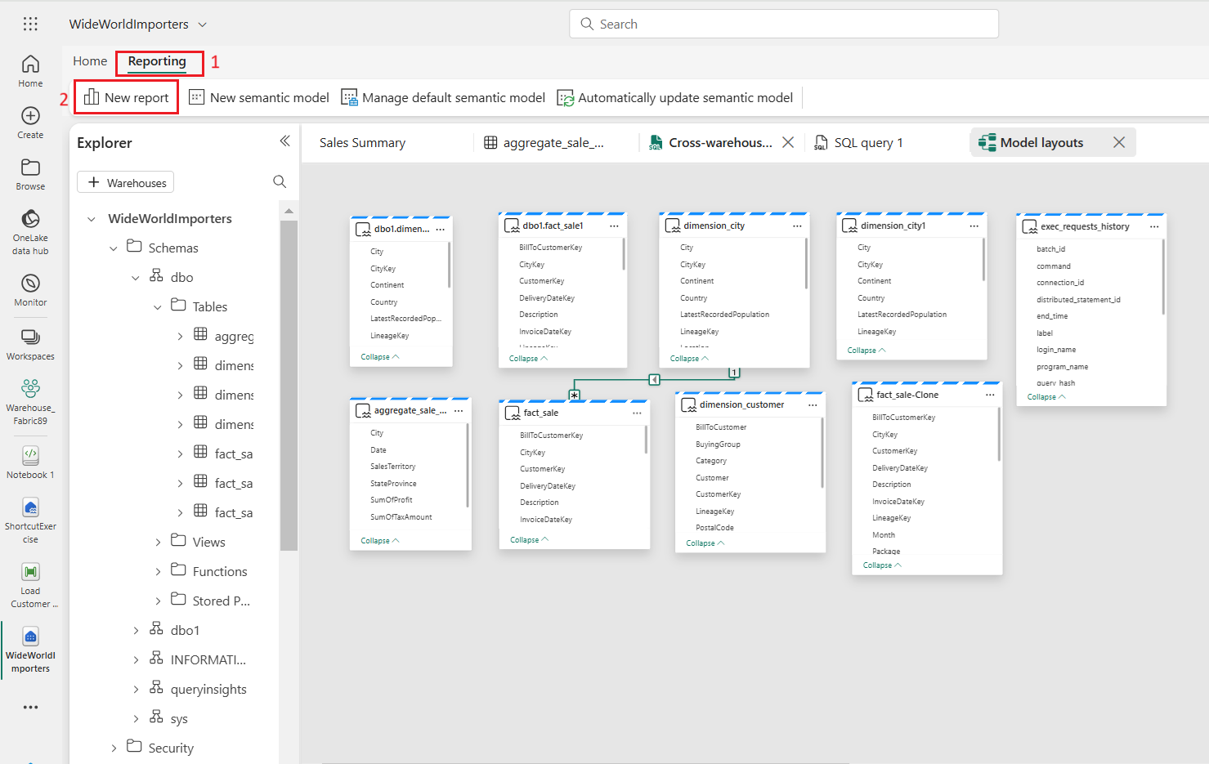

* 1. In the **Synapse Data Engineering Warehouse_FabricXX** page, under **Visualizations**, click to the **Column chart** icon to add a **Column chart** to your report.
* On the **Data** pane, expand **fact_sales** and check the box next to **Profit**. This creates a column chart and adds the field to the Y-axis.
* On the **Data** pane, expand **dimension_city** and check the box next to **SalesTerritory**. This adds the field to the X-axis.
* Reposition and resize the column chart to take up the top left quarter of the canvas by dragging the anchor points on the corners of the visual.

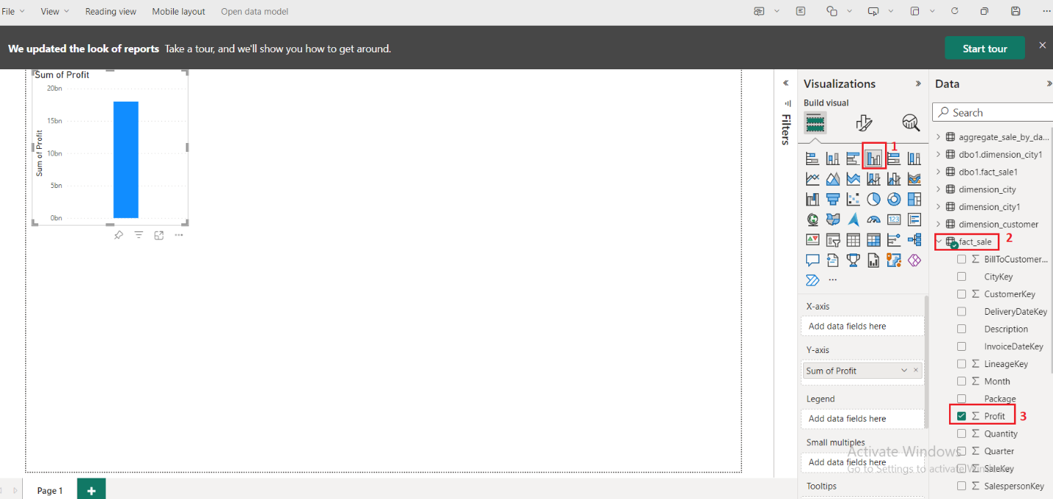

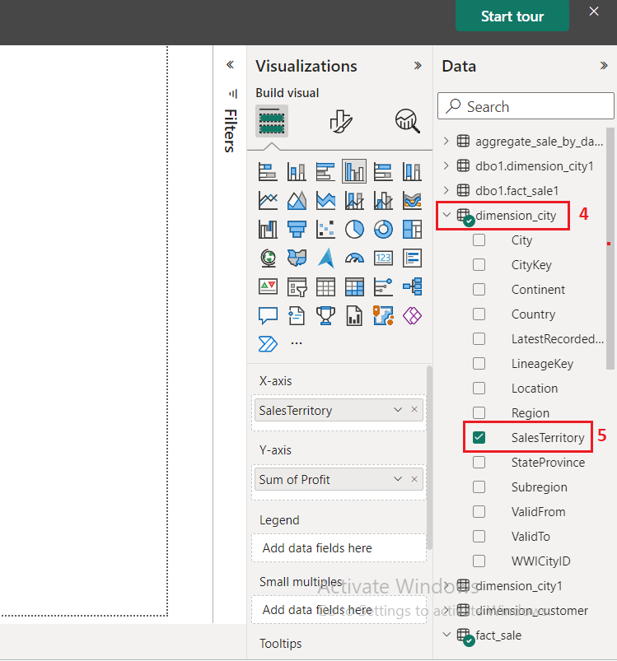

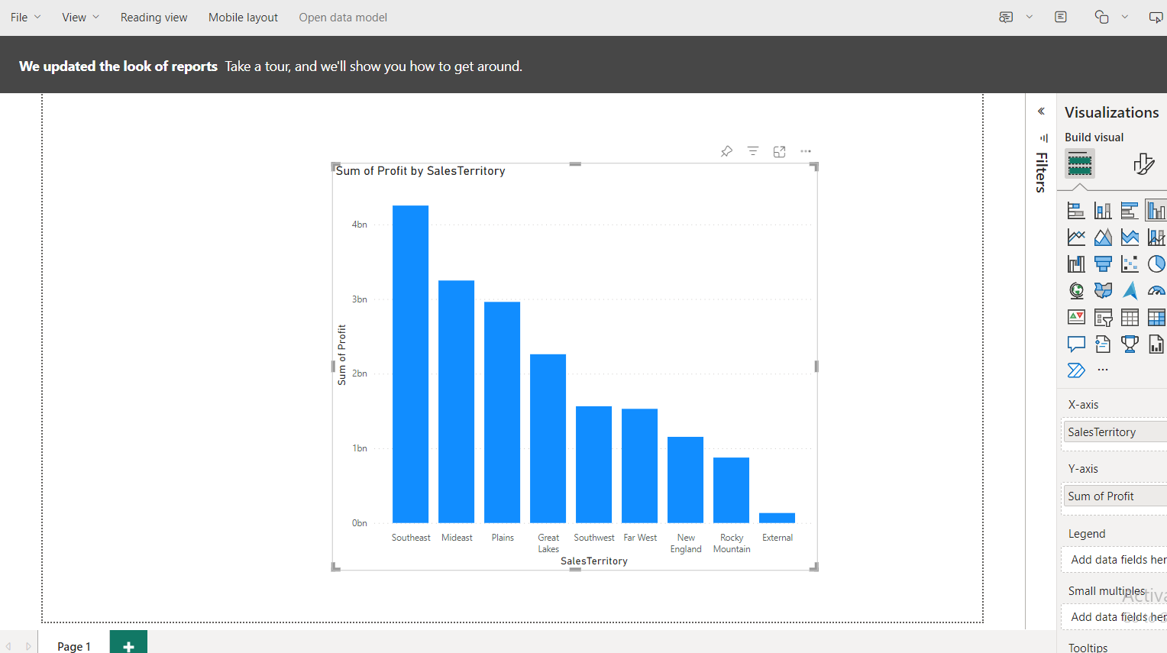

* 1. Select anywhere on the blank canvas (or press the Esc key) so the column chart visual is no longer selected.
  2. 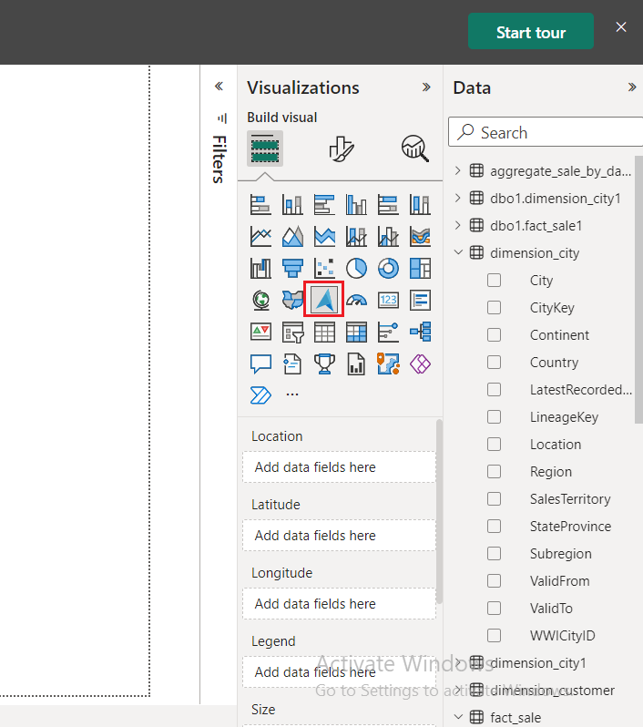Build a **Maps** visual,On the **Visualizations** pane, select the **ArcGIS Maps for Power BI** visual.
  3. From the **Data** pane, drag **StateProvince** from the **dimension_city** table to the **Location** bucket on the **Visualizations** pane.

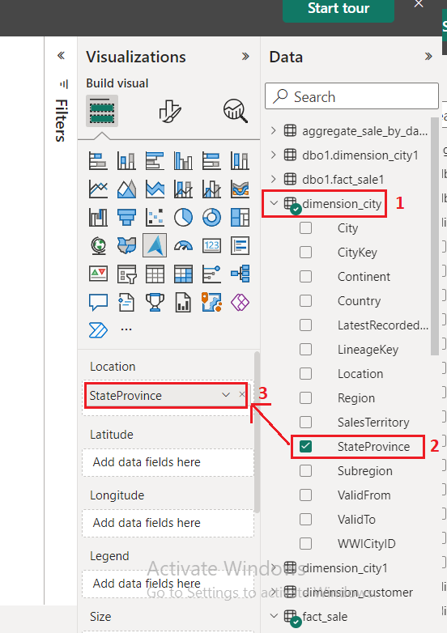

* 1. From the **Data** pane, drag **Profit** from the **fact_sale** table to the **Size** bucket on the **Visualizations** pane.

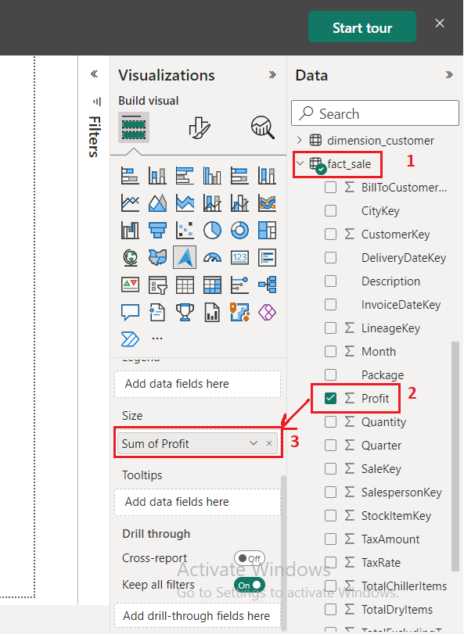

* 1. If necessary, reposition and resize the map to take up the bottom left quarter of the canvas by dragging the anchor points on the corners of the visual.

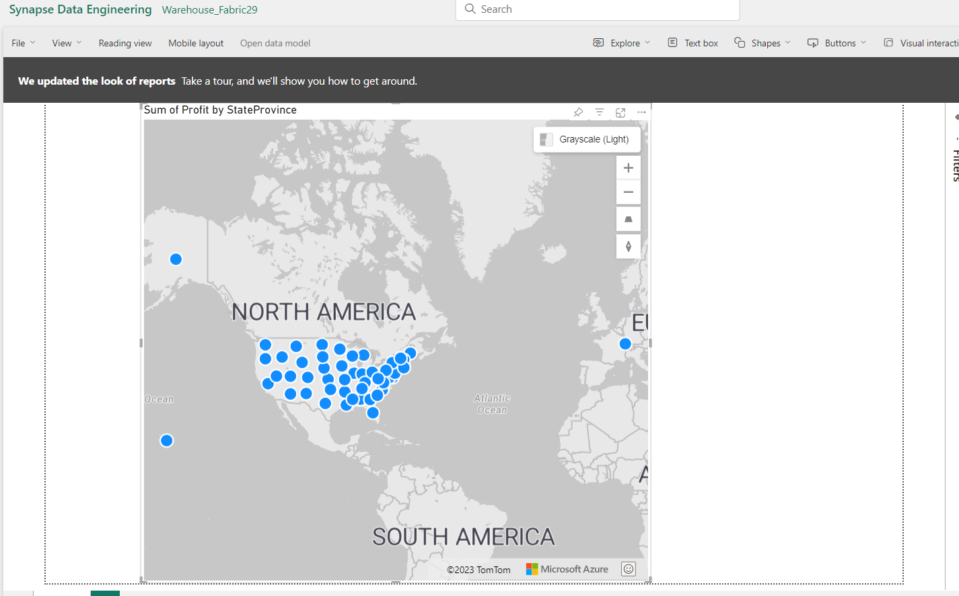

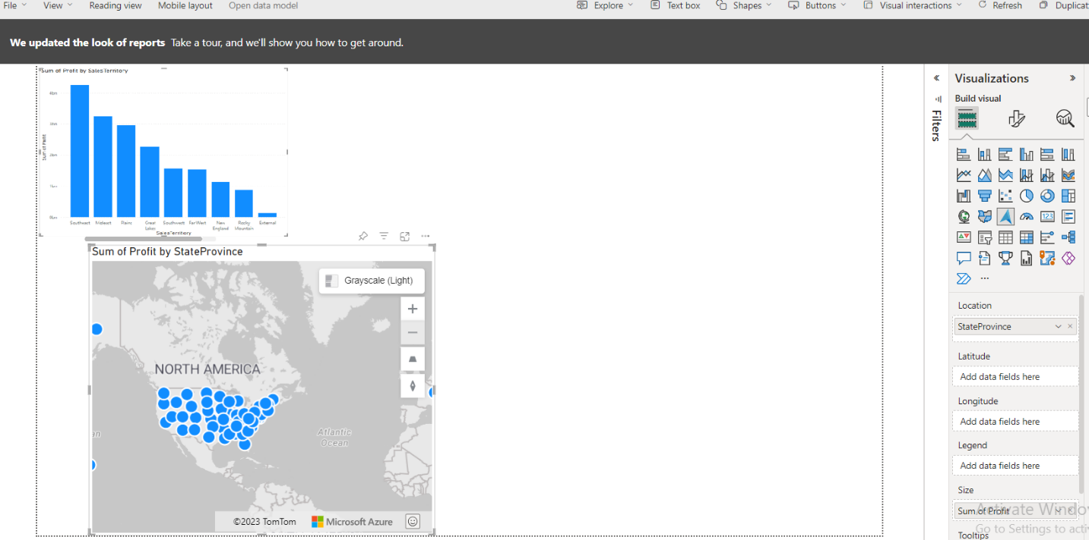

* 1. Select anywhere on the blank canvas (or press the Esc key) so the map visual is no longer selected.
  2. 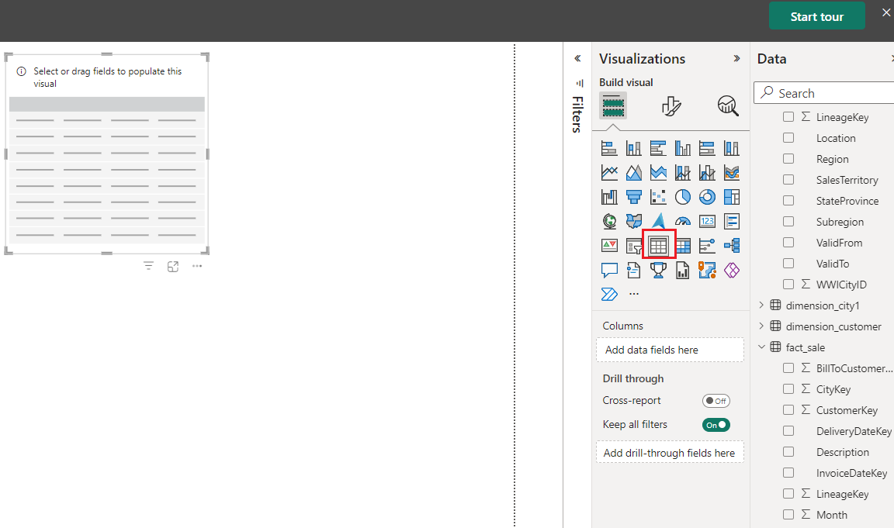Build a **Table** visual on the **Visualizations** pane, select the **Table** visual.
  3. From the **Data** pane, check the box next to **SalesTerritory** on the **dimension_city** table.
  4. From the **Data** pane, check the box next to **StateProvince** on the **dimension_city** table.

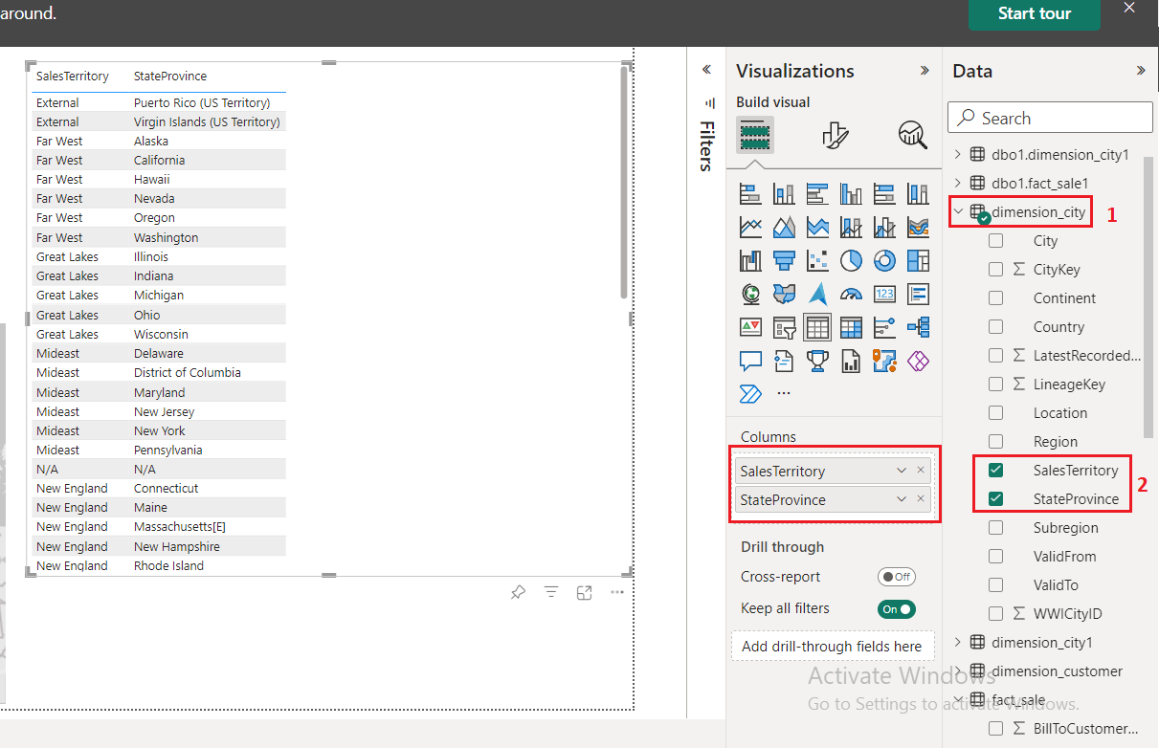

* 1. From the **Data** pane, check the box next to **Profit** on the **fact_sale** table.
  2. From the **Data** pane, check the box next to **TotalExcludingTax** on the **fact_sale** table.

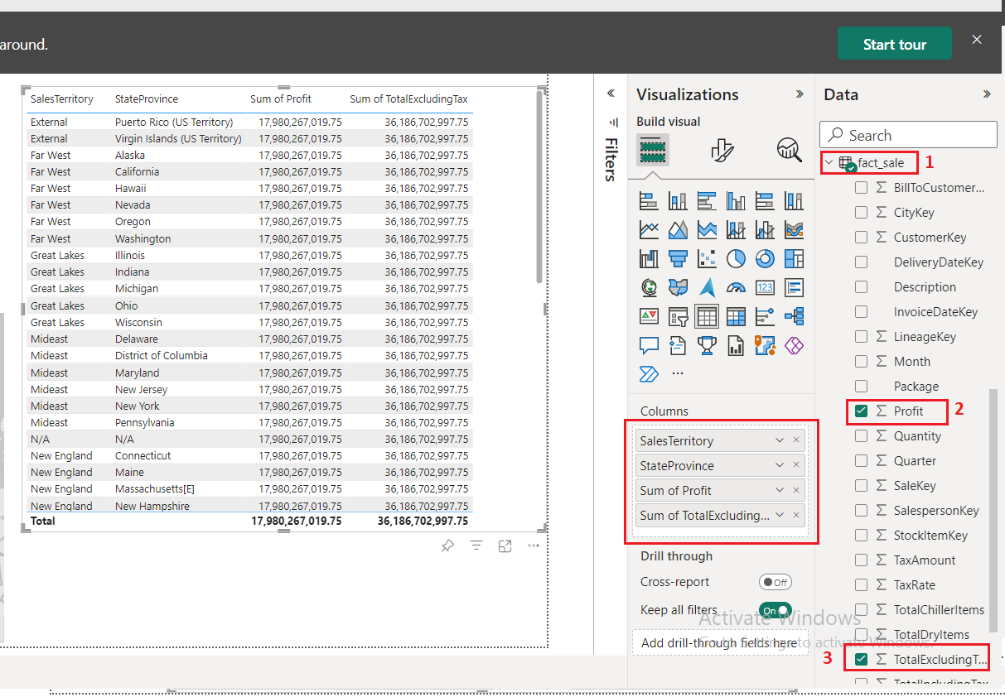

* 1. Reposition and resize the column chart to take up the right half of the canvas by dragging the anchor points on the corners of the visual.

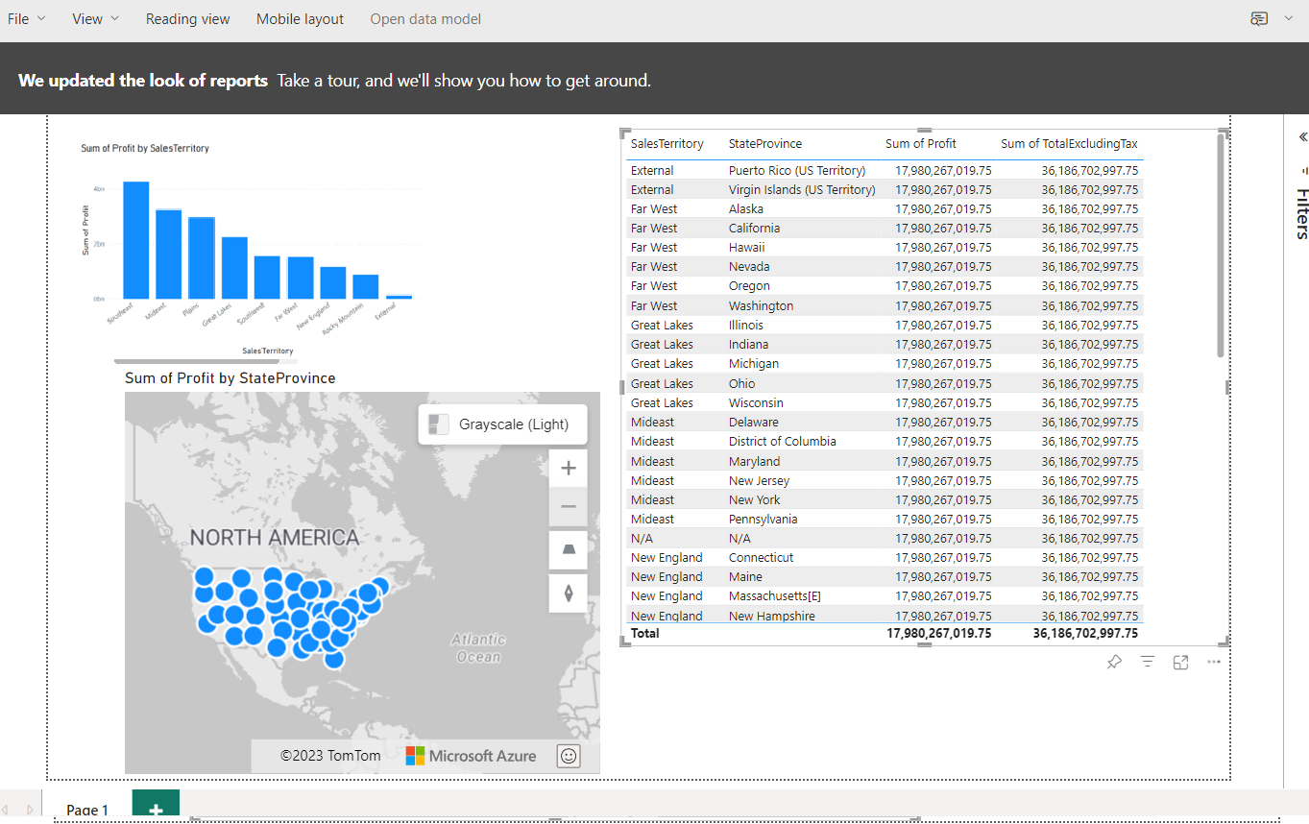

* 1. In the Synapse Data Engineering Warehouse_FabricXX page, from the ribbon, select **File** and select the **Save**.

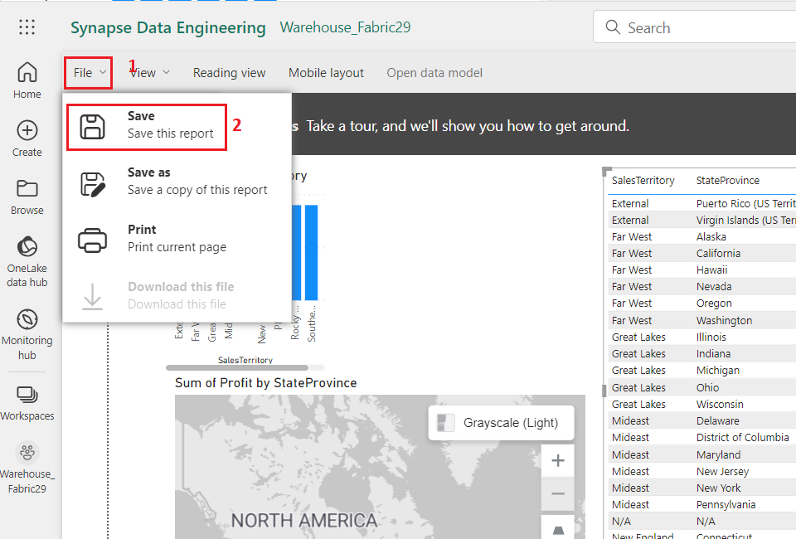

* 1. In the Save your report dialog box, enter +++**Sales Analysis+++** as the name of your report and click on the **Save button**.

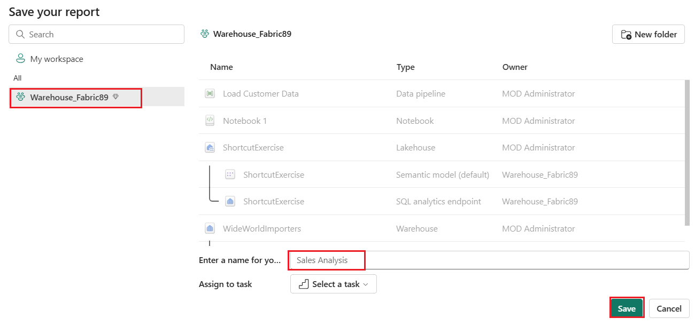

* 1. 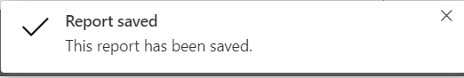You will see a notification stating **Report saved.**

## Task 3: Build a report from the OneLake data hub

Learn how to build a report with the data you ingested into your Warehouse in the last step.

* 1. In the **Sales Analysis** pane, select the **OneLake data hub** in the left navigation menu.

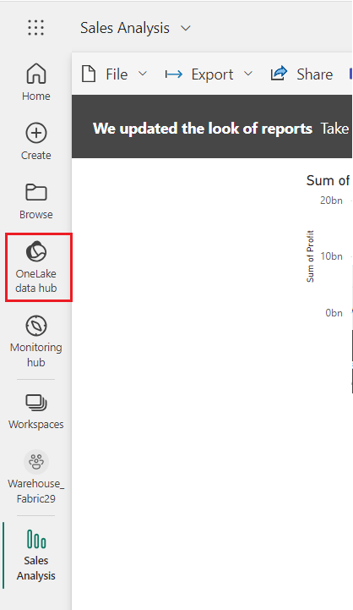

* 1. From the item list, select **WideWorldImporters** with the type of **Dataset (default)**.

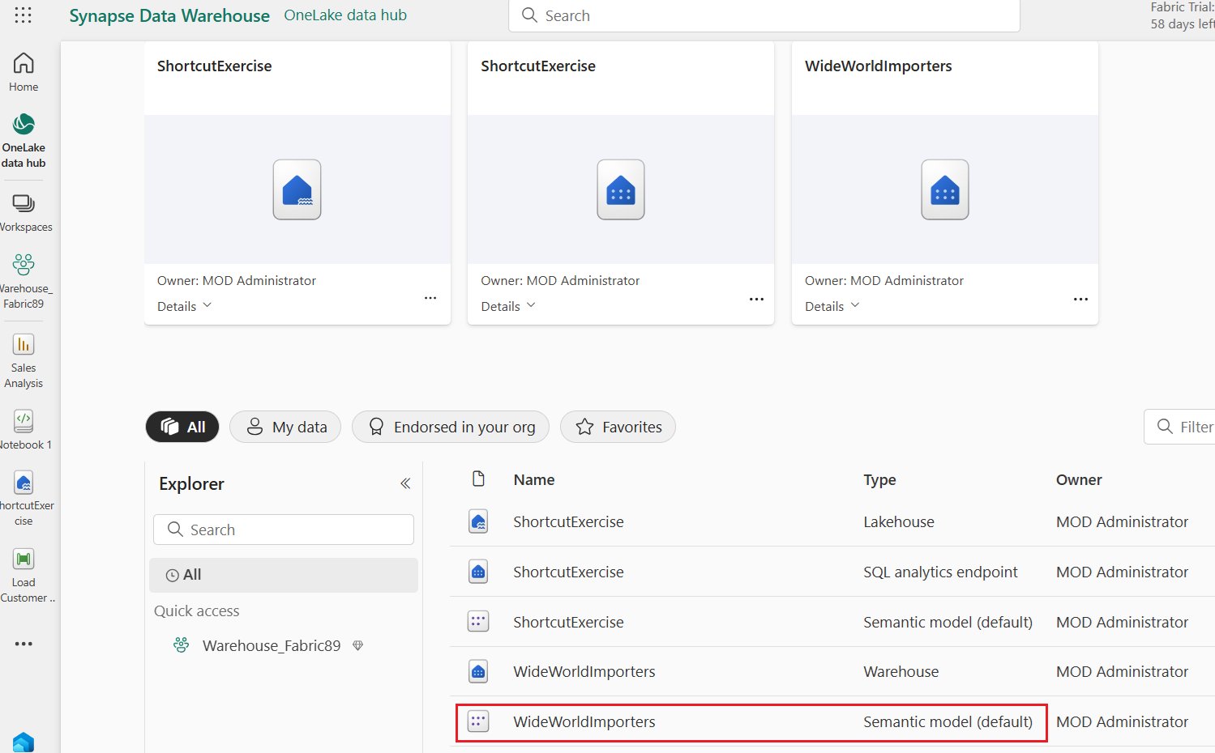

* 1. In the **Visualize this data** section, select **Create a report** and select **Auto-create**. A report is generated from the **dimension_customer** table that was loaded in the previous section.

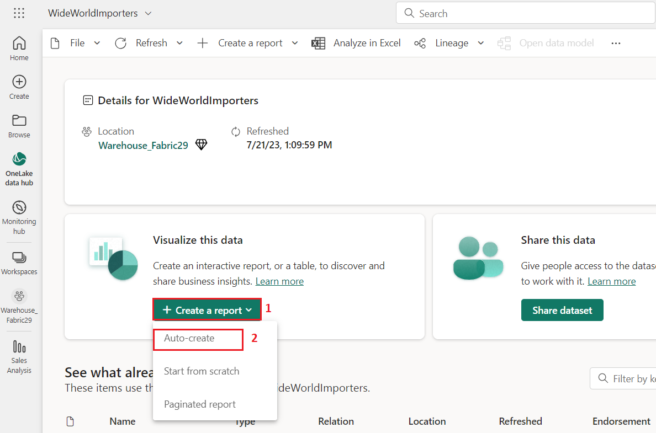

* 1. A report similar to the following image is generated.

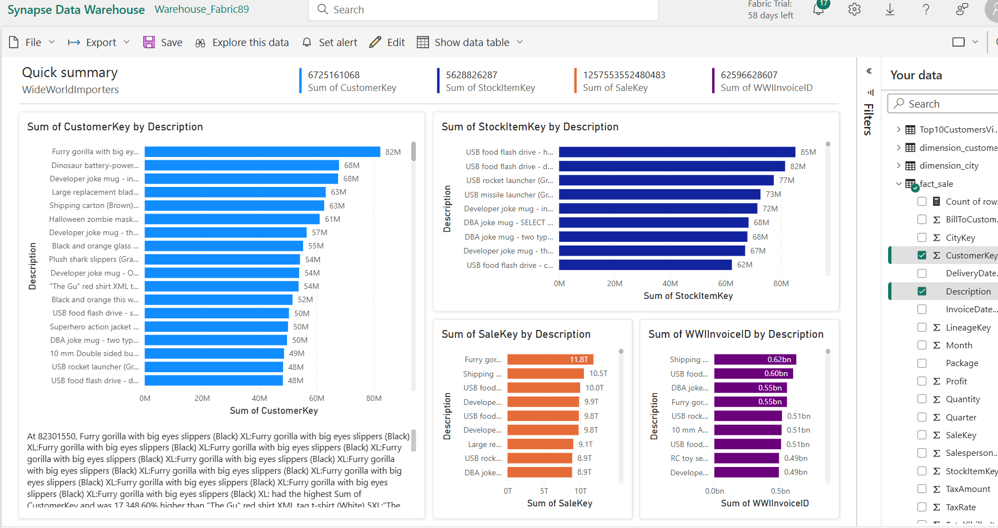

* 1. From the ribbon, select **Save**.

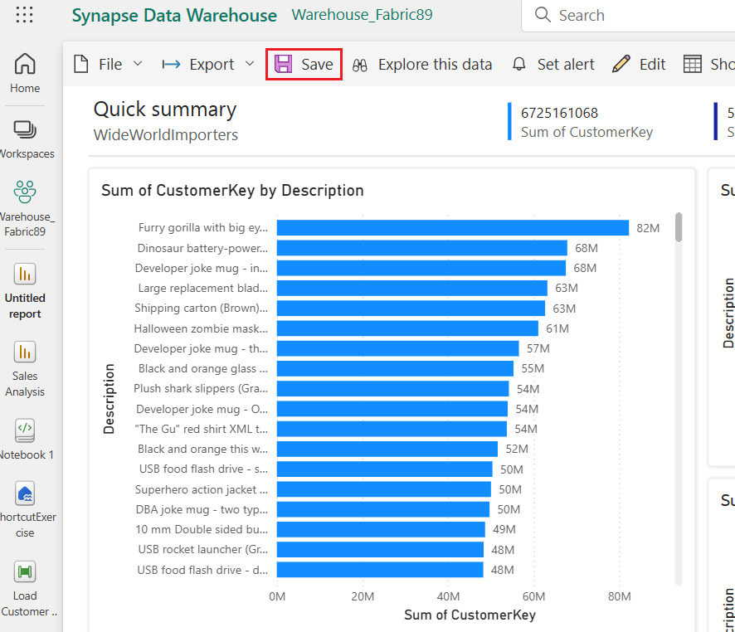

* 1. In the **Save your report** dialog box, enter +++**Customer Quick Summary+++** in the name box. In the **Save your report** dialogue, select **Save**.

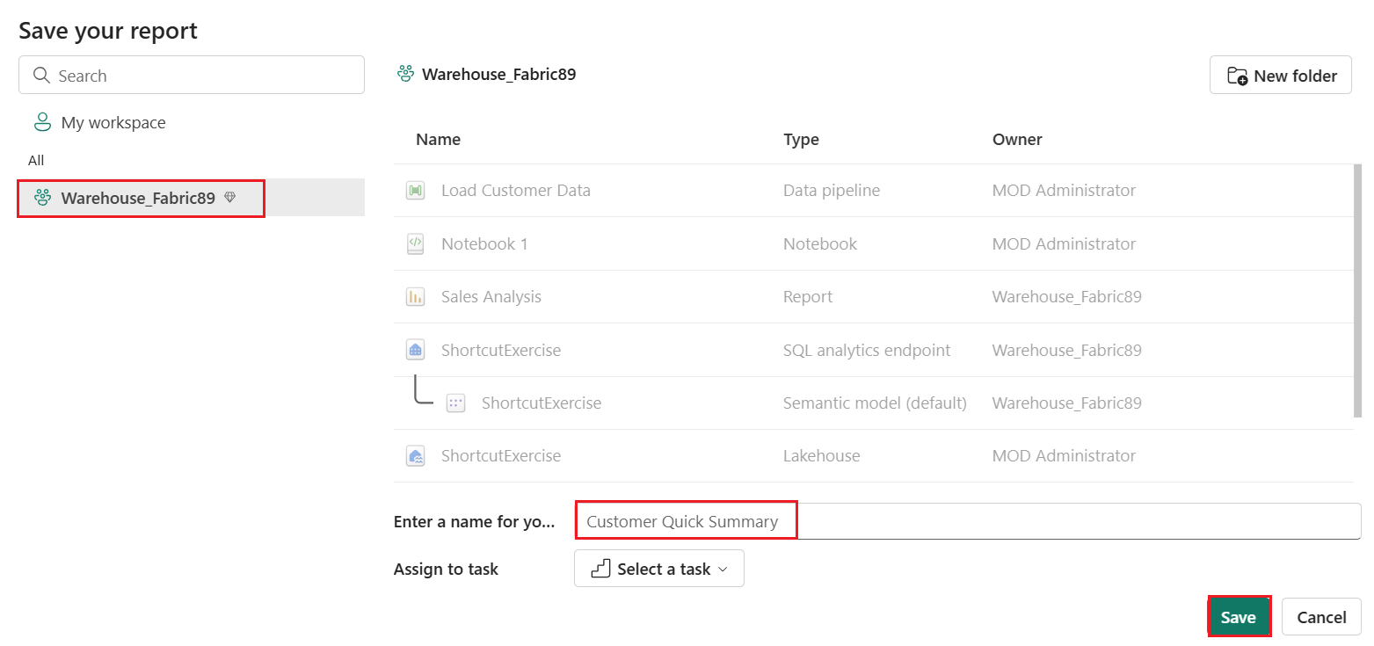

* 1. 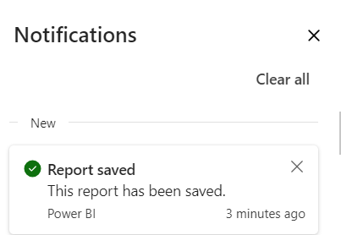You will see a notification stating **Report saved.**

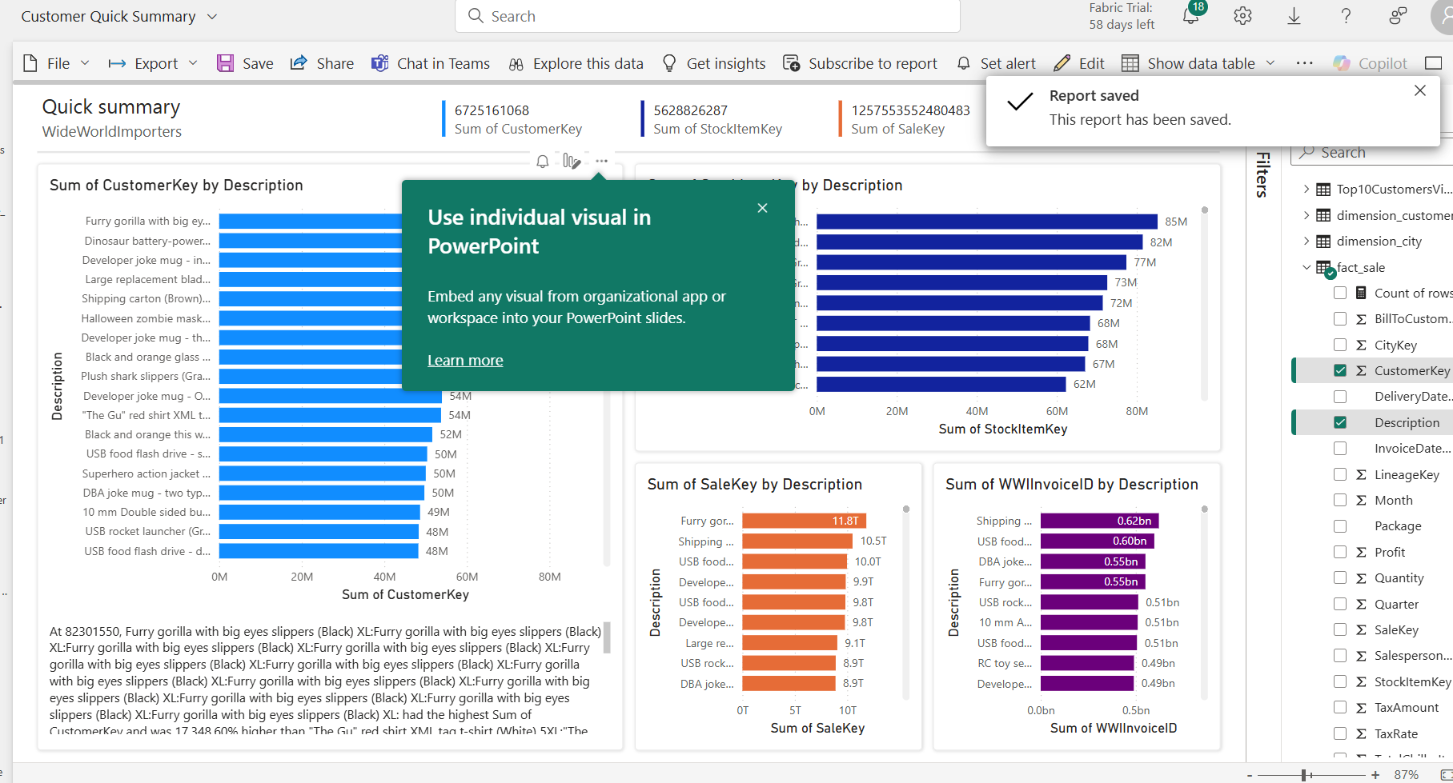

## Task 4: Clean up resources

You can delete individual reports, pipelines, warehouses, and other items or remove the entire workspace. In this tutorial, you will clean up the workspace, individual reports, pipelines, warehouses, and other items you created as part of the lab.

1. Select **Warehouse_FabricXX** in the navigation menu to return to the workspace item list.

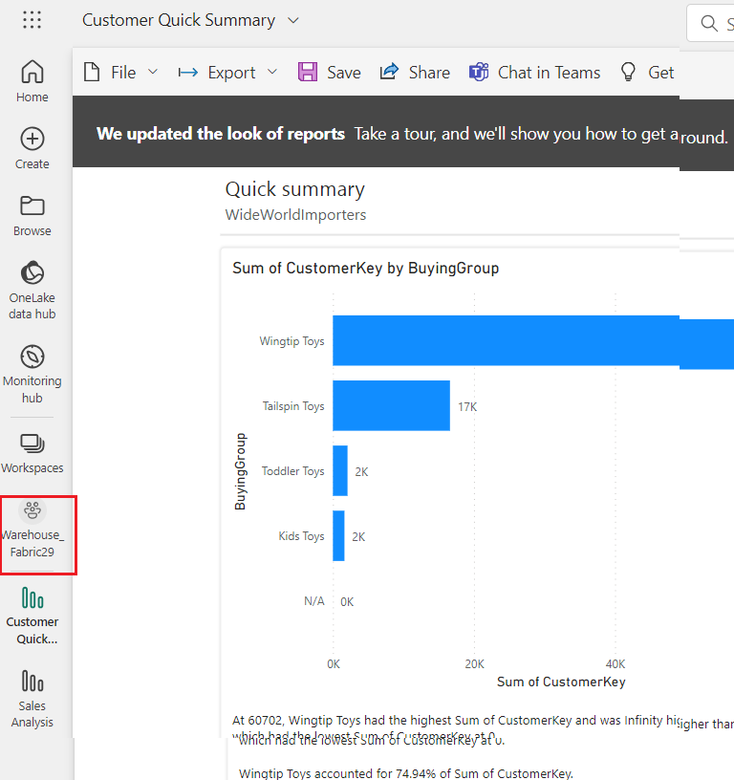

1. In the menu of the workspace header, select **Workspace settings**.

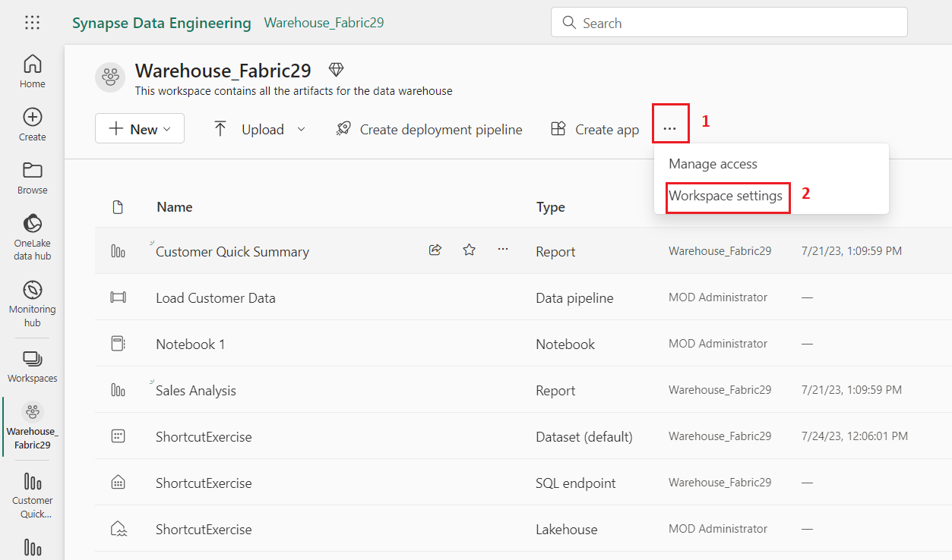

1. In the **Workspace settings** dialog box, select **Other** and select the **Remove this workspace**.

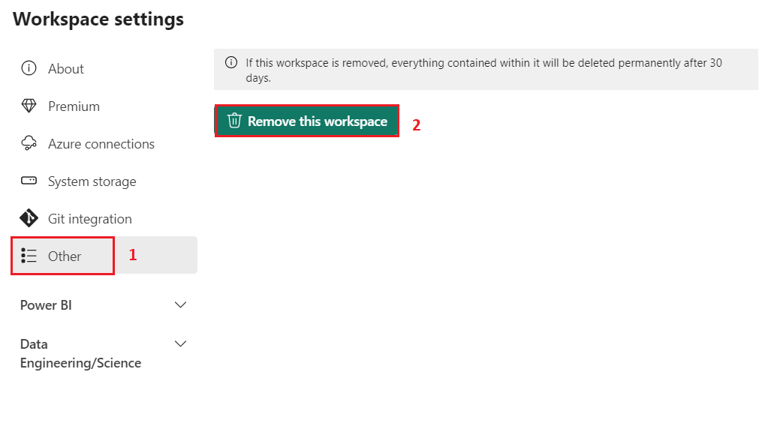

1. 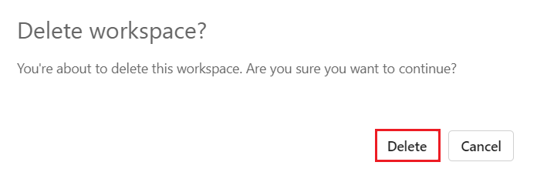In the **Delete workspace?** dialog box, click on the **Delete** button.

**Summary**

This comprehensive lab walks through a series of tasks aimed at establishing a functional data environment in Microsoft Fabric. It starts with the creation of a workspace, essential for data operations, and ensures the trial is enabled. Subsequently, a Warehouse named WideWorldImporters is established within the Fabric environment to serve as the central repository for data storage and processing. Data ingestion into the Warehouse_FabricXX workspace is then detailed through the implementation of a Data Factory pipeline. This process involves fetching data from external sources and integrating it seamlessly into the workspace. Critical tables, dimension_city, and fact_sale, are created within the data warehouse to serve as foundational structures for data analysis. The data loading process continues with the use of T-SQL, where data from Azure Blob Storage is transferred into the specified tables. The subsequent tasks delve into the realm of data management and manipulation. Cloning tables is demonstrated, offering a valuable technique for data replication and testing purposes. Additionally, the cloning process is extended to a different schema (dbo1) within the same warehouse, showcasing a structured approach to data organization. The lab progresses to data transformation, introducing the creation of a stored procedure to efficiently aggregate sales data. It then transitions to visual query building, providing an intuitive interface for complex data queries. This is followed by an exploration of notebooks, demonstrating their utility in querying and analyzing data from the dimension_customer table. Multi-warehouse querying capabilities are then unveiled, allowing for seamless data retrieval across various warehouses within the workspace. The lab culminates in enabling Azure Maps visuals integration, enhancing geographical data representation in Power BI. Subsequently, a range of Power BI reports, including column charts, maps, and tables, are created to facilitate in-depth sales data analysis. The final task focuses on generating a report from the OneLake data hub, further emphasizing the versatility of data sources in Fabric. Finally, the lab provides insights into resource management, emphasizing the importance of cleanup procedures to maintain an efficient workspace. Collectively, these tasks present a comprehensive understanding of setting up, managing, and analyzing data within Microsoft Fabric.